

**SALS EDUCATIONAL ACADEMY PRIVATE LIMITED**

**IT – DEPARTMENT**

**CORE TEAM TRAINING**

**Edu – Tech WEBSITES ANALYSIS**

**SUBMITTED BY**

**AKASH.B**

**Overview about Tutoria.pk**

**About tutoria.pk:**

tutoria.pk stands as Pakistan's premier e-learning platform, offering comprehensive study tools tailored for matric and intermediate students. These include past paper solutions, book notes, and video lectures, ensuring personalized exam preparation. Launched as Pakistan's inaugural digital self-study platform, tutoria.pk empowers students with personalized learning recommendations, 24/7 support, and access to a user-friendly app for on-the-go learning.

**Their Story:**

tutoria.pk emerged from a vision to provide a reliable, practical, and easily accessible self-study platform, offering customized exam preparation materials at affordable rates. Continuously evolving, tutoria.pk remains committed to nurturing academic growth and personal development through innovative e-learning solutions.

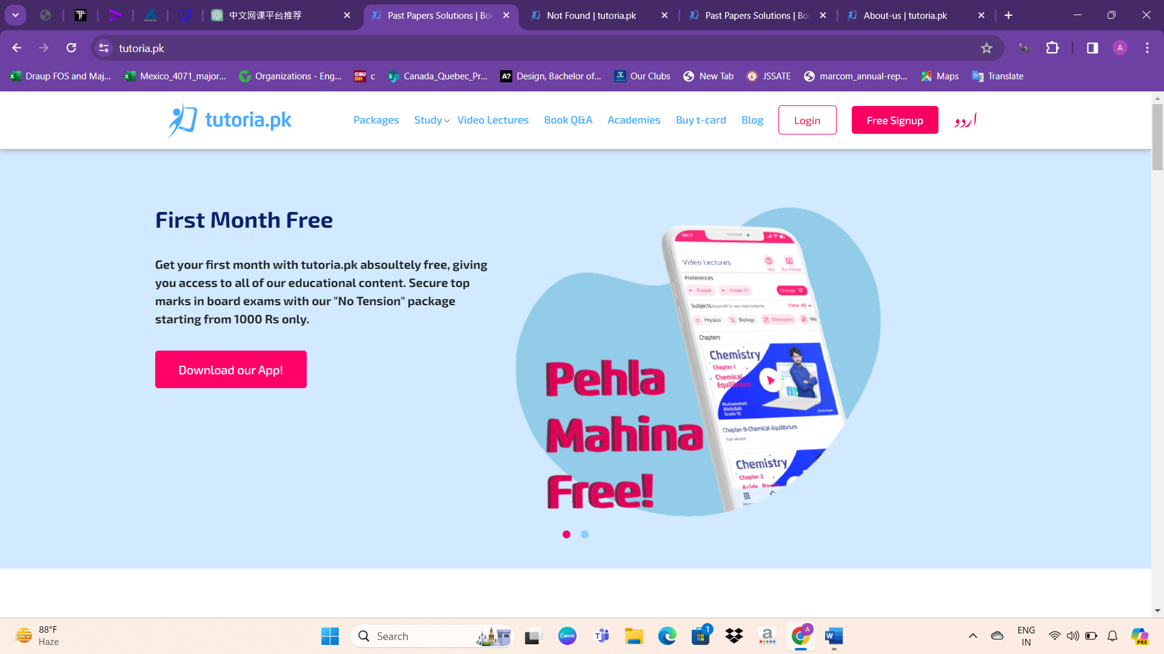

**Modern E-learning Technology:**

With tutoria.pk, students can pursue their academic goals while maintaining their daily routines. Leveraging modern e-learning technology, the platform offers flexibility and convenience, enabling students to prepare for exams without disrupting their lives.

**Guaranteed Premium Quality:**

Every study material provided by tutoria.pk undergoes rigorous testing to ensure premium quality and adherence to academic standards. With complete coverage of all subjects and thorough chapter-by-chapter notes, solved past papers, MCQs, and quizzes, tutoria.pk guarantees excellent grades for students affiliated with various educational boards.

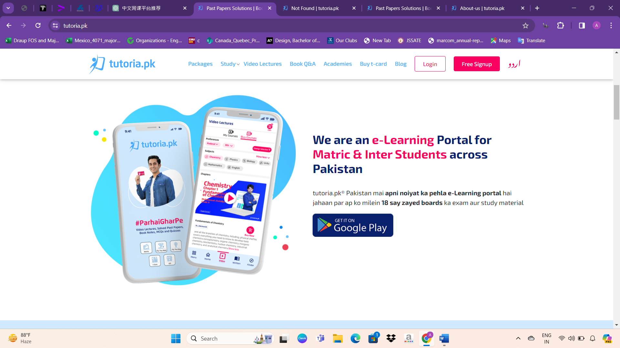

About websites Design

* Navbar design

Packages: Explore different subscription packages offered by the website, providing access to various study materials and features.

**Study:** Access study resources such as notes, practice questions, and solutions to aid in exam preparation and academic success.

**Video Lectures:** Watch educational videos covering a wide range of topics and subjects to enhance learning through visual instruction.

**Book Q&A:** Access a collection of questions and answers related to textbooks and course materials, providing additional study support.

**Academies:** Discover academic institutions or learning centers affiliated with the website, offering specialized courses or programs.

**Buy T-Card**: Purchase a T-Card, which may provide additional benefits or access to premium features on the website.

**Blog:** Explore articles, posts, or updates related to education, learning tips, and relevant topics of interest.

**Login:** Sign in to your account to access personalized features, saved progress, and exclusive content.

**Free Signup:** Register for a new account on the website to access free resources, receive updates, and personalize your learning experience.

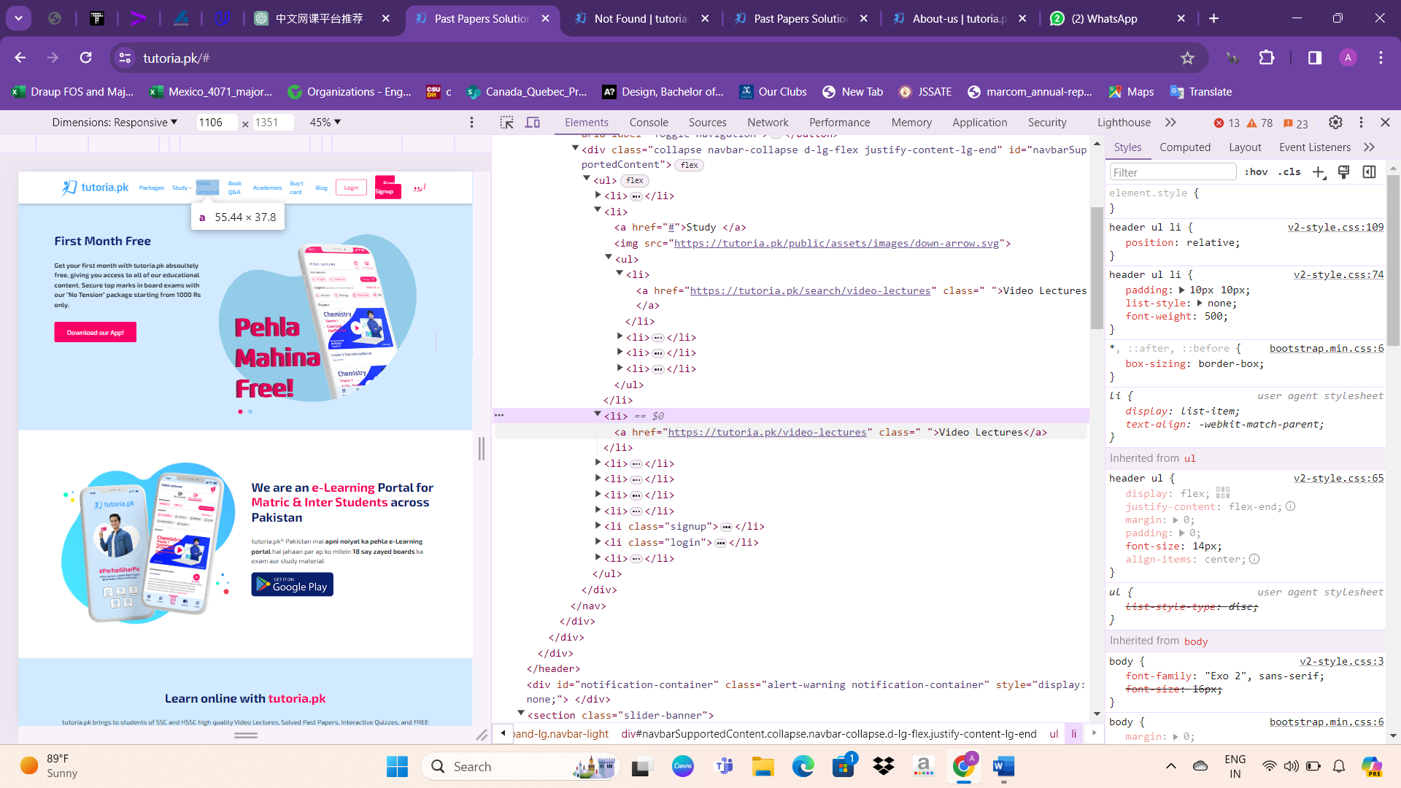

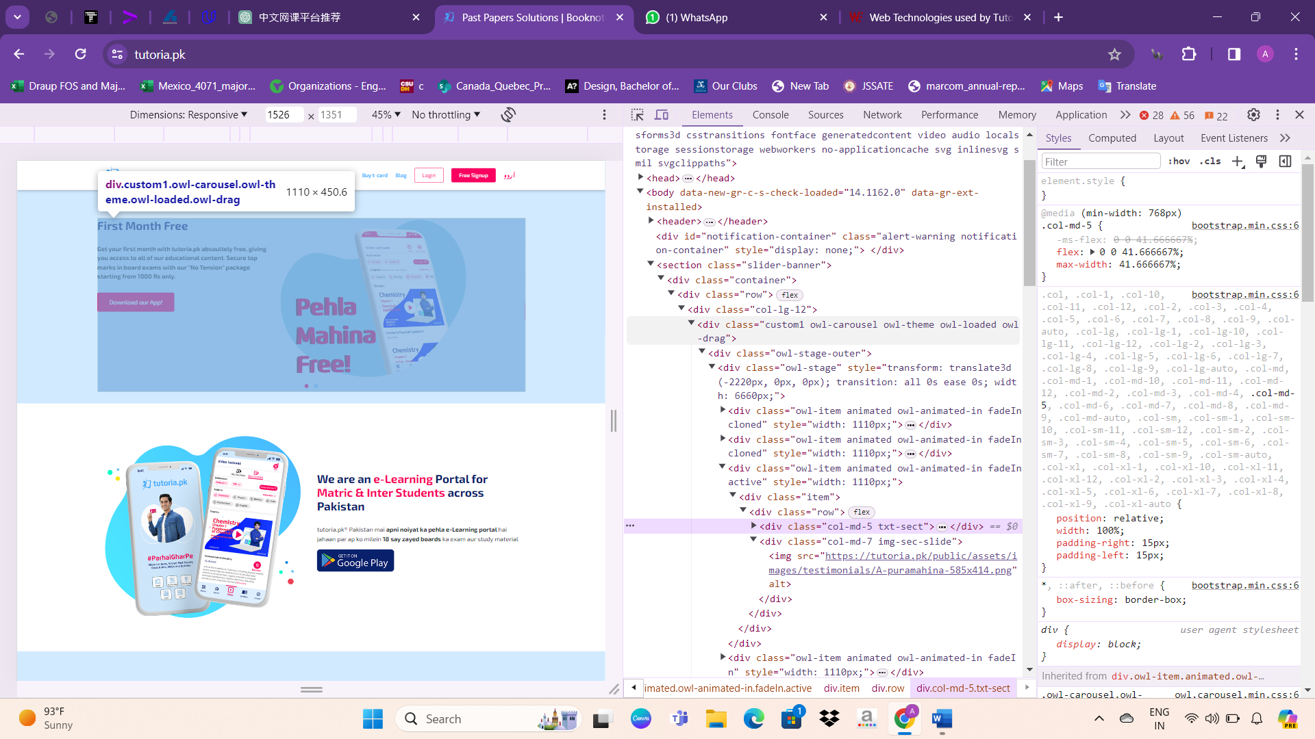

Next, a well-designed carousel with smooth transitions using Bootstrap showcases various offerings:

Free Trial for One Month: The carousel's first image highlights a promotion for a one-month free trial, enticing users to experience the platform's features and benefits without commitment.

Free Book Access: The subsequent image emphasizes free access to educational materials or books, enhancing the value proposition for users seeking additional resources.

The carousel's point navigation system provides seamless transitions between images, enhancing user engagement and visually conveying key offerings effectively. By leveraging Bootstrap's framework, the carousel ensures a smooth and responsive user experience across devices.

The website design incorporates Bootstrap, utilizing flexible images and grids to create a visually appealing layout. A featured video on the homepage enhances engagement and showcases key offerings. Towards the end of the page, essential information, akin to tutoria.pk, is provided:

Location: Office No. 2, 2nd Floor, Beverly Center, Jinnah Avenue, Blue Area, Islamabad, Islamabad Capital Territory (ICT) 44000

Contact:

Phone: +92 3041-110-207

Email: info@tutoria.pk

Sections:

Their Story

Blog

FAQs

Buy T-Card

Contact Us

Careers

Terms and Conditions

Privacy Policy

The website is powered and designed by E-Learning Services Pvt Ltd, with all rights reserved © 2021.

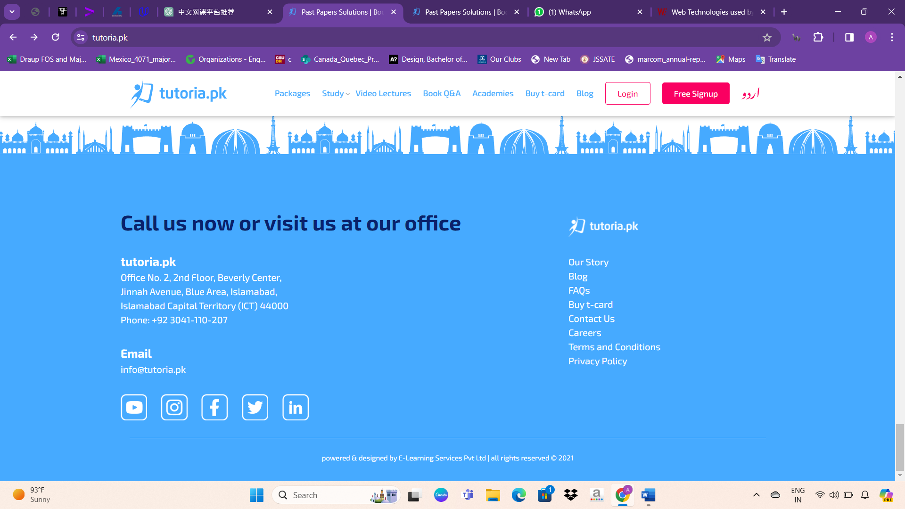

Study materials

The study materials are available in two formats:

**Video Lectures:** Comprehensive video content covering various subjects and topics, providing visual instruction and explanations to aid in learning.

**Book Q&A:** Questions and answers related to textbooks and course materials, offering additional study support and clarification on key concepts and topics.

**Package options**

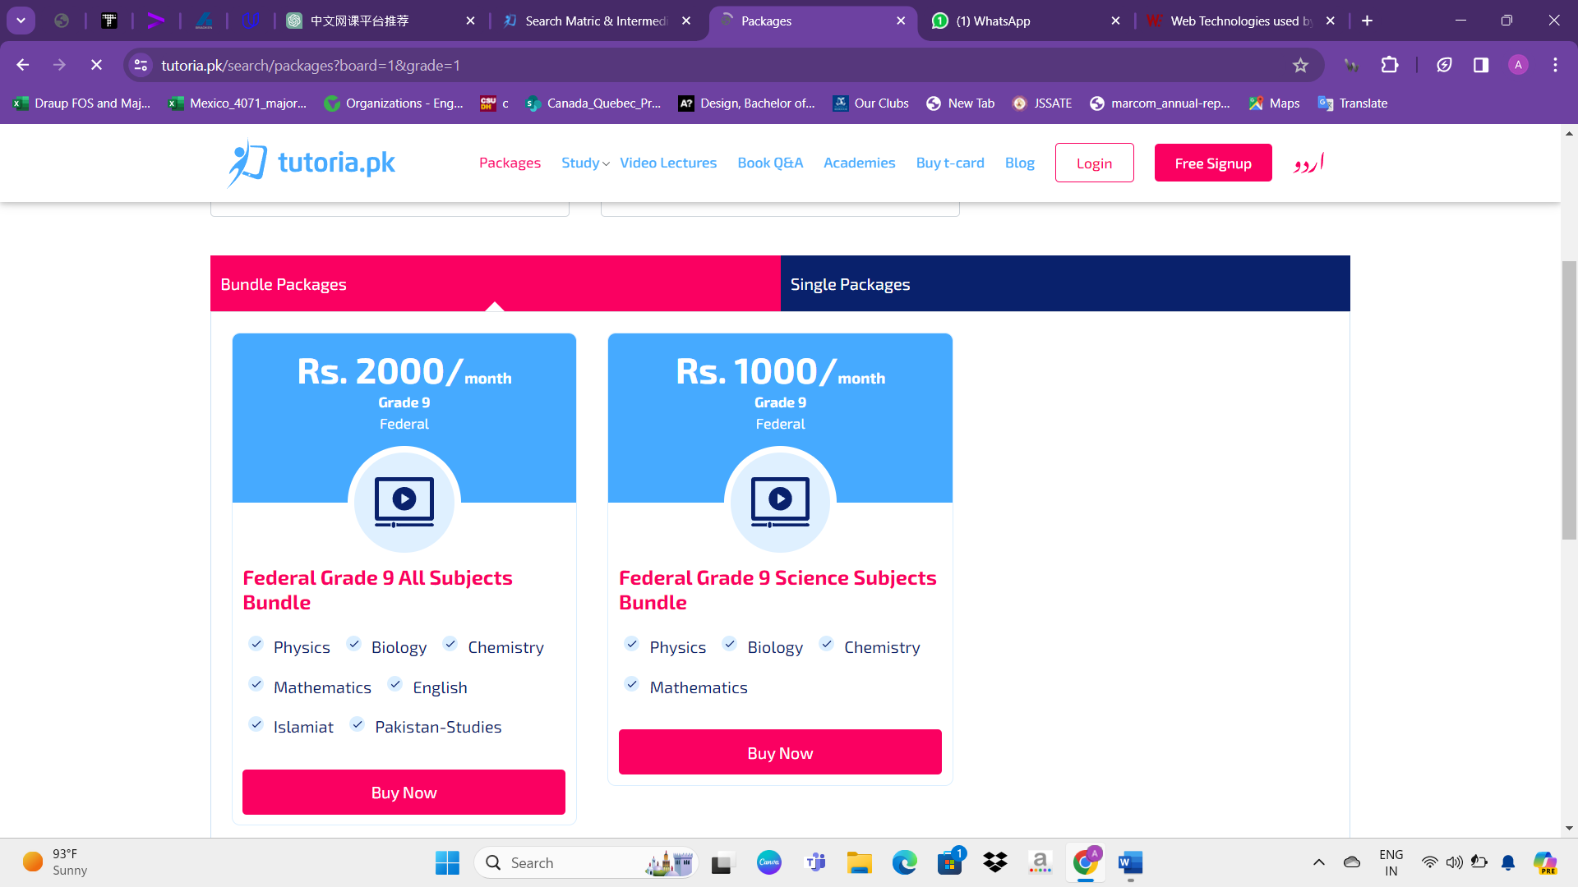

When a user clicks on any study material, the website displays the available packages for that particular material. This approach streamlines the user experience, providing immediate access to subscription options tailored to the selected study material. By presenting relevant packages directly after clicking on a study material, users can easily explore their options and choose the package that best suits their needs and preferences.

**Video Lectures:**

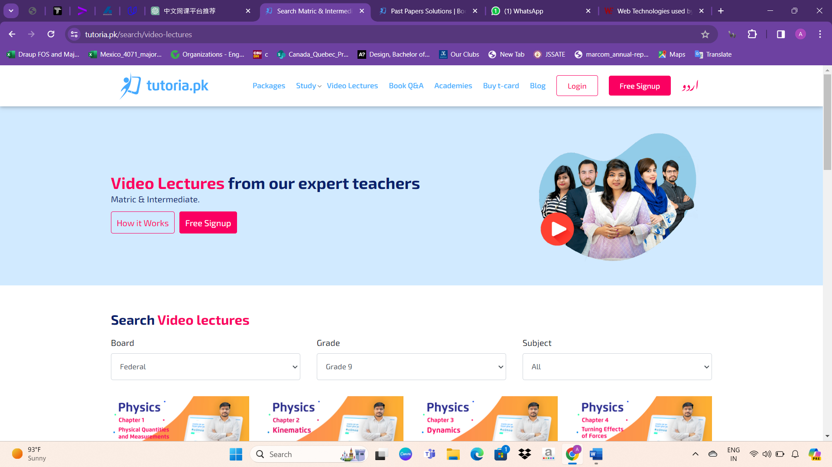

On the video lectures page, users can filter content using the following options:

**Search:** Enables users to input specific keywords or phrases to find relevant video lectures.

**Board:** Allows users to select the educational board they are affiliated with, such as Federal Board or others.

**Grade:** Permits users to choose the academic grade level they are studying at, such as Grade 9 or others.

**Subject:** Provides users with the option to select the specific subject they are interested in, allowing for targeted content discovery.

Each filter option is presented as a drop-down list, allowing users to conveniently select their preferences and refine their search for video lectures according to their specific needs and requirements.

**Book Q&A:**

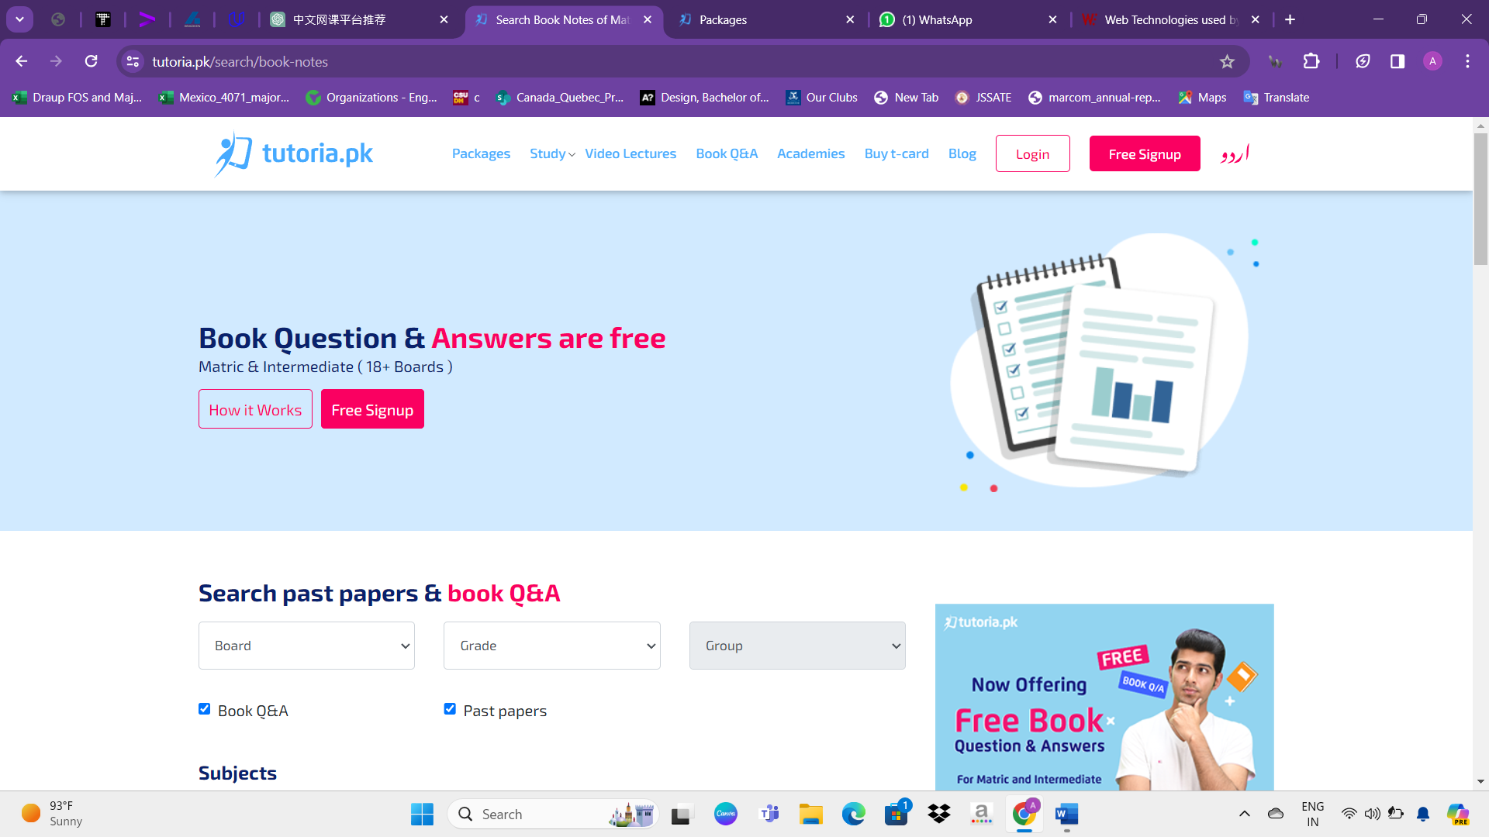

On the search page for past papers and book Q&A, users can filter content using the following options:

**Search:** Allows users to input specific keywords or phrases to find relevant past papers and book Q&A.

**Board:** Enables users to select the educational board they are affiliated with, such as Federal Board or others.

**Grade:** Permits users to choose the academic grade level they are studying at, such as Grade 9 or others.

**Group:** Provides users with the option to select a specific group or category relevant to their study material.

**Subjects:** Allows users to narrow down their search by selecting the specific subject they are interested in, facilitating targeted content discovery.

Each filter option is presented as a drop-down list, enabling users to refine their search results and find the past papers and book Q&A materials that best match their requirements.

Below are the **terms and conditions** of tutoria.pk, which users agree to abide by when registering for an account:

* Compliance: Users must comply with tutoria.pk's terms and conditions and refrain from engaging in any illegal activities.
* Account Information: Users agree to provide accurate and complete information when registering for an account to ensure security and verification.
* Identity: Users agree not to commit identity fraud and must provide truthful details about their identity.
* Terms and Conditions: Users agree to abide by the terms and conditions set forth by tutoria.pk.
* Password Security: Users agree not to share their password with anyone and to keep it confidential.
* Account Sharing: Users agree not to share their account with anyone else.
* Content Protection: Users agree not to reproduce, redistribute, transmit, or share tutoria.pk's content without permission.
* Prohibited Content: Users agree not to upload inappropriate images or use obscene language on any contract forms.
* Security Measures: Users agree not to transmit any viruses, malware, worms, trojan horses, etc., through tutoria.pk's servers.
* It's important to note that these terms and conditions may be subject to periodic revisions and changes. By creating an account on tutoria.pk, users agree to the terms and conditions outlined in the sign-up agreement.

Below are the terms and conditions users must adhere to when registering for an account on tutoria.pk:

**Compliance:** Users must adhere to tutoria.pk's terms and conditions and refrain from participating in any illegal activities.

**Account Information:** Users are required to provide accurate and complete information during registration to ensure security and verification.

**Identity:** Users must not engage in identity fraud and must truthfully disclose their identity details.

**Terms and Conditions:** Users are bound by tutoria.pk's terms and conditions and must comply with them.

**Password Security:** Users must keep their password confidential and refrain from sharing it with anyone.

**Account Sharing:** Users are prohibited from sharing their account credentials with others.

**Content Protection:** Users must not reproduce, redistribute, transmit, or share tutoria.pk's content without explicit permission.

**Prohibited Content:** Users must refrain from uploading inappropriate images or using obscene language in any form of communication on the platform.

**Security Measures:** Users must not transmit any malicious software or content through tutoria.pk's servers.

It's important to note that these terms and conditions may be subject to periodic revisions and updates. By registering for an account on tutoria.pk, users agree to abide by the terms and conditions outlined in the sign-up agreement.

Here's an analysis of the **technical details and components of the tutoria.pk** website:

Website Background:

- The website offers past paper solutions, booknotes, and video lectures for matric and intermediate students in Pakistan.

CMS (Content Management System):

- WordPress 5.7.2 is used for managing blog publishing and content.

Server-side Programming Language:

- PHP is utilized for scripting and website creation.

Client-side Programming Language:

- JavaScript enhances interactivity within web pages.

JavaScript Libraries:

- jQuery 3.5.1 simplifies HTML document manipulation and interaction.

- Bootstrap assists in HTML, CSS, and JavaScript framework implementation.

- Popper.js facilitates tooltips and popovers functionality.

CSS Framework:

- Bootstrap is employed for responsive web design and development.

Web Server:

- Nginx, a lightweight open-source server, serves web content.

Web Hosting Provider and Data Center Provider:

- DigitalOcean hosts the website and data centers.

DNS Server Provider:

- Cloudflare provides DNS services and web support.

Email Server Providers:

- Gmail and Mailgun serve as email service providers.

SSL Certificate Authority:

- DigiCert offers SSL certificates.

JavaScript Content Delivery Networks (CDNs):

- jsDelivr and CDNJS are used for hosting JavaScript files.

Traffic Analysis Tools:

- Google Analytics provides website visitor statistics.

- Facebook Pixel tracks actions on websites.

Advertising Network:

- Google Ads manages advertisements.

Tag Manager:

- Google Tag Manager aids in tag management.

Social Widgets:

- Facebook, Twitter, WhatsApp, Pinterest, and LinkedIn widgets facilitate social sharing.

Site Elements:

- External, embedded, and inline CSS styles are utilized for defining website appearance.

- Persistent cookies, HttpOnly cookies, and non-secure cookies manage user sessions and data.

- Gzip compression optimizes file sizes for faster loading.

- Strong ETag validation and HTTP/2 protocol improve website performance and security.

- HTTP Strict Transport Security (HSTS) enforces secure connections.

Structured Data Formats:

- Open Graph, Twitter Cards, Generic RDFa, and JSON-LD formats enhance website content presentation.

Markup Language and Character Encoding:

- HTML5 and UTF-8 ensure modern and universal compatibility.

Image File Formats:

- PNG, SVG, and JPEG formats optimize image quality and compatibility.

Top Level Domain and Server Location:

- The website is hosted in the United States, with a top-level domain of ".pk" indicating a Pakistani origi

Overview about MIT OpenCourseWare

MIT OpenCourseWare (OCW) has been a pioneer in the field of Open Educational Resources (OER) since 2001, democratizing access to knowledge worldwide. By offering free access to materials from thousands of MIT courses, OCW has empowered millions of learners and educators globally.

With a new web platform and a commitment to expanding its content, MIT OpenCourseWare continues to drive the open education movement forward. It collaborates with partners in the open education ecosystem to foster inclusivity and equity in education.

OCW provides a vast collection of materials covering the entire MIT curriculum, enabling self-directed, lifelong learning. Users can access these resources without any enrollment or registration, at their own pace and convenience.

MIT OpenCourseWare encourages sharing, allowing users to download, distribute, and adapt materials for personal or educational use. While MIT doesn't offer credit or certification for OCW usage, it champions the spirit of knowledge dissemination without expecting anything in return.

Over the past two decades, MIT OpenCourseWare (OCW) has been instrumental in democratizing access to knowledge and driving the global Open Educational Resources (OER) movement. As we embark on our next chapter with a new platform, we are committed to further expanding and enhancing OCW to better serve learners worldwide.

Here's what we can expect in the months and years ahead:

Increased Focus on Global Challenges: We will continue to provide emerging knowledge on pressing global issues such as equity, climate change, and advancements in computing and artificial intelligence.

Enhanced Multimedia Content: Our platform will feature more dynamic media formats, including video lectures, podcasts, interactive assessments, and innovative technologies like augmented and virtual reality.

Real-World Problem Solving: We will showcase inspiring examples of MIT's holistic approach to education, which integrates "mind, hand, and heart" to engage learners in solving real-world problems.

Support for Educators: We are committed to providing more support for educators using OER, empowering them to adapt and remix OCW content to suit the cultural needs and preferences of their students.

Collaboration and Equity: We will foster collaborations within the OER ecosystem to advance educational equity through open content and practices, ensuring that knowledge is accessible to all.

These milestones reflect our ongoing dedication to innovation, accessibility, and inclusivity in education. We look forward to continuing this journey of knowledge sharing and transformative learning experiences with our global community.

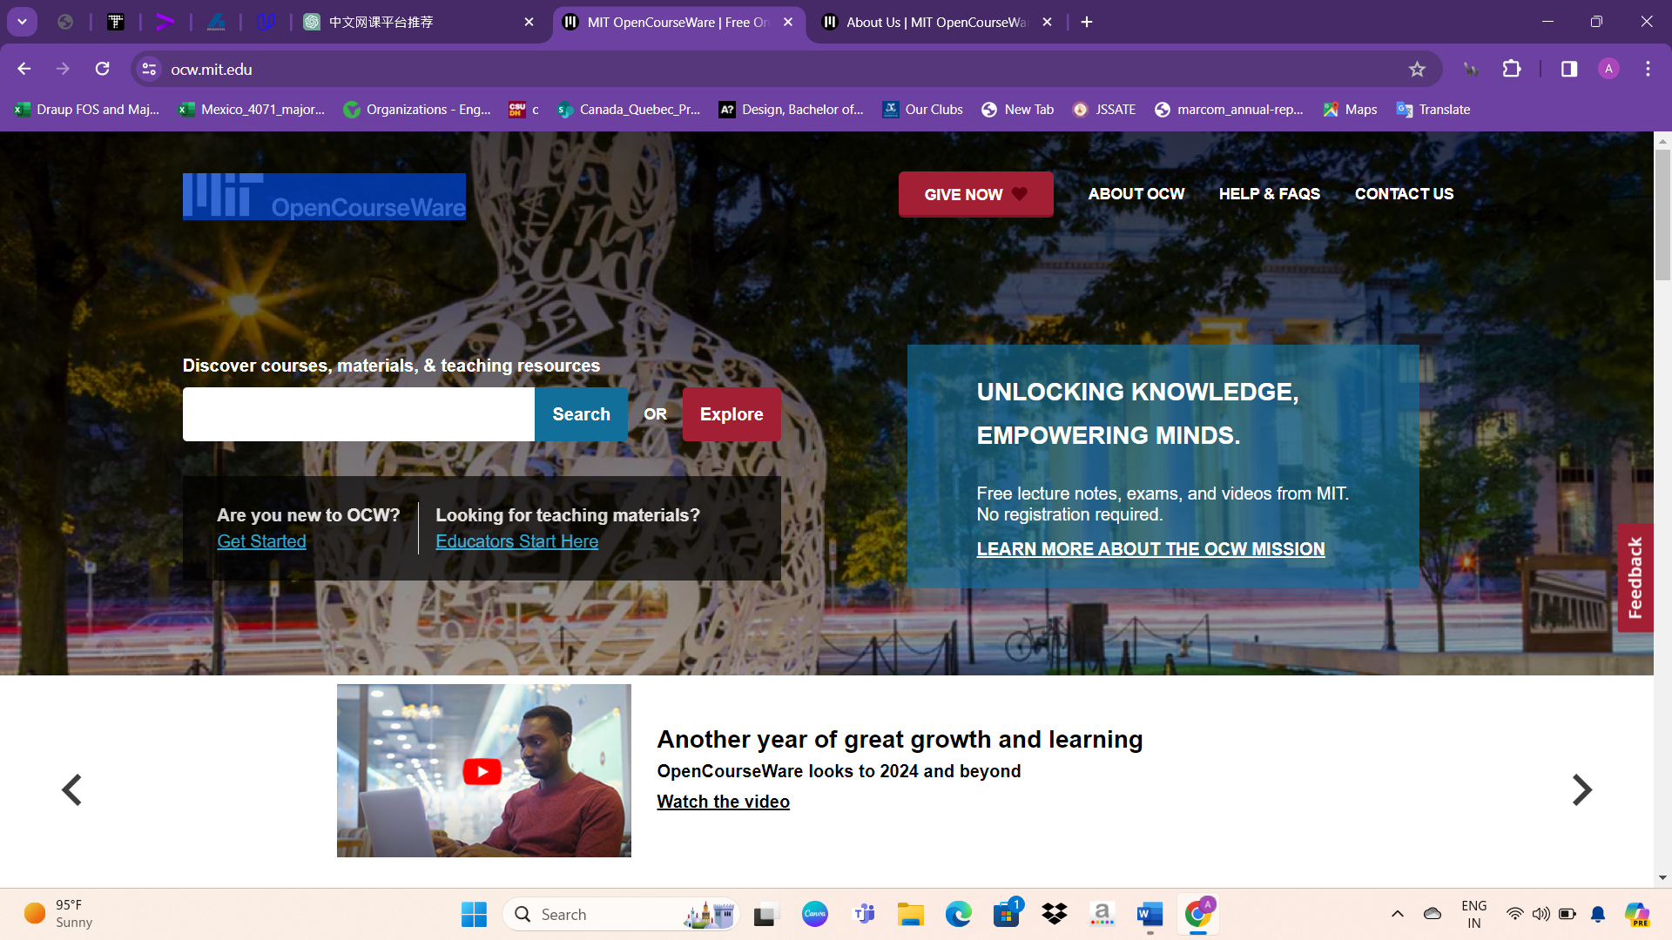

About website design

When opening the website, users encounter major elements such as:

**Give Now:** This option allows users to make donations or contribute financially to support the mission and operations of OCW.

**About OCW:** This section provides information about MIT OpenCourseWare, including its mission, history, and objectives.

**Help & FAQs:** Users can access assistance and frequently asked questions (FAQs) to address any queries or concerns they may have while navigating the website or using its resources.

**Contact Us:** This feature enables users to reach out to OCW administrators or support staff for further assistance, inquiries, or feedback.

Discover Courses, Materials, & Teaching Resources: Users are presented with the option to explore OCW's extensive collection of courses, educational materials, and teaching resources. They can search for specific content or browse through different categories to find relevant resources.

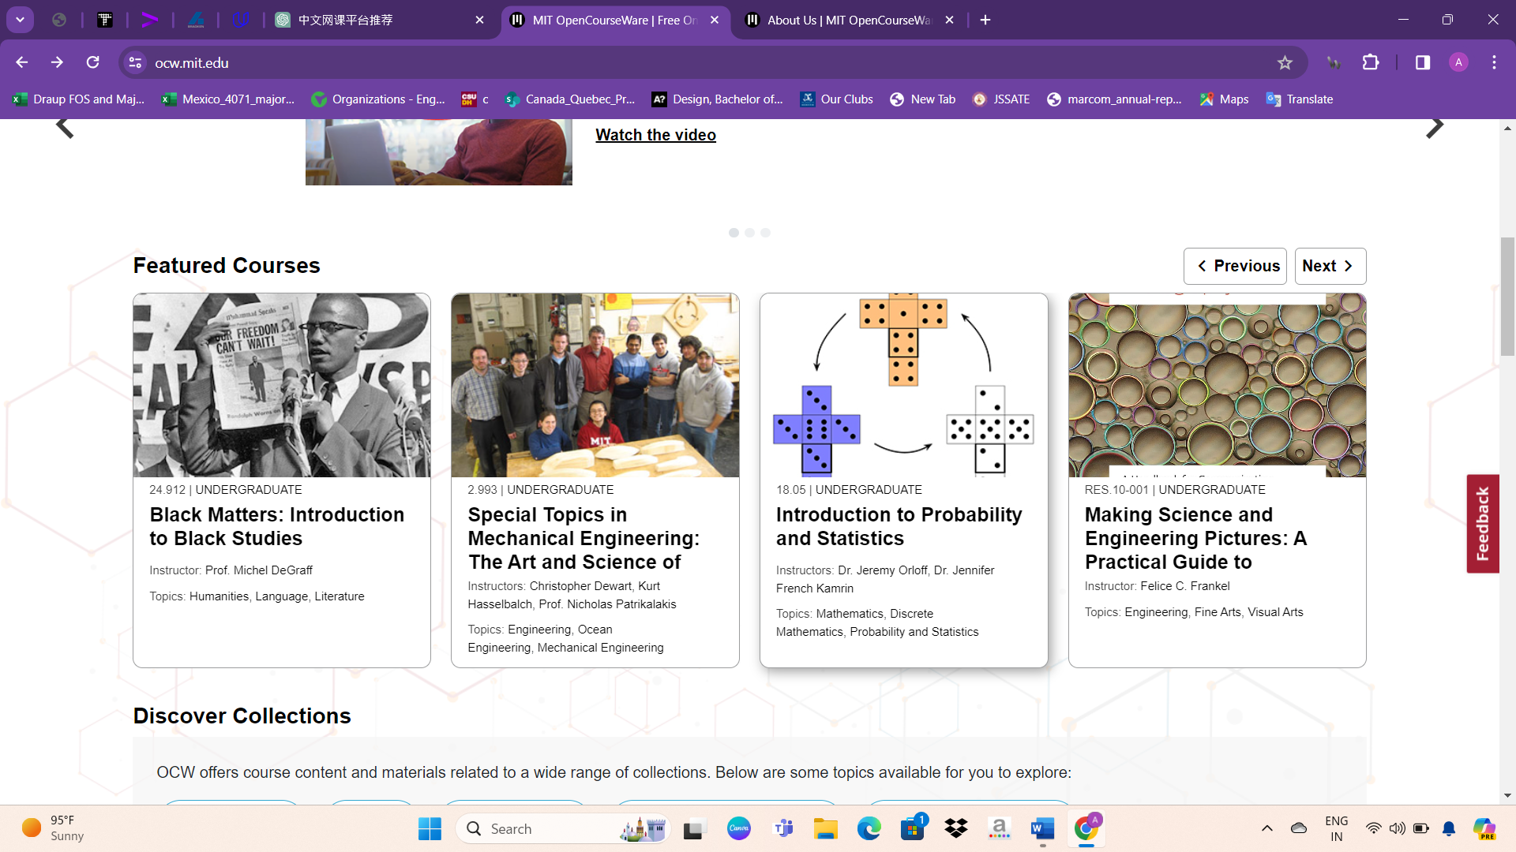

Following the major elements mentioned earlier, the website is structured around the display of courses categorized into different subjects or topics. Additionally, users can explore news related to the platform and its updates. There may also be sections dedicated to the history of the website, highlighting milestones, achievements, and significant events since its inception. This organization allows visitors to easily access educational content, stay informed about recent developments, and learn about the evolution of the platform over time.

The website acknowledges its corporate and foundation supporters, including:

* Ab Initio
* MathWorks
* William and Flora Hewlett Foundation
* Andrew W. Mellon Foundation

These organizations have contributed to the mission and initiatives of the website, demonstrating their commitment to supporting education and open access to knowledge.

The website proudly identifies as a member of Open Education Global, showcasing its commitment to the global open education community.

Additionally, it acknowledges its affiliation with the Massachusetts Institute of Technology (MIT), underscoring the prestigious institution's involvement in the platform's initiatives and resources.

Social media icons are also displayed, allowing users to connect with the website through various channels, including Facebook, Instagram, YouTube, and LinkedIn.

About Courses

Explore MIT OpenCourseWare by searching for courses, materials, and teaching resources tailored to your needs:

* **Departments:** Filter courses by department to find content specific to your area of interest or study.
* **Level:** Narrow down your search by selecting the academic level of the courses, such as undergraduate or graduate.
* **Topics:** Explore courses related to specific topics or subjects that align with your learning goals.
* **Features:** Customize your search by filtering courses based on specific features, such as video lectures, interactive assessments, or hands-on projects.

Use the search bar to find relevant content, and utilize the filters to refine your search criteria for a more tailored learning experience.

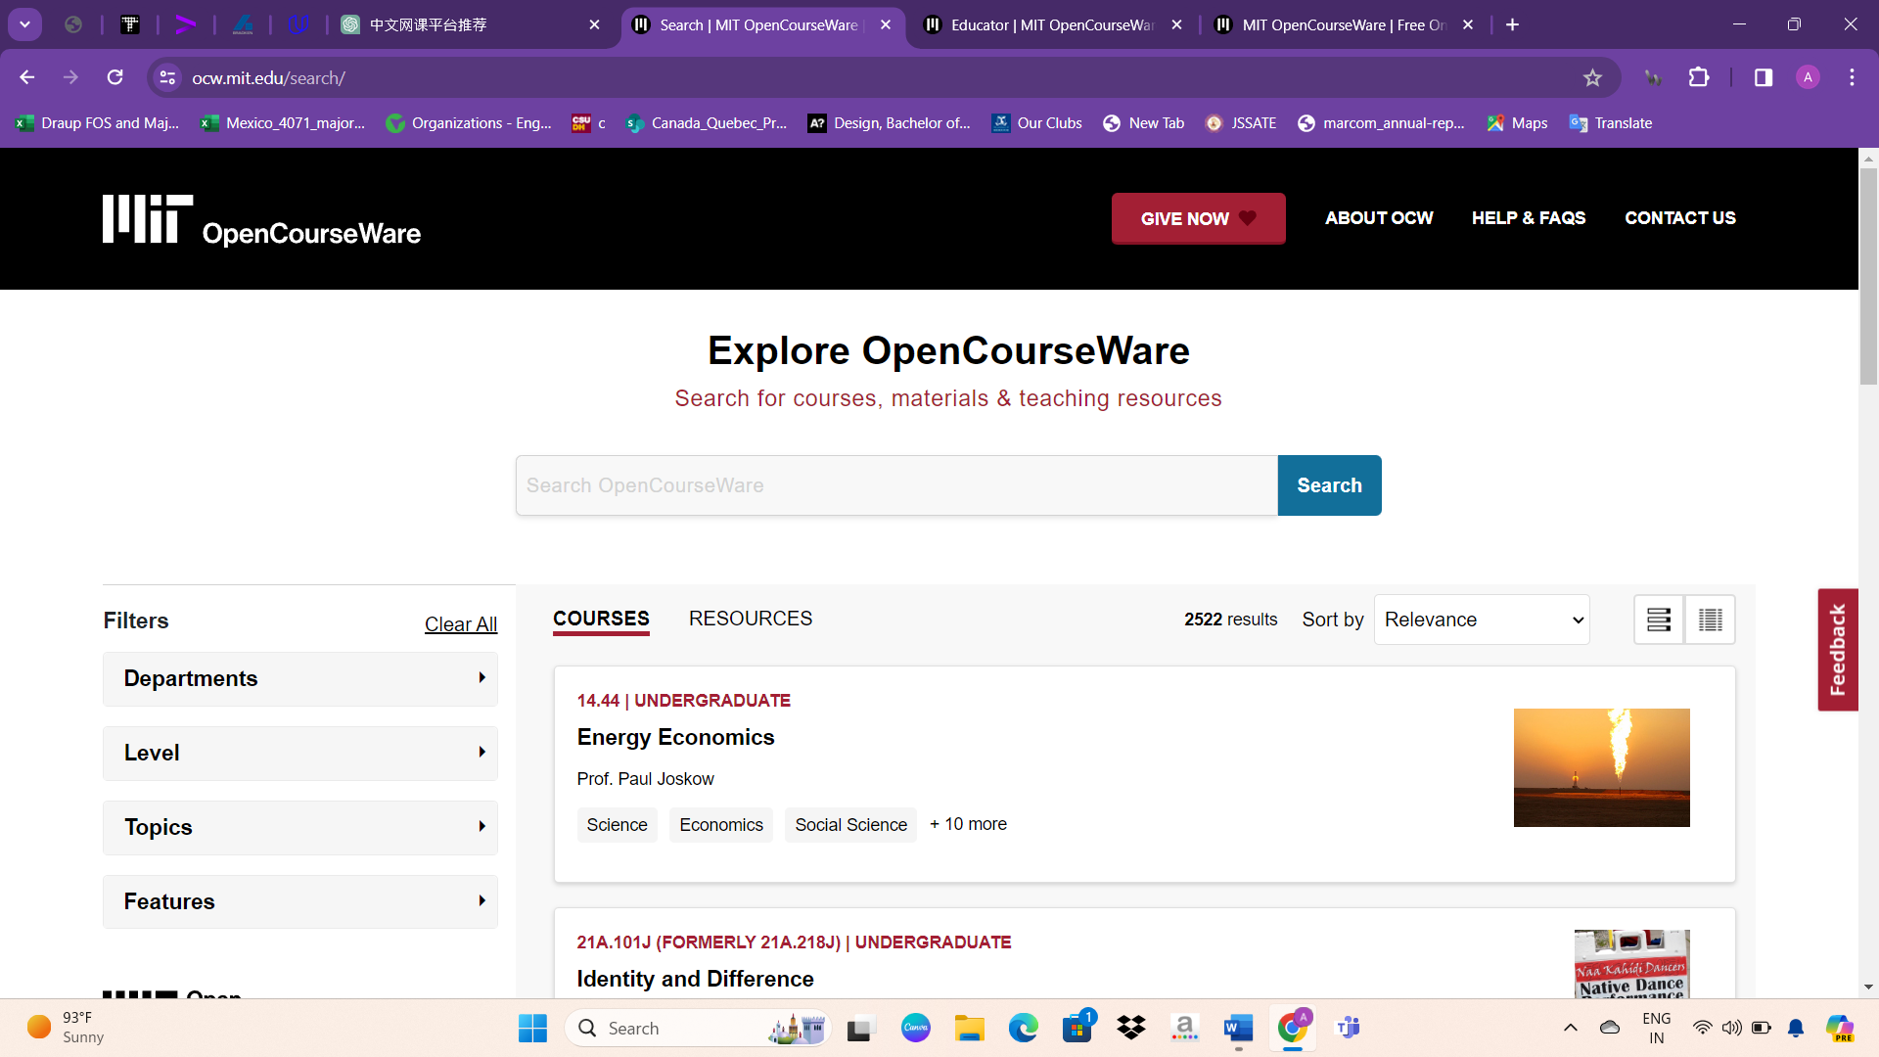

Course design

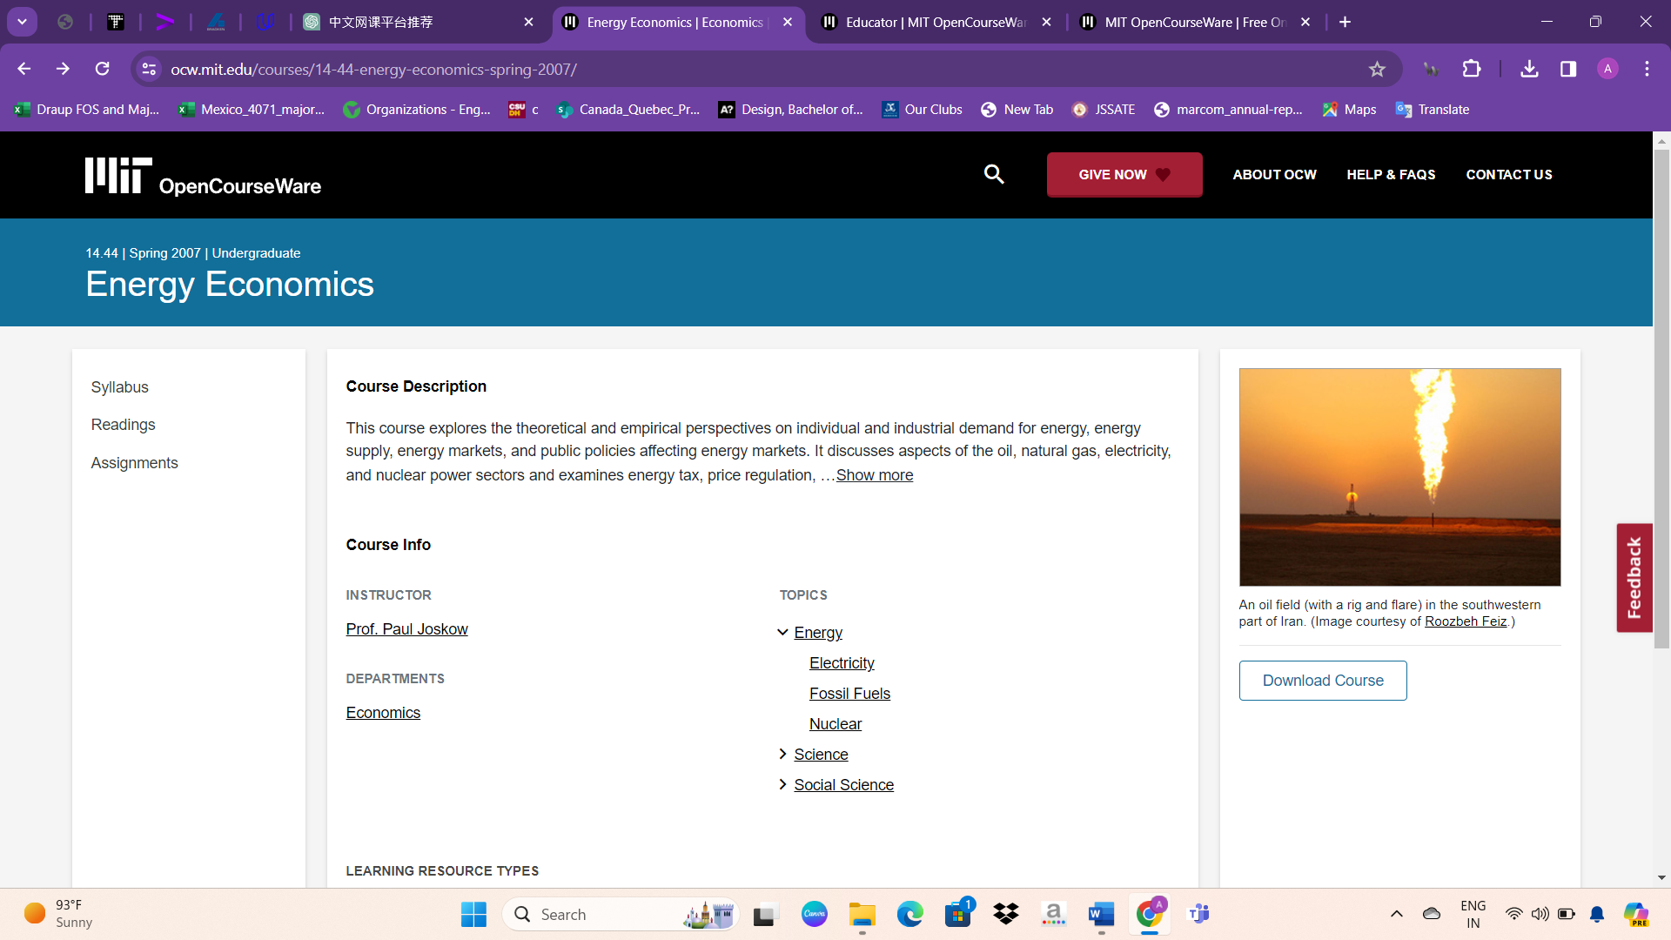

When accessing any course on MIT OpenCourseWare, users can expect to find the following details:

**Short Description:** A brief overview or summary of the course content, providing insights into the topics covered and learning objectives.

**Instructor:** Information about the instructor or instructors responsible for teaching the course, including their credentials and expertise in the subject matter.

**Department:** The academic department or discipline to which the course belongs, providing context for its relevance within the broader educational framework.

**Level:** The academic level or difficulty level of the course, indicating whether it is designed for undergraduate, graduate, or other levels of study.

These details help users make informed decisions about which courses align best with their interests, academic goals, and proficiency levels.

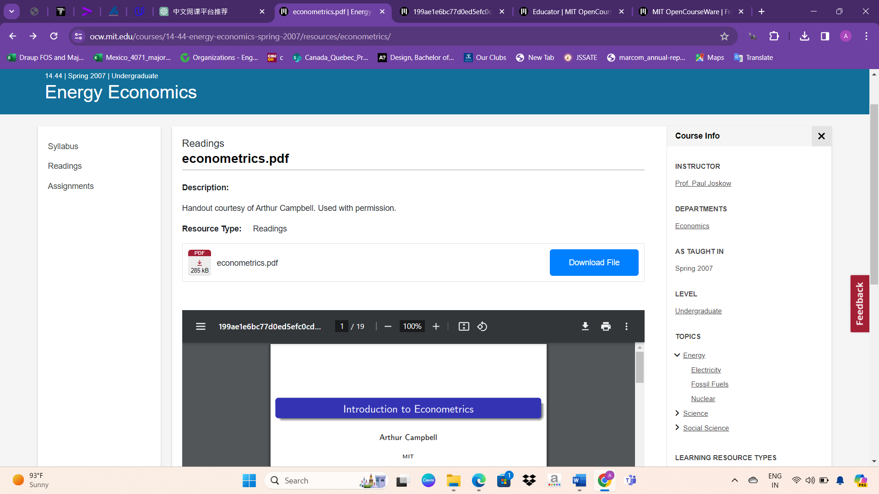

Users typically have the option to download course materials or resources from MIT OpenCourseWare for offline access or further study. This download feature allows learners to save course content, such as lecture notes, assignments, readings, and supplementary materials, to their devices for convenient access at any time, even without an internet connection. It enhances flexibility and accessibility for users who prefer to study offline or require access to materials while traveling or in areas with limited internet connectivity.

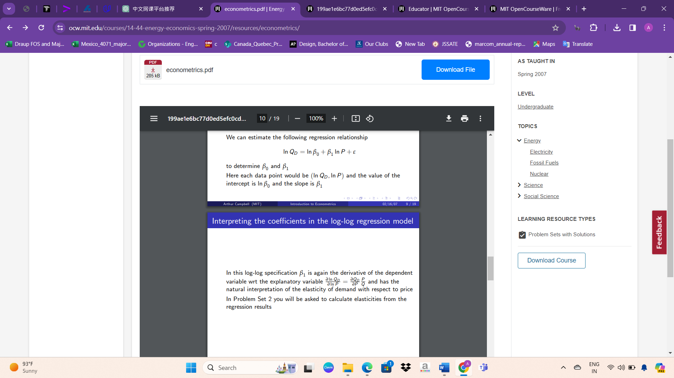

Typically after initiating the download process, a box or dialog box appears at the bottom of the page, indicating the file that is being downloaded. This box provides information about the download progress, including the file name, file size, and estimated time remaining for the download to complete. It serves as a visual confirmation for users that their download request has been initiated and provides real-time feedback on the download status. This ensures transparency and helps users track the progress of their downloads effectively.

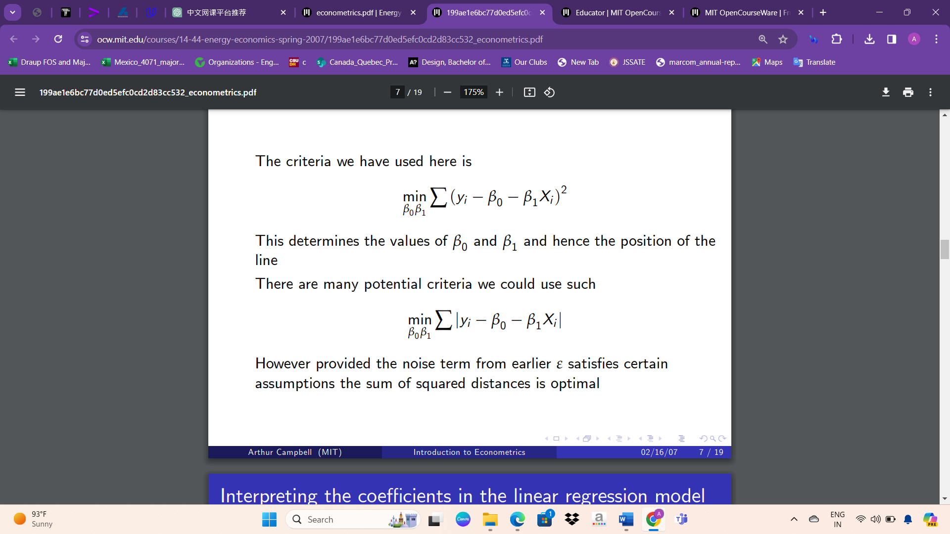

Absolutely, once you've downloaded course materials from MIT OpenCourseWare to your system, you can utilize them for your studies in various ways:

**Offline Study:** Access downloaded materials even without an internet connection, allowing for uninterrupted study sessions.

**Review and Referenc**e: Use downloaded resources for reviewing course content, referencing materials during assignments or projects, or refreshing your understanding of key concepts.

**Supplementary Learning:** Enhance your understanding of course topics by studying additional resources beyond what's covered in your current coursework.

Technologies used in website

- Name: MIT - Massachusetts Institute of Technology

- Description: MIT OpenCourseWare (OCW) is a free and open collection of material from thousands of MIT courses, covering the entire MIT curriculum. It offers course content, materials, and teaching resources to a global audience.

- Popularity Rank: Top 1k among all websites.

Content Management System:

- Platform: Drupal 9, an open source content management system written in PHP.

- Usage: Used on a subdomain.

Server-side Programming Language:

- Language: PHP 7.4.33, a scripting language for creating websites.

- Usage: Used on a subdomain.

Client-side Programming Language:

- Language: JavaScript, a lightweight, object-oriented, cross-platform scripting language.

JavaScript Libraries:

- Modernizr: Detects HTML5 and CSS3 features in the visitor's browser.

- Vue.js: A library for building interactive web interfaces.

- jQuery: Simplifies HTML document traversing, event handling, animating, and Ajax interaction.

Web Servers:

- Apache HTTP Server: An open source web server.

- Nginx: A lightweight open source web server.

Operating System:

- Platform: Linux, a Unix-like open source operating system.

Web Hosting Provider:

- Provider: Pantheon, offering CMS hosting.

Reverse Proxy Services:

- Akamai: A content delivery network.

- Fastly: A content delivery network.

DNS Server Provider:

- Provider: Akamai.

Email Server Provider:

- Provider: Microsoft, offering email services.

SSL Certificate Authorities:

- Providers: DigiCert, IdenTrust, Sectigo.

JavaScript Content Delivery Network:

- Provider: Google Hosted Libraries.

Traffic Analysis Tools:

- Tools: Google Analytics, Facebook Pixel, Microsoft UET, New Relic, CrazyEgg, Contentsquare.

Advertising Network:

- Network: Google Ads.

Tag Manager:

- Service: Google Tag Manager.

Social Widgets:

- Platforms: Facebook, Twitter, LinkedIn, AddThis, Reddit.

Site Elements:

- CSS: External, Embedded, Inline.

- Compression: Gzip.

- ETag: Strong, Weak.

- IPv6 Support: Yes.

- HTTP Strict Transport Security (HSTS): Enabled.

Structured Data Formats:

- Formats: Open Graph protocol, Twitter Cards, Generic RDFa, Microdata.

Markup Language:

- Language: HTML5.

Character Encoding:

- Encoding: UTF-8.

Image File Formats:

- Formats: JPEG, SVG, PNG, GIF.

Top Level Domain:

- Domain: .edu (United States educational institutes).

Server Location:

- Location: United States.

Content Language:

- Language: English.

Corporate and Foundation Supporters:

- Supporters: Ab Initio, MathWorks, William and Flora Hewlett Foundation, Andrew W. Mellon Foundation.

Membership:

- Member of: Open Education Global.

Copyright:

- © 2001–2024 Massachusetts Institute of Technology.

Social Media Links:

- Facebook, Instagram, Twitter (formerly), YouTube, LinkedIn.

This document provides a comprehensive overview of the MIT OCW website's technical details and partnerships.

Overview about Masterclass

* MasterClass, operating under the legal entity Yanka Industries, Inc., is an American online education platform renowned for its subscription-based model. It provides access to a diverse array of tutorials and lectures delivered by experts across various fields.
* The brainchild of David Rogier, MasterClass was conceived during his tenure as a student at Stanford University. Rogier, serving as the CEO, invited Aaron Rasmussen to join as a co-founder and Chief Technology Officer. Rasmussen also held the role of Creative Director until January 2017, when he departed from the company. Originally established as "Yanka Industries," the platform officially launched as MasterClass on May 12, 2015.
* Upon its inception, MasterClass featured three instructors, and its offerings expanded steadily. However, the company faced a significant setback in late 2017 when an acting class instructed by Kevin Spacey was removed following multiple allegations of sexual assault against the actor. Despite this challenge, MasterClass continued to grow, reaching approximately 50 classes and 1,000 lessons by late 2018.
* MasterClass attracted considerable investment over the years. It commenced with an initial funding of $4.5 million, followed by subsequent seed-funding rounds totaling $1.9 million. Subsequently, the platform secured $15 million in funding in 2016, $35 million in 2017, and $80 million in 2018. Notably, in May 2020, MasterClass raised $100 million in a Series E funding round led by Fidelity Investments, bringing its total funding to approximately $240 million.
* In May 2021, MasterClass reached new heights with a Series F round, securing $225 million and achieving a valuation of $2.75 billion, as reported by CNBC. However, the company faced challenges in June 2022, leading to the unfortunate decision to lay off 20% of its staff, citing adverse macroeconomic conditions.

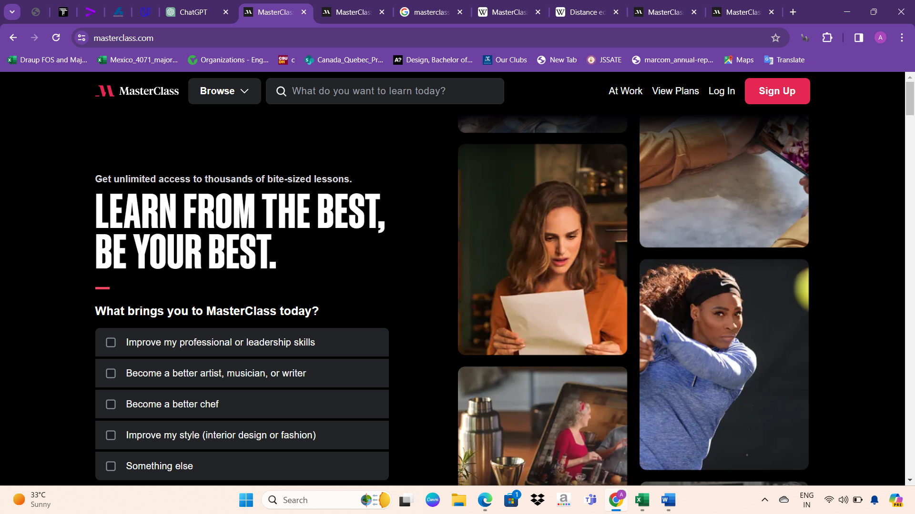

* Website Type: Private
* Founded: October 2014 (as Yanka Industries)
* Headquarters: San Francisco, California, U.S.
* Founders: David Rogier, Aaron Rasmussen
* Key People: David Rogier (CEO), Valen Tong (CFO), David Schriber (CMO), Len Amato (CCO)
* Industry: Online education
* Number of Employees: 480 (2022)
* URL: masterclass.com
* MasterClass is renowned for producing high-quality online classes featuring well-known instructors who are experts in their respective fields. These classes cover a diverse range of topics, including writing, sports, cooking, and more. Over time, MasterClass has expanded its offerings to include subjects such as politics, economics, and video game design, catering to a broader audience.
* Instructors often incorporate live demonstrations into their classes, particularly when the topic lends itself well to visual illustration. For example, cooking instructors may showcase recipes and techniques in real-time, while writers typically deliver lectures.
* Access to MasterClass courses is typically granted through an annual subscription model. While the courses are primarily pre-recorded and not interactive, some may include interactive assignments. These assignments may involve student participation with others, either in-person or via platforms like Skype, enhancing the learning experience and fostering a sense of community among participants.
* The statement provided outlines MasterClass's commitment to diversity, equity, and inclusion (DEI) across its platform, workforce, and workplace. Here's a breakdown of the key points and actions outlined in the statement:

1. Using the Platform for Change: MasterClass commits to creating content that educates on issues of social justice, inspires activism, and opposes systemic racism. This commitment is exemplified through classes like "Black History, Black Freedom, and Black Love" and those addressing topics like feminism, leadership, team culture, and social change.

2. Amplifying Diverse Instructor Voices: MasterClass aims to ensure that its instructors represent the diversity of the U.S. population across gender, race, and sexual orientation by the end of 2026. This commitment emphasizes the importance of representation and diverse perspectives in the learning experience.

3. Building an Inclusive Workplace: MasterClass pledges to develop and invest in strategies to create a workplace that reflects the diversity of the countries where it operates. This includes fostering an inclusive culture where all employees feel valued and respected.

4. Supporting Causes for Diversity, Equity, and Inclusion: MasterClass has committed financial support of up to $500,000 per year for donations and employee-directed donation matching to individuals and organizations advancing equity and inclusion.

5. Creating a Company Culture of DEI: MasterClass dedicates resources to lead and develop strategies for diversity, equity, and inclusion initiatives internally and externally. This includes implementing policies and practices that promote diversity and inclusion within the organization.

6. Ensuring Employee Voices are Heard: MasterClass commits to giving its team a full day off for state and federal elections to ensure they have time to cast their votes and help others do the same, fostering civic engagement among employees.

Overall, MasterClass acknowledges that achieving diversity, equity, and inclusion is an ongoing journey. The company commits to regularly measuring and reviewing progress, as well as continually challenging itself to drive meaningful change.

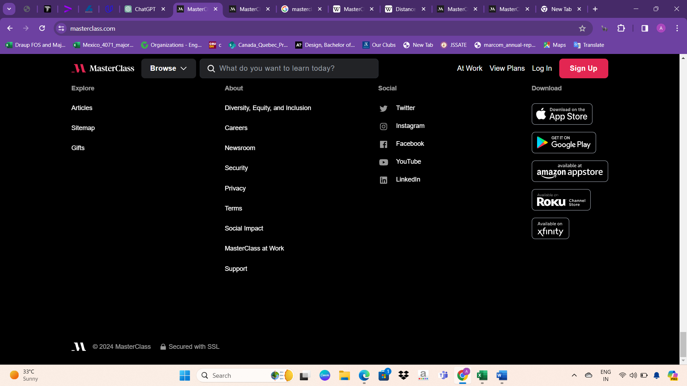

Courses offered

It appears you've listed a diverse range of subjects available on the MasterClass platform, each offering various courses taught by experts in their respective fields. Here's a breakdown of the subjects and the types of courses you might find within each category:

* Art & Design: Courses covering various aspects of visual arts, graphic design, photography, and creativity, taught by renowned artists and designers.
* Beauty & Style: Classes focusing on makeup artistry, fashion design, personal style, grooming, and beauty industry insights led by experts in the beauty and fashion world.
* Business & Career: Courses on entrepreneurship, leadership, management, marketing, finance, and career development taught by successful business leaders and professionals.
* Food & Drink: Culinary courses featuring cooking techniques, recipes, food styling, wine tasting, and mixology, instructed by celebrity chefs and culinary experts.
* Music: Lessons covering music theory, instrument mastery, songwriting, music production, and performance skills led by acclaimed musicians and music producers.
* Relationships & Self-Improvement: Classes focusing on personal development, communication skills, mindfulness, emotional intelligence, and building healthy relationships, taught by psychologists, therapists, and life coaches.
* Science & Math: Courses exploring various scientific disciplines, mathematics, and critical thinking skills, led by scientists, mathematicians, and educators.
* Society & Government: Classes on social issues, political science, history, and government systems taught by scholars, activists, and political leaders.
* Sports & Gaming: Courses covering sports techniques, strategy, coaching, and gaming skills instructed by professional athletes, coaches, and gaming experts.
* Tech & Digital Media: Lessons on coding, web development, digital marketing, cybersecurity, and media production led by tech entrepreneurs, engineers, and digital media professionals.
* TV, Film, & Theater: Classes on acting, filmmaking, screenwriting, directing, and theater production taught by industry veterans, actors, directors, and screenwriters.
* Wellness: Courses focusing on physical and mental well-being, fitness, nutrition, mindfulness, and stress management led by health experts, fitness trainers, and wellness coaches.
* Writing: Instruction on various writing genres, storytelling techniques, creative writing, journalism, and publishing, taught by bestselling authors, journalists, and writing experts.

Each subject category offers a range of courses designed to provide comprehensive learning experiences and insights from leading professionals in their respective fields

Course design

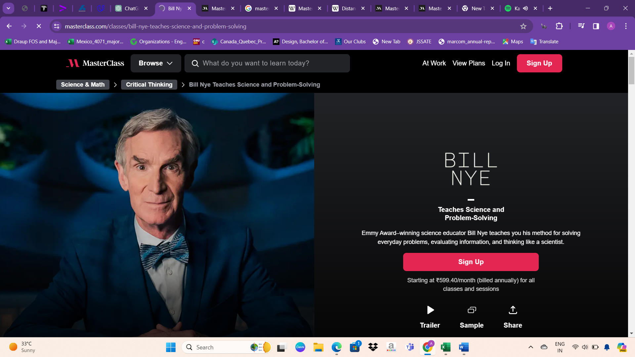

* The typical layout and features of a course page on the MasterClass website. Let's break down the components you mentioned:
* Teacher: Information about the instructor or teacher of the course, including their name, background, expertise, and possibly a brief biography.
* Course Amount: The price or subscription fee required to access the course. This may be displayed prominently on the course page.
* Short Description: A concise overview or summary of the course content, objectives, and what students can expect to learn.
* Short Video for Intro: A short introductory video featuring the instructor, providing an overview of the course and what students will learn. This video serves as a preview to entice potential learners.
* Sample or Trailer: A sample video clip or trailer from the course, offering a glimpse of the instructional content, teaching style, and production quality.
* Plans of Course: Details about the structure, duration, and format of the course, including the number of lessons/modules, estimated completion time, and any additional materials or resources provided.
* FAQ: Frequently Asked Questions section addressing common queries or concerns related to the course, such as prerequisites, technical requirements, certification, or refund policies.
* Related Courses: Links or recommendations for other courses on similar topics or by the same instructor, helping students discover additional learning opportunities.
* These components collectively provide potential learners with valuable information about the course, the instructor, and what they can expect to gain from participating. This structured presentation helps users make informed decisions and ensures a positive user experience on the platform.

About website design

the navigation bar or menu options typically found on the MasterClass website. Here's a breakdown of each option:

**Browse:** This option likely takes users to a page where they can explore and browse through the various courses available on MasterClass. Users can filter courses by category, instructor, or other criteria to find topics of interest.

**What do you want to learn today?:** This may be a search bar or a prompt inviting users to enter keywords or phrases related to the topics they want to learn about. It provides a quick and direct way for users to find specific courses or content.

**At Work:** This option may lead to a section or page specifically curated for professional development and workplace-related learning. It could include courses tailored for career advancement, leadership skills, or industry-specific knowledge.

**View Plans:** This option likely directs users to view the available subscription plans or pricing options for accessing MasterClass content. Users can choose the plan that best suits their needs and budget.

**Log In:** This option allows registered users to log in to their MasterClass accounts. Users can access their saved courses, track progress, and engage with the platform's features.

**Sign Up:** This option is for new users who want to create a MasterClass account. Signing up allows users to access courses, save their preferences, and engage with the platform's content and community.

Overall, these navigation options provide users with easy access to browse, search, and engage with the wide range of educational content available on the MasterClass platform.

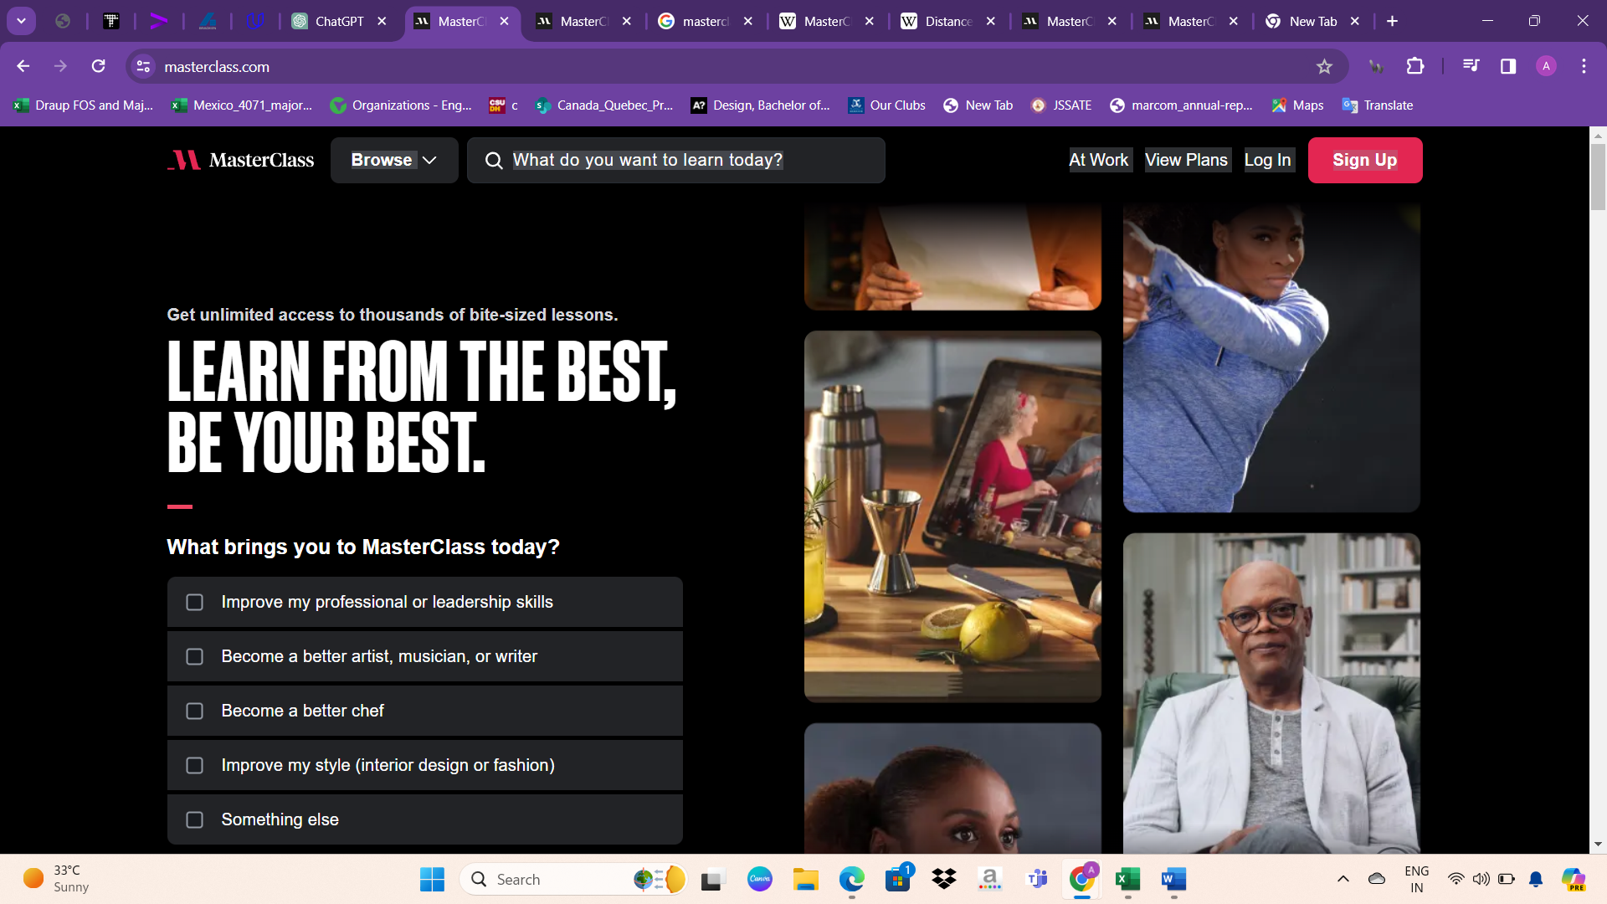

The home page of the MasterClass website features a captivating layout designed to engage visitors from the moment they arrive. Through a series of carefully crafted div tags and dynamic elements, such as moving images and animations, users are drawn into the site's immersive experience. One prominent section highlights the esteemed team behind MasterClass, showcasing their members' pictures and detailing their impressive achievements. This not only instills confidence in the platform but also humanizes the brand, allowing users to connect with the faces and stories behind the scenes. Additionally, a dedicated FAQ section addresses common user inquiries, ensuring clarity and transparency in navigating the platform's offerings, subscriptions, and policies. Together, these elements contribute to a seamless and informative browsing experience, enticing visitors to explore the diverse array of courses and content MasterClass has to offer.

Overall, the MasterClass website is meticulously designed and user-friendly, making effective use of Bootstrap for responsiveness across devices. The choice of a black background lends the site an attractive and sophisticated appearance, while also ensuring content stands out prominently. Dynamic elements such as moving images and videos in the background enhance the site's elegance and visual appeal, capturing visitors' attention and creating a memorable browsing experience. This combination of sleek design, responsiveness, and captivating visuals contributes to a website that not only looks polished but also provides a seamless and enjoyable user experience.

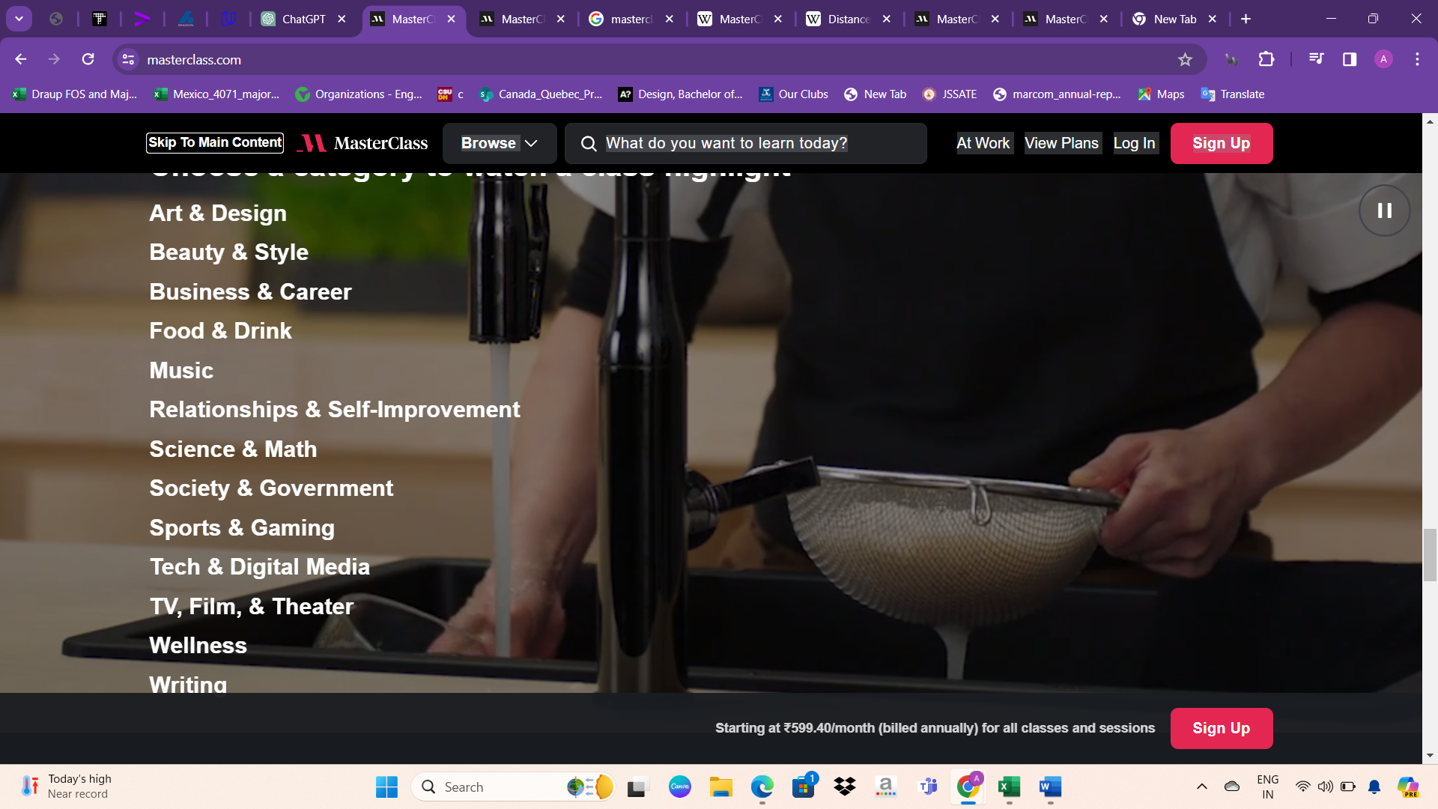

While the MasterClass website offers a wide range of courses across various subjects, including art, music, cooking, and more, it may have a limitation in terms of technical subjects within computer science. This could be considered a disadvantage for users specifically seeking courses in technical fields such as programming, software development, or computer engineering. However, it's important to note that MasterClass aims to provide high-quality instruction from experts in their respective fields, and their course offerings may evolve over time to include a broader range of topics based on user demand and industry trends. In the meantime, individuals interested in technical subjects within computer science may need to explore alternative online learning platforms or resources that specialize in these areas.

Privacy Policy

Effective Date: November 3, 2023

This Privacy Policy outlines the data protection practices of Yanka Industries, Inc., operating as MasterClass ("MasterClass," "we," "us," or "our"). The policy applies to information collected and utilized when accessing or using the MasterClass website, mobile application, or any other online or mobile service linking to or presenting this Privacy Policy. The term "Services" collectively refers to these products and offerings.

Information We Collect

1. Information Provided to Us:

- Details provided while using the Services or processing orders.

- Inquiries or submissions via online forms, email, etc.

- Participation in sweepstakes, contests, surveys, etc.

- Reviews submitted about the Services.

- Account registration and administration.

- Uploads or posts to the Services.

- Requests for customer support.

- Personal information provided directly, such as email address, name, log-in credentials, billing information, phone number, demographic details, user-generated content, etc.

- Information about others if providing purchases to third parties.

2. Information Collected Through Automated Means:

- Data collected when using the website or mobile applications, including IP address, browser details, operating system, device identifiers, browsing activity, content viewed, error logs, etc.

- General location information automatically collected from devices.

3. Information Collected from Social Media and Other Platforms:

- Access to and storage of certain information from social network profiles if accessing Services through third-party connections.

- Posting Services activities to Social Networking Services, allowing friends and followers to view such activities.

4. Information Collected from Others:

- Additional information like demographic and statistical data from third parties to supplement collected information, attribute to users, and provide more relevant experiences.

How We Use Your Information

MasterClass uses collected information to:

- Provide Services, complete purchases, communicate with users, provide updates, and offer customer support.

- Customize marketing content and advertising, improve Services, test new products, and ensure website/application security.

- Comply with legal requirements, establish, exercise, or defend legal rights.

- Combine and anonymize data for research, marketing, and disclosure to third parties.

X Combined Information:

Data collected through Services may be combined with information from other sources for various purposes outlined in this Privacy Policy.

Aggregate/Anonymous Data:

Information collected may be aggregated or anonymized for research, marketing, and disclosure to third parties.

Please read this Privacy Policy carefully to understand how MasterClass handles your information. If you disagree with any terms, refrain from using the Services.

Cookies and Similar Technologies

To collect information detailed in the "Information We Collect Through Automated Means" section, we and our service providers utilize Internet server logs, cookies, tracking pixels, and similar tracking technologies. These technologies enable us to offer you a more personalized experience by understanding and remembering your browsing preferences. Cookies, small text files placed on your computer or mobile device, help us recognize your computer, store preferences, understand visited web pages, enhance user experience, perform analytics, and assist with security and administrative functions. Some cookies are stored in your browser cache, while those linked to Flash technologies are stored with Adobe Flash Player files.

As we adopt additional technologies, we may use other methods to gather information. You can adjust your browser settings to receive notifications when a cookie is set or updated, or to block cookies entirely. Please refer to your browser's "Help" section for more information. Additionally, you can manage Flash technologies via Adobe's Flash management tools. Note that blocking or disabling cookies may limit access to certain features or offerings of the Services. For more details about our use of cookies, please review our Cookie Policy.

Technologies used

**Website Background**

MasterClass is an online platform offering classes designed for students of all skill levels, featuring instructors renowned as the best in their fields.

**Description on Homepage**

Ranked among the top 100,000 websites globally, MasterClass provides a diverse range of courses taught by world-leading experts.

**Content Management System**

Zendesk hosts the customer service software utilized by MasterClass, operating on a subdomain.

**Server-side Programming Languages**

JavaScript and Ruby are employed, with Ruby being used on a subdomain.

**Client-side Programming Language**

JavaScript is utilized within web pages for its lightweight, object-oriented, and cross-platform scripting capabilities.

**JavaScript Library**

MasterClass employs jQuery 3.5.1, a JavaScript library simplifying HTML document manipulation, event handling, animation, and Ajax interactions. It's used on a subdomain, with 53% of sites employing a newer version.

**Web Servers**

MasterClass utilizes Cloudflare Server and Node.js for web server functionalities.

**Web Hosting Provider**

Zendesk hosts MasterClass's customer service software on a subdomain.

**Reverse Proxy Service**

Cloudflare provides a content delivery network (CDN) and serves as a reverse proxy for MasterClass.

**DNS Server Provider**

Cloudflare offers DNS servers and various web services utilized by MasterClass.

**Email Server Providers**

MasterClass employs Gmail and Zendesk for email services, with Zendesk hosting customer service software on a subdomain.

**SSL Certificate Authorities**

DigiCert and IdenTrust are SSL certificate authorities used by MasterClass.

**JavaScript Content Delivery Network**

Google Hosted Libraries (formerly Google Libraries API) serves as a content distribution network for popular open-source JavaScript libraries, employed by MasterClass on a subdomain.

**Traffic Analysis Tool**

MasterClass utilizes Snowplow, an open-source web analytics platform, on a subdomain.

**Site Elements**

MasterClass utilizes external, embedded, and inline CSS for styling. It employs session, persistent, HttpOnly, and secure cookies for user interaction. Compression technologies like Brotli and Gzip are employed for efficient data transfer. The website supports IPv6, HTTP/2, HTTP Strict Transport Security (HSTS), and redirects visitors to the www subdomain and SSL encryption. Structured data formats such as Open Graph, JSON-LD, and Twitter Cards enhance content visibility. The website primarily uses HTML5 and UTF-8 encoding, and employs Scalable Vector Graphics (SVG) for image formats.

**Top Level Domain**

MasterClass's domain utilizes the commercial ".com" top-level domain.

Overview about Datacamp

DataCamp is on a mission to democratize data and AI skills for everyone, empowering companies and individuals to make better data-driven decisions. Here's an overview of DataCamp's impact, core values, and commitment to supporting data education:

Mission: Democratizing data and AI skills for everyone.

Impact:

Over 2,500 companies and 3,000 academic organizations use DataCamp.

DataCamp has helped over 13 million learners from 180+ countries.

Core Values:

Data-driven decision-making: Base decisions on data and facts.

Action: Move quickly and decisively.

Transparency: Believe in openness for improvement and success.

Act like an owner: Take initiative and embrace accountability.

Customer-focused: Prioritize meeting learners' and members' needs.

Supporting Data Education for All:

DataCamp provides free, unlimited access to DataCamp for Classrooms for instructors and students, benefiting over 350,000 students globally.

Partnerships with over 120 nonprofit organizations have provided 25,000 free DataCamp subscriptions to communities in need.

Courses available

Technology:

1. Python

2. R

3. SQL

4. Power BI

5. Tableau

6. Google Sheets

7. Excel

8. Spark

9. AWS (Amazon Web Services)

10. Julia

11. OpenAI

12. PyTorch

13. Shell

14. Azure

15. ChatGPT

16. Git

17. Snowflake

18. Airflow

19. Alteryx

20. BigQuery

21. Databricks

22. Docker

23. MLflow

24. Scala

Topic:

1. Machine Learning

2. Probability & Statistics

3. Programming

4. Data Manipulation

5. Data Visualization

6. Applied Finance

7. Artificial Intelligence

8. Data Preparation

9. Data Literacy

10. Other

11. Data Engineering

12. Reporting

13. Exploratory Data Analysis

14. Data Management

15. Data Warehouse

16. Case Studies

17. Cloud

18. Leadership

These technologies and topics cover a wide range of subjects related to data science, analytics, machine learning, programming, and more. They provide learners with comprehensive resources to develop their skills in various domains.

Course design

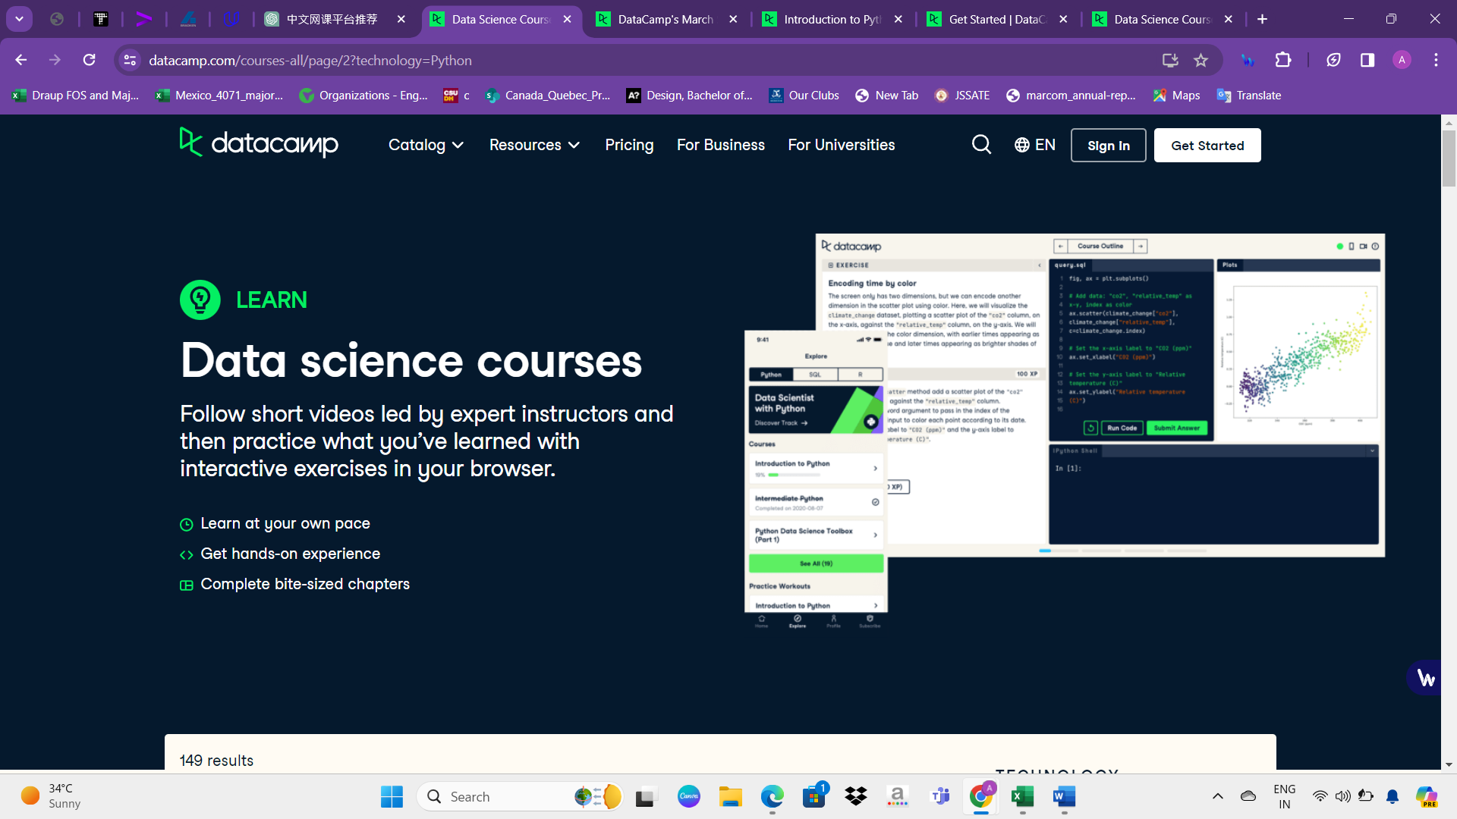

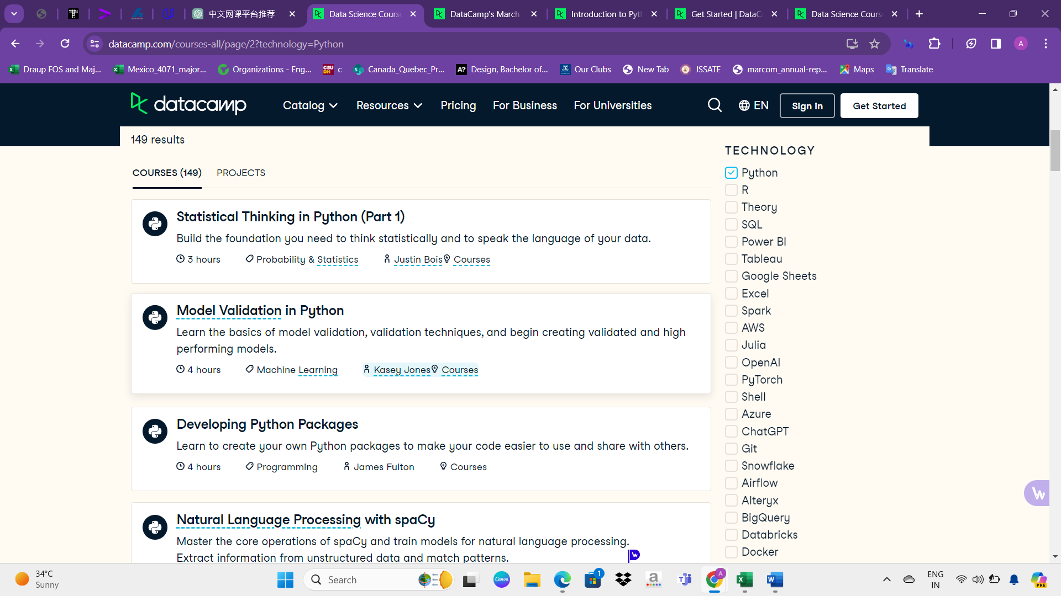

* Upon selecting a technology, learners can access information regarding the available courses, including their quantity, duration, and a concise description of each course, facilitating informed decision-making and tailored learning experiences.
* Users can view the course outline topics, with only the first topic accessible to all. Access to subsequent topics is restricted to paid accounts, ensuring exclusive content for premium subscribers.
* The course display includes the required payment amount, allowing users to clearly see the cost associated with accessing the course content.

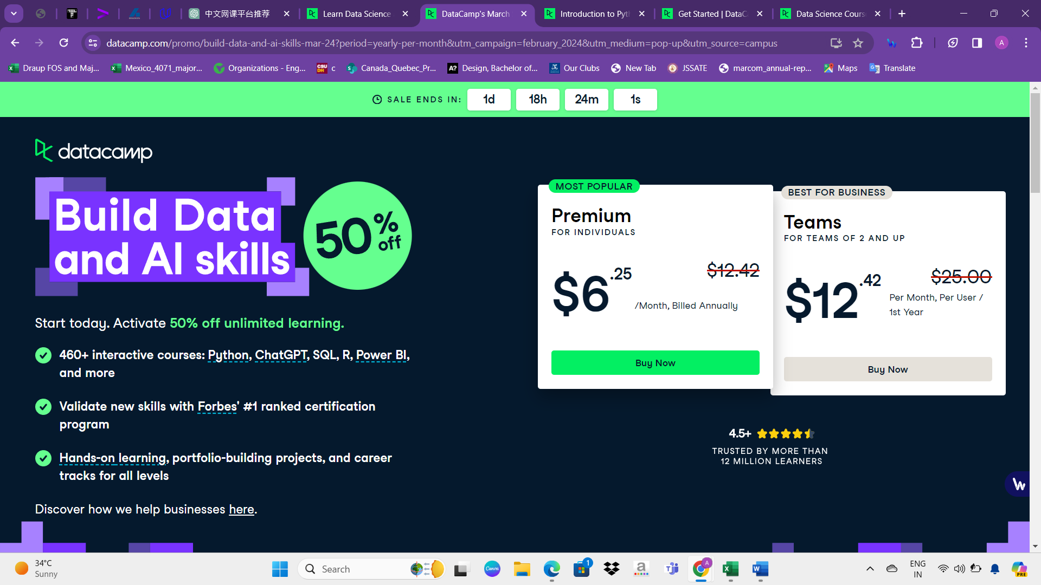

To incentivize faster payment, a countdown timer labeled "SALE ENDS IN" is prominently displayed, indicating the remaining time in days, hours, minutes, and seconds until the offer expires.

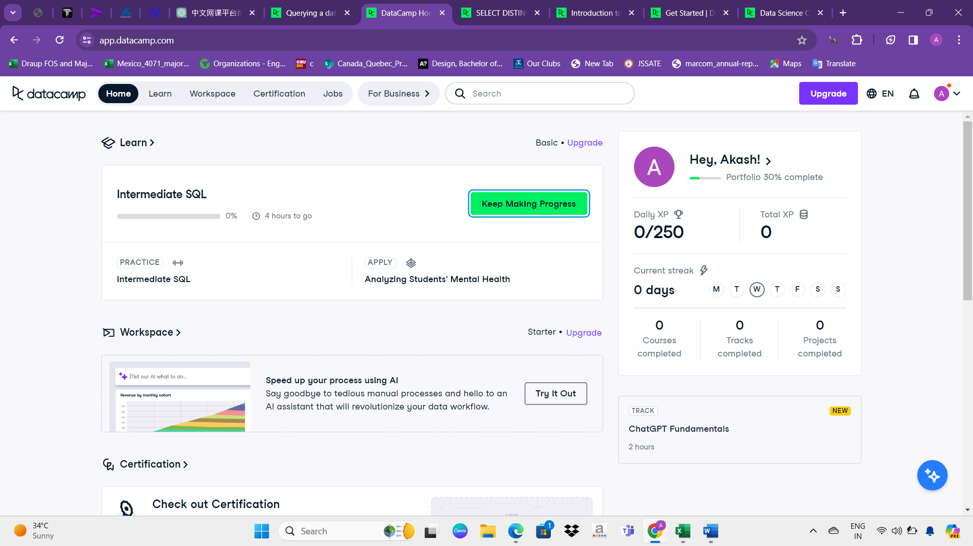

* The portfolio progress is tracked, showing a completion status of 30%. Daily and total experience points (XP) are displayed, along with the current streak. A visual representation of days is shown, indicating activity. Additionally, specific course details, like "ChatGPT Fundamentals," are presented, with an option to go to learning or upgrade.
* This is the course design, with progress tracking and options for upgrades, but payment is required for access.
* They provide a wide range of tech courses that are popular and in-demand. This attracts many users who are interested in learning these skills. By offering courses aligned with current trends, they ensure that their platform stays relevant and attracts more people looking to improve their knowledge in technology. This helps them grow and keeps their users engaged in learning.

Privacy policy

* DataCamp's privacy policy applies to its website, e-learning platform, mobile app, and community site.
* It operates as both a data controller and processor based on the subscription plan.
* Personal data collected includes names, email addresses, payment details, and device information.
* Educational or professional background data may also be collected.
* Third-party sources may provide additional data, such as marketing providers and online platforms.
* The policy emphasizes user control over personal information.
* It highlights DataCamp's commitment to security and compliance with privacy regulations.
* Cookie usage and links to external sites are addressed in the policy.
* Sensitive data handling and children's privacy are outlined.
* DataCamp provides mechanisms for users to control their marketing preferences.
* Users are informed about their rights regarding their personal data.
* The policy outlines DataCamp's procedures for data retention and deletion.
* It clarifies the purposes for which personal data is collected and used.
* Users are notified about updates to the privacy policy.
* DataCamp's contact information for privacy-related inquiries is provided.

Cookies

* DataCamp's Cookie Notice applies to its website, e-learning platform, community site, and mobile app.
* Cookies are text pieces stored on a user's computer to remember preferences and enhance user experience.
* First-party cookies are set by DataCamp, while third-party cookies enable additional features.
* Cookies allow websites to provide services, analyze browsing, display relevant ads, and customize user experiences.
* Users can control cookie settings via their browser preferences.
* Opting out of targeted advertising is possible through advertising networks.
* The Cookie Notice provides information on the types of cookies used and their purposes.
* Users can contact DataCamp at privacy@datacamp.com for inquiries about cookie usage.
* The lifespan of cookies varies, and details are available in DataCamp's cookie table.
* Users may still access DataCamp's website with restricted functionality if they reject cookies.
* DataCamp uses cookies to provide secure login and enable users to move around the website.
* Analytics cookies help measure and improve the performance of DataCamp's platforms.
* Advertising cookies show ads tailored to users' interests.
* Preference cookies remember choices made by users to provide a personalized browsing experience.
* DataCamp respects users' preferences regarding cookie usage.
* Information collected through cookies is handled in accordance with DataCamp's Privacy Policy.
* Users can find resources for cookie preferences specific to their region.
* Browser help menus offer guidance on managing cookie preferences.
* DataCamp provides users with options to accept or reject cookies at any time.
* DataCamp encourages users to contact privacy@datacamp.com with any cookie-related questions.

Technologies used

**Website Background:**

- MasterClass offers online courses for students of all skill levels.

- Renowned instructors teach classes in various fields.

- Classes feature world-leading experts.

- The platform is accessible globally.

**Homepage Description:**

- MasterClass ranks among the top 100,000 websites worldwide.

- It offers a diverse range of courses taught by experts.

**Content Management System:**

- Zendesk hosts customer service software on a subdomain.

**Server-side Programming Languages:**

- MasterClass utilizes JavaScript and Ruby, with Ruby on a subdomain.

**Client-side Programming Language:**

- JavaScript is used for its versatility and cross-platform capabilities.

**JavaScript Library:**

- MasterClass employs jQuery 3.5.1 for HTML manipulation and Ajax interactions.

**Web Servers:**

- Cloudflare Server and Node.js serve as web servers.

**Web Hosting Provider:**

- Zendesk hosts customer service software on a subdomain.

**Reverse Proxy Service:**

- Cloudflare acts as a reverse proxy and content delivery network.

**DNS Server Provider:**

- Cloudflare provides DNS servers and web services.

Overall, MasterClass leverages a combination of technologies to deliver high-quality online learning experiences.

Overview about edX

edX, the online learning platform owned by 2U, Inc., stems from a collaborative effort between Harvard and MIT. Initially an experiment to democratize education, edX has evolved into a global platform connecting over 83 million learners worldwide. Partnering with leading universities and organizations, edX offers thousands of career-focused programs covering diverse disciplines like artificial intelligence, sustainability, and public health. Its mission is to provide accessible, high-quality education to ambitious learners, empowering them to achieve professional growth and success.

The vision for 2U's online learning platform, edX, entails a world where learners worldwide have access to expert-led educational experiences, flexible pathways to personal and professional achievement, and educational opportunities at various investment levels. With over 83 million learners, 4,500+ online programs, and collaborations with 260+ content partners, the focus is on delivering top-notch learning outcomes at scale. Guided by the mission to eliminate barriers in higher education, the aim is to innovate and expand access to affordable, career-relevant learning experiences. Partnering with universities, institutions, and industry-leading companies, the goal is to transform ambition into impactful career journeys, empowering individuals and organizations alike.

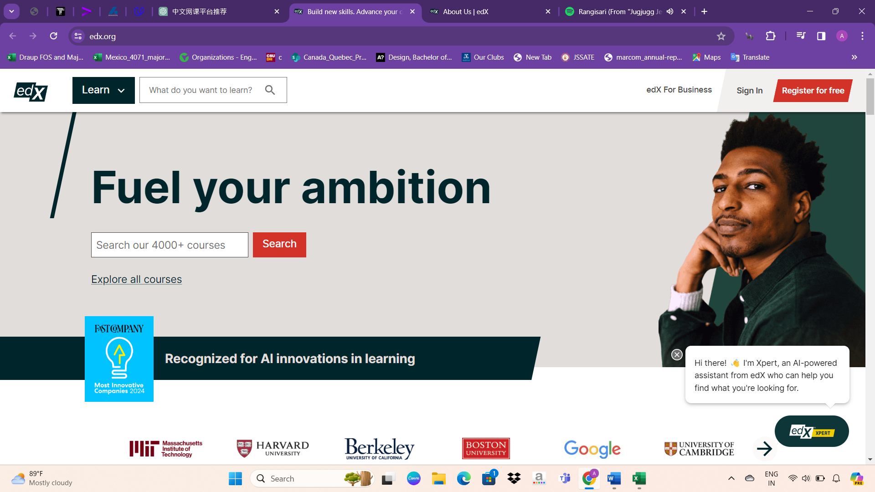

Website Design

* The edX Online platform features a convenient navigation bar that includes essential elements such as a search bar for easy course discovery, options to access "edX For Business" services, as well as options to "Sign In" and "Sign Out" for registered users.

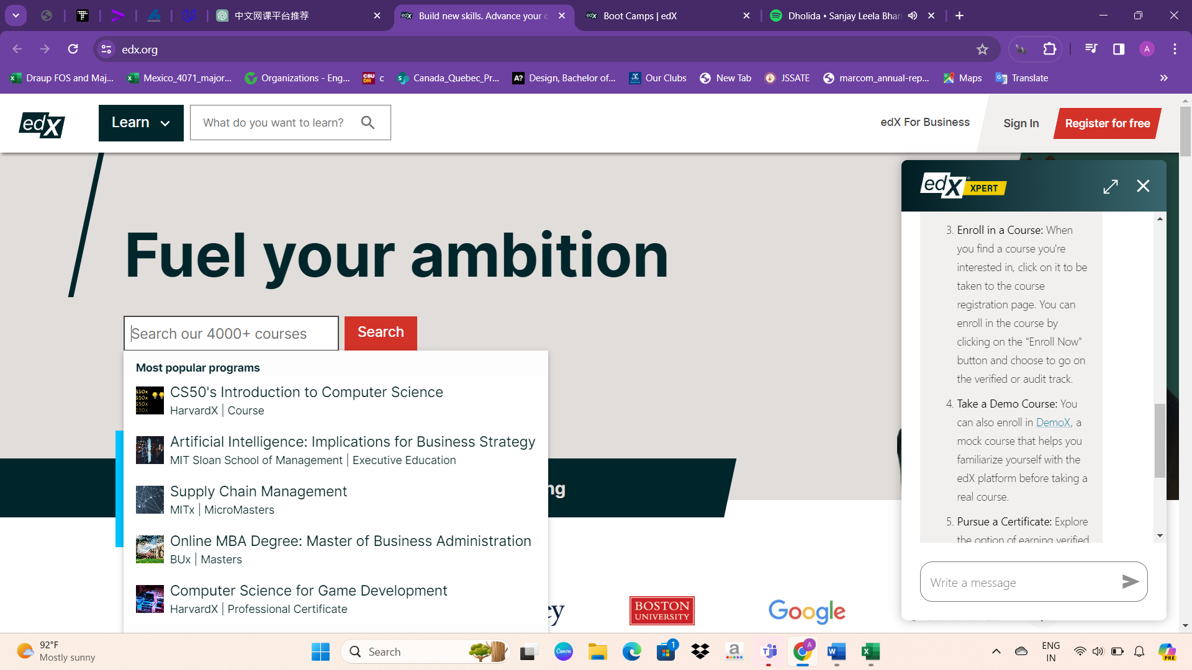

* Below the navigation bar, the search option on the edX Online platform dynamically displays a variety of courses when the cursor is placed on the search bar. This feature allows users to explore and discover a wide range of available courses directly from the search interface.
* edX collaborates with renowned institutions and partners who share our dedication to innovation and excellence in education. With over 4,500 online programs and courses available, our platform serves a diverse learner network of over 83 million individuals worldwide. We work with more than 260 content partners to offer high-quality educational experiences across various disciplines, ensuring that learners have access to top-tier learning opportunities.

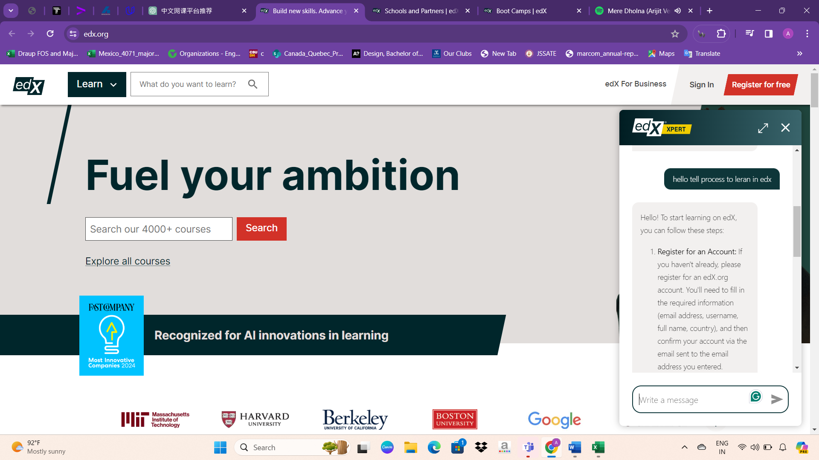

Another notable feature of the edX website is the chat option located in the bottom right corner. This feature allows users to interact with support staff and ask any questions they may have. For instance, if a user inquires about the learning process on edX, the chat tool provides detailed guidance on the steps to get started, making the learning experience more accessible and user-friendly.

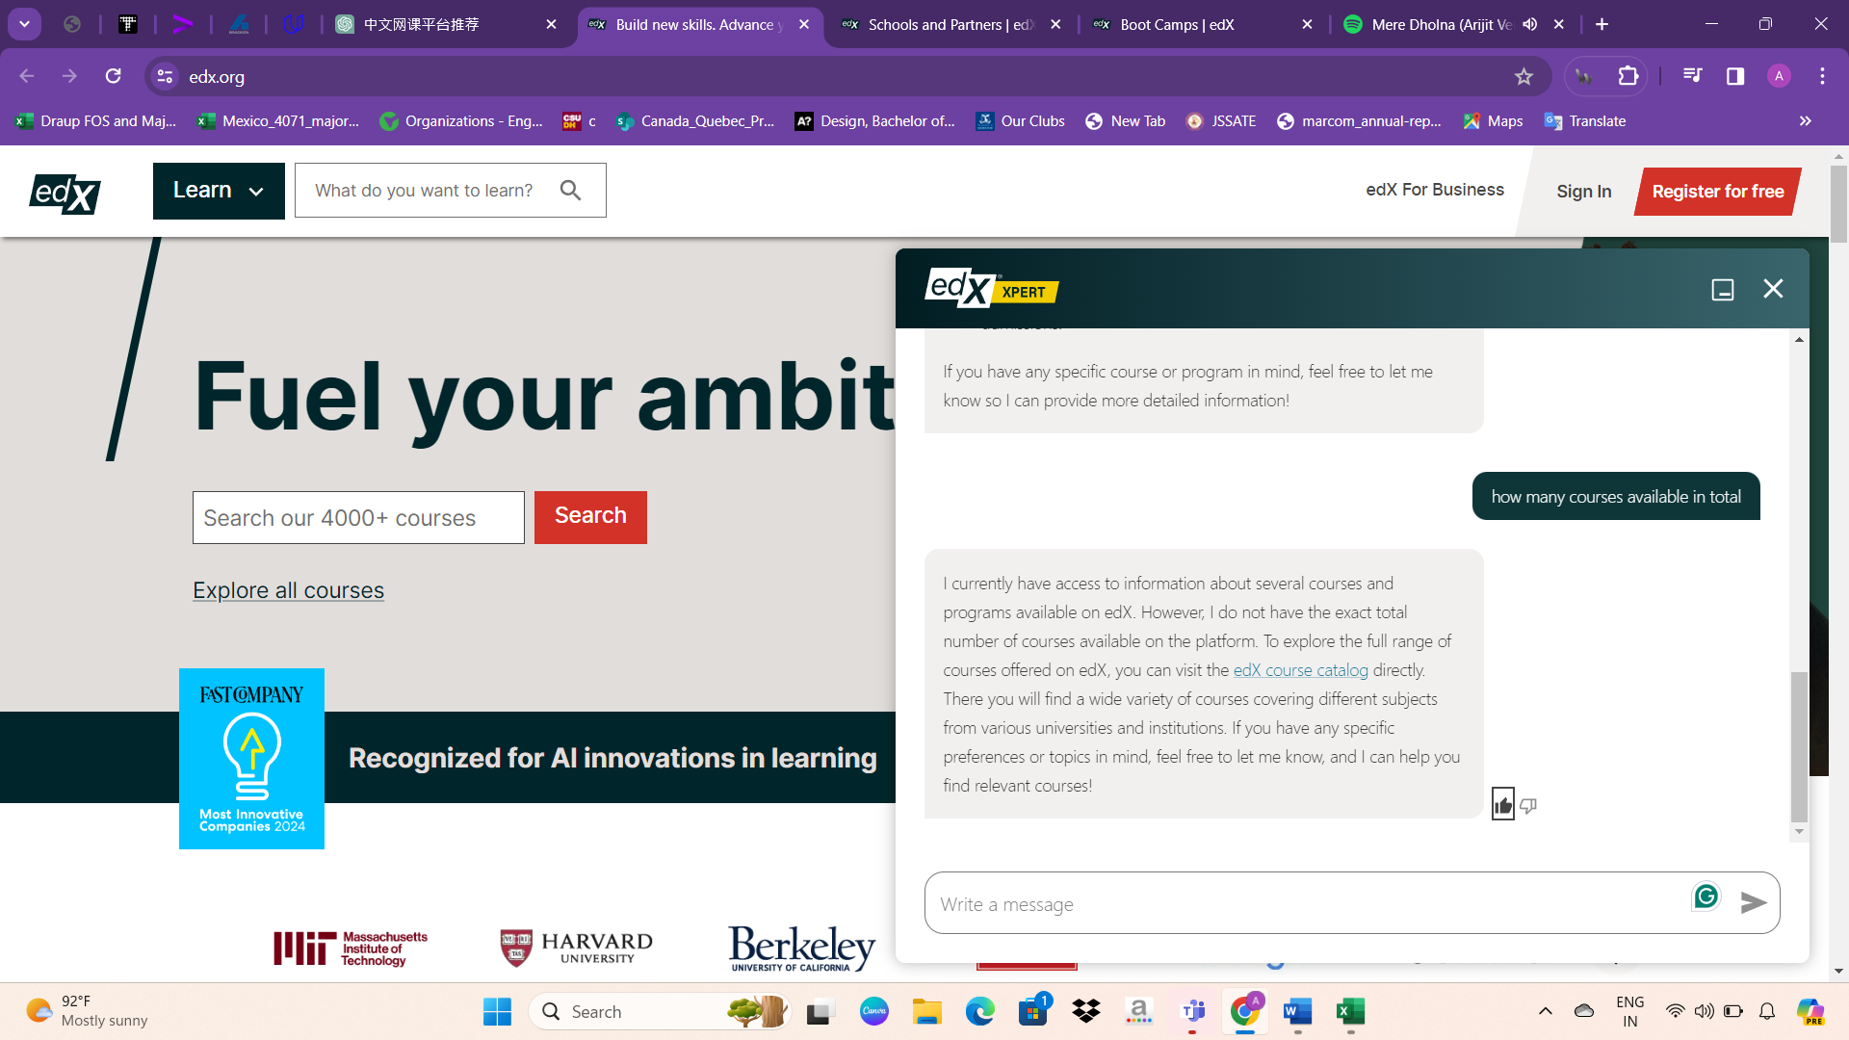

The chat feature on the edX website is a valuable addition as it promptly addresses user inquiries. This interactive tool offers assistance by answering various questions posed by users, enhancing the overall user experience. Whether it's queries about courses, enrollment procedures, or any other topic related to online learning, the chat feature ensures that users receive timely and helpful responses, making the learning journey smoother and more accessible.

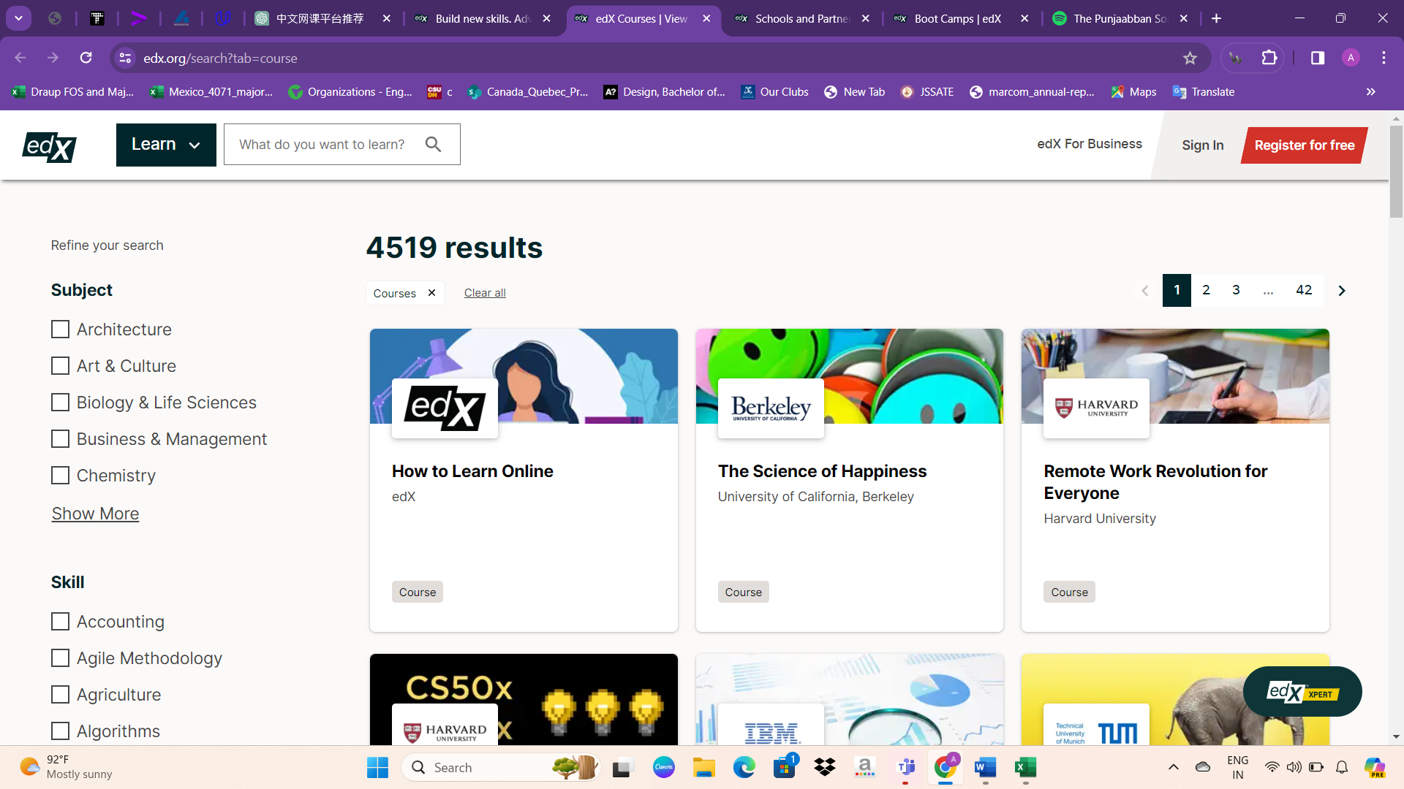

Below the search bar on the edX website, there's an "Explore Courses" option allowing users to browse through all available courses. This section offers various filter options, enabling users to refine their search according to their preferences. These filters may include criteria such as subject area, institution, level of difficulty, language, and more. By utilizing these filters, users can tailor their search to find courses that best suit their interests, goals, and learning preferences, enhancing their overall experience on the platform.

On the courses page of the edX website, the courses are displayed in a paginated format. Each page typically shows a certain number of courses, such as 20 or 50, and users can navigate between pages using navigation buttons. These buttons typically include options to go to the next page (>) or the previous page (<), allowing users to browse through multiple pages of courses. This pagination system helps users easily navigate through the extensive catalog of courses offered on the platform.

On the edX platform, users can explore various educational offerings, including Executive Education programs, Master's Degrees, Bachelor's Degrees, and Certificates. These options cater to individuals seeking professional development, advanced academic qualifications, or specialized skill certifications. Whether users are looking to enhance their leadership skills, pursue higher education degrees, or acquire industry-recognized certificates, edX provides a diverse range of learning opportunities to meet their educational goals and career aspirations.

In honor of International Women's Day, edX is offering a special promotion where users can save up to 30% with the code IWDEDX24. This offer is valid until March 31, 2024. Join in celebrating the achievements and contributions of women worldwide while advancing your own success through learning.

Promotions like these not only celebrate International Women's Day but also encourage women to take advantage of learning opportunities to further their personal and professional development. By offering discounts and special offers, platforms like edX make it easier for women to access high-quality education and skills training, ultimately empowering them to pursue their goals and make meaningful contributions to society. It's a win-win situation that promotes gender equality and lifelong learning.

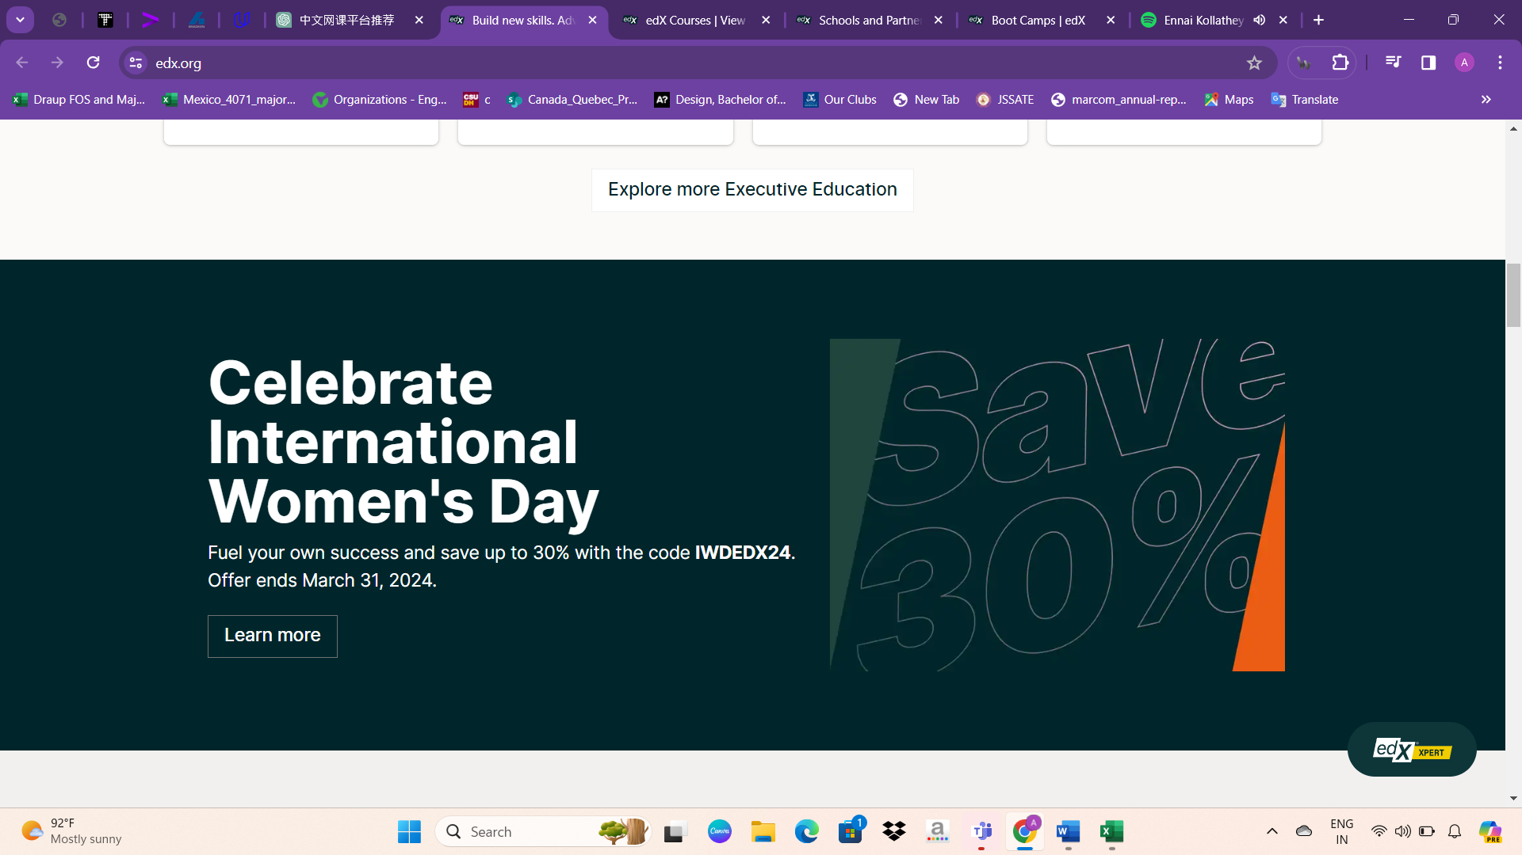

In the next section, visitors will find content titled "Explore Top Courses." This section likely showcases some of the most popular and highly recommended courses available on the platform. It's designed to help users discover trending topics, sought-after skills, and courses that are generating buzz among learners. Whether individuals are looking to enhance their career prospects, explore a new interest, or simply broaden their knowledge, exploring these top courses can be a great starting point on their learning journey.

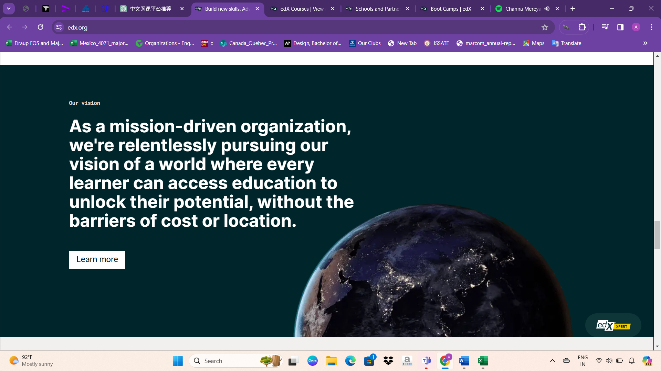

Next, users will encounter interactive designs and images within div elements that illustrate various aspects of the platform, such as its courses, specialties, vision, and mission. These visually appealing elements aim to provide users with engaging and informative content about the offerings and goals of the platform. By incorporating interactive features and captivating visuals, the platform enhances user experience and effectively communicates its values and objectives to visitors.

Following that, the next div displays popular subjects and specific topic areas. This section provides users with an overview of the most sought-after subjects and topics available on the platform. By highlighting popular areas of study, users can easily navigate to their areas of interest and explore relevant courses and content.

Following that, the next section includes various links and options such as:

- Boot Camps

- About

- edX For Business

- Affiliates

- Open edX

- 2U Advisory Council

- Careers

- News

- Connect

- Idea Hub

- Contact Us

- Help Center

- Security

- Media Kit

- Legal

- Terms of Service & Honor Code

- Privacy Policy

- Cookie Policy

- Accessibility Policy

- Trademark Policy

- Modern Slavery Statement

- Sitemap

- Your Privacy Choices

- Choose Language (English)

- Apply

- Copyright information: © 2024 edX LLC. All rights reserved.

- Download on the App Store

- Get it on Google Play

This section provides users with access to various resources, support, and information related to edX, its services, policies, and more. These elements are essential for any website to ensure transparency, accessibility, and legal compliance.

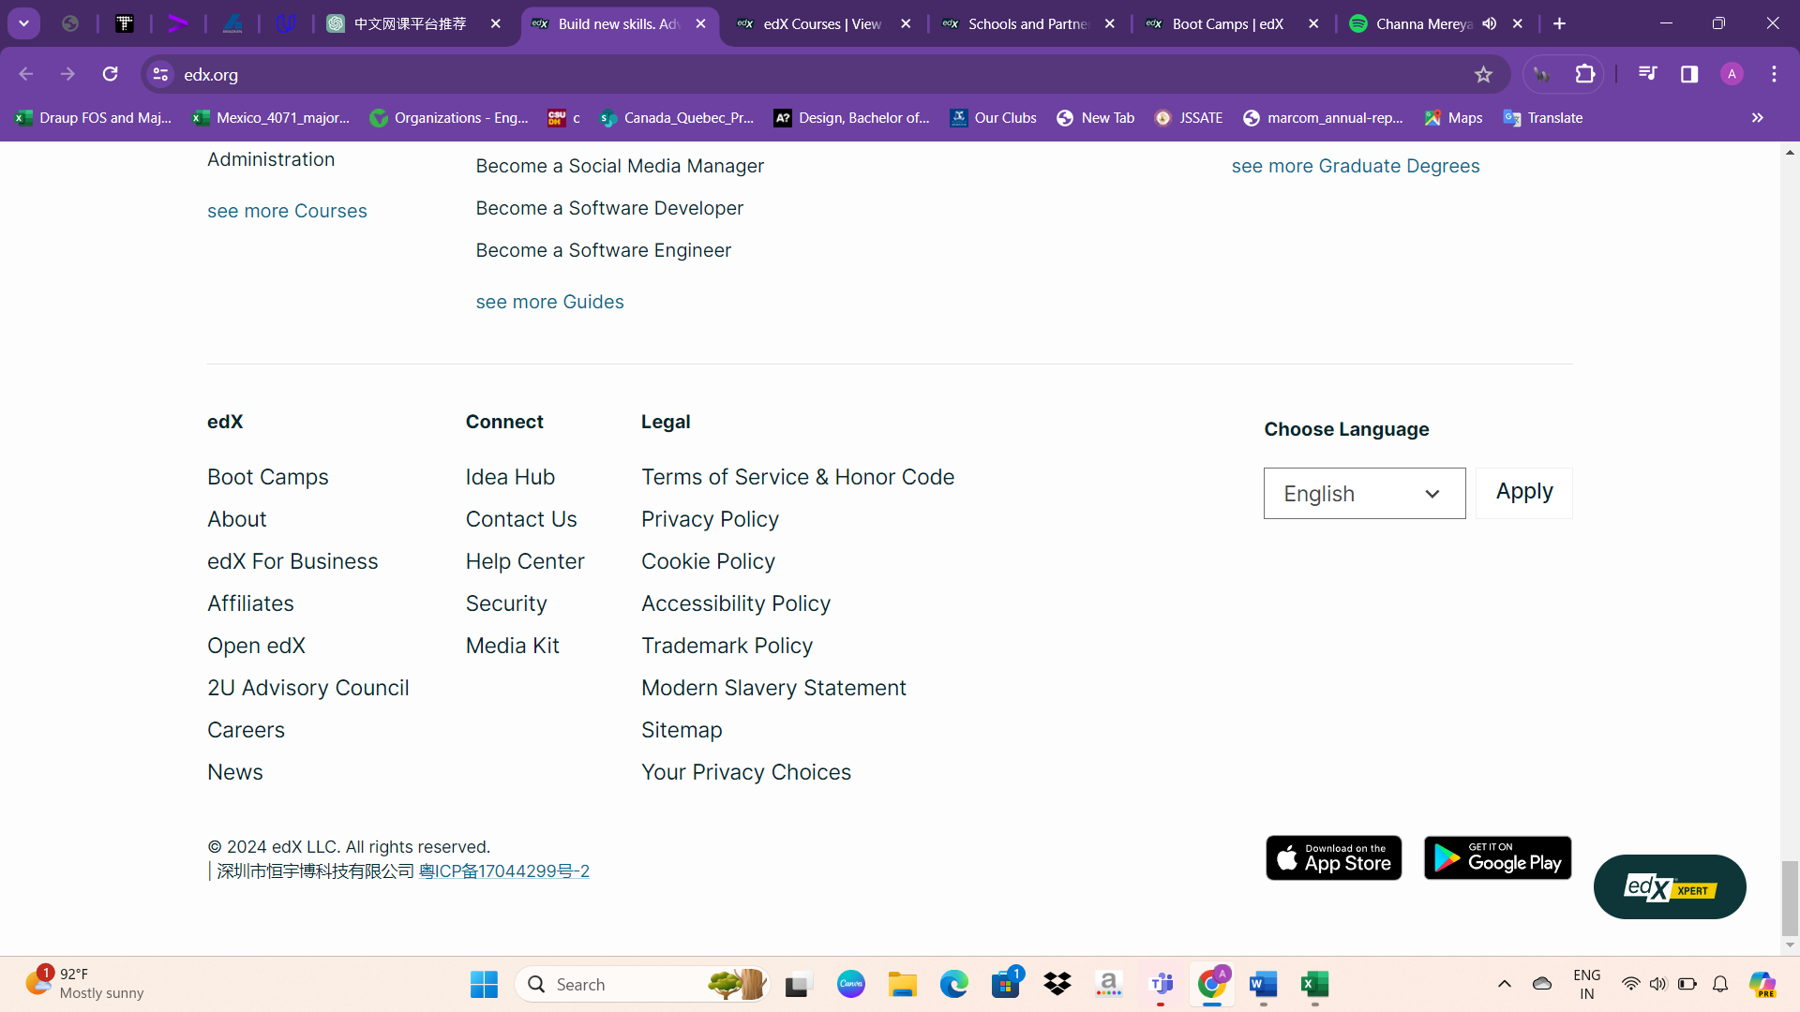

About UI Design

Overall, the UI is well-designed and user-friendly. It effectively showcases important features such as the explore course option, sign-in/sign-out functionality, and search bar prominently at the entrance of the website. The use of interactive images, appropriate font sizes and colors enhances the visual appeal and readability. Additionally, utilizing grid options from Bootstrap ensures that courses are displayed in an aligned and organized manner, contributing to a seamless user experience.

To enhance interactivity, incorporating animations, images, and videos can captivate users. Implementing background videos can add depth to the visual experience. Utilizing rounded corners for div boxes can soften the design, while experimenting with various color palettes, including lighter tones, can elevate the website's aesthetic appeal. These enhancements contribute to a more engaging and visually appealing user experience, creating a modern and dynamic interface.

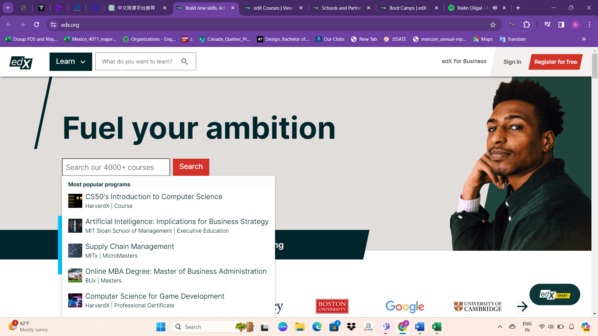

Course design

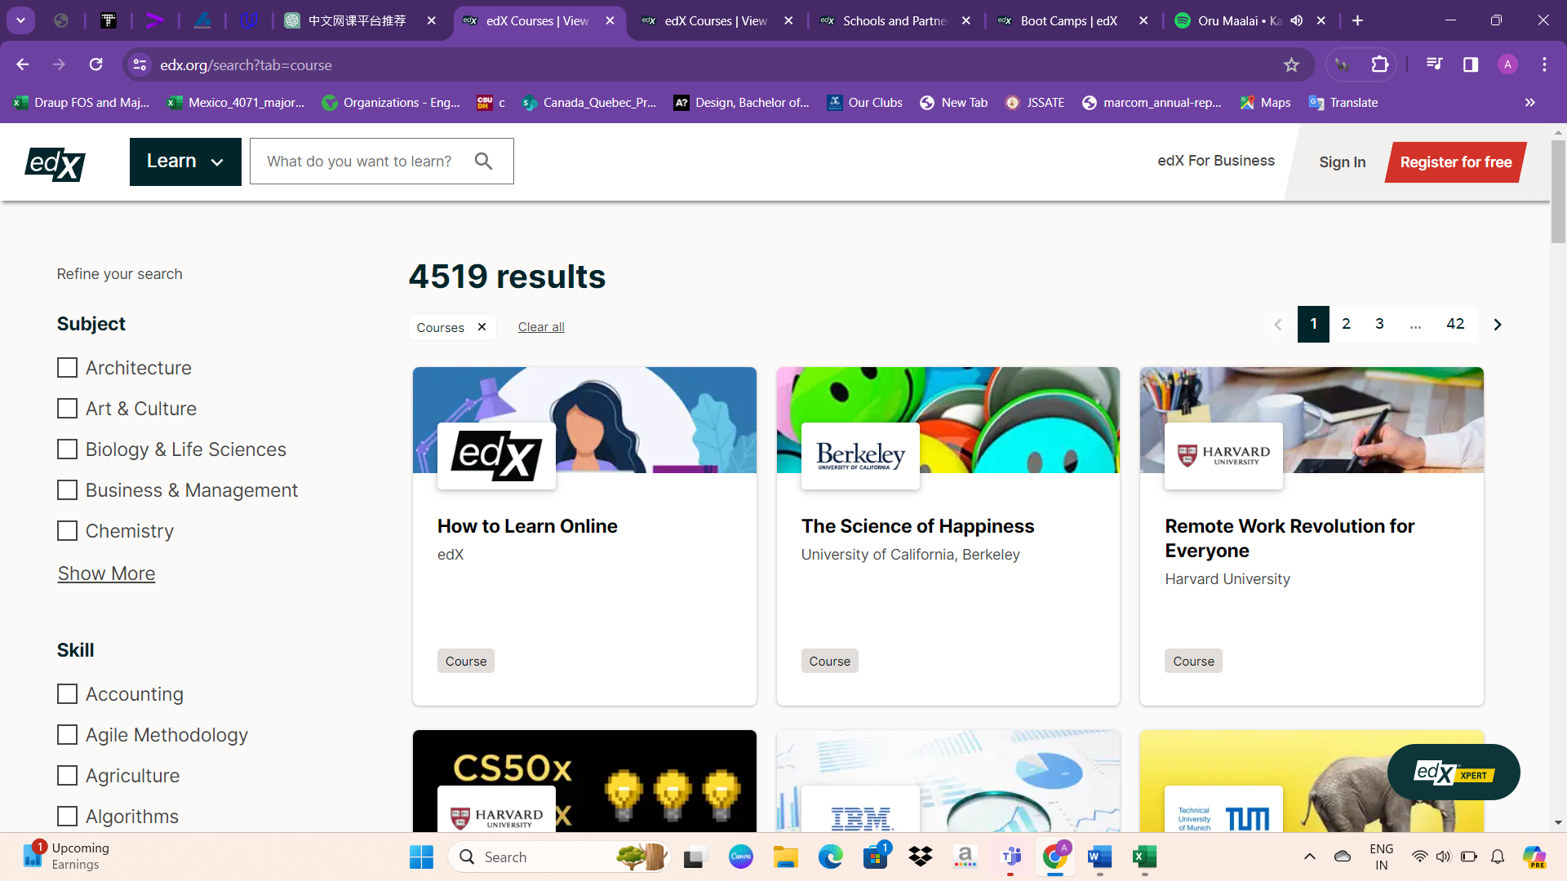

When clicking on the "Explore Courses" option, users are directed to the courses page, where a wide array of courses is displayed. This page serves as a hub for discovering and exploring the available courses, allowing users to browse through various categories, topics, and levels of difficulty. With intuitive navigation and categorization, users can easily find courses that match their interests and learning goals. The courses page provides a comprehensive overview of the diverse learning opportunities offered on the platform, empowering users to embark on their educational journey with ease.

The courses page offers refined search options to help users find the most relevant courses:

**Subject:** Users can filter courses by subject area, such as Architecture, Art & Culture, Biology & Life Sciences, Business & Management, and Chemistry, among others.

**Skill:** Courses can be filtered based on specific skills, including Accounting, Agile Methodology, Agriculture, Algorithms, and Amazon Web Services, among others.

**School & Partner:** Users can explore courses offered by specific institutions or partners, such as ACCA, Amazon Web Services, Arizona State University, and Arm Education, among others.

**Learning Type:** Courses can be filtered based on the type of learning program, including Courses, MicroMasters® Program, MicroBachelors® Program, Professional Certificates, and XSeries.

**Level:** Users can select the difficulty level of courses, including Advanced, Intermediate, and Introductory.

**Language:** Courses are available in various languages, and users can filter based on their language preference.

**Availability:** Users can choose to view courses that are currently available or archived.

These filter options allow users to customize their search and find courses that best suit their needs, preferences, and skill levels.

The filter options serve as invaluable tools for users seeking to streamline their course discovery process on the platform. By enabling individuals to specify their preferences based on subjects, skills, schools/partners, learning types, levels, languages, and availability, these filters facilitate a more targeted search experience. Users can easily narrow down their options, exploring a wide array of courses while honing in on those that best align with their interests and requirements. Whether users are looking to enhance their skills in a specific subject, pursue a particular learning path, or find courses tailored to their proficiency level and schedule, these filter options empower them to navigate the platform with efficiency and precision.

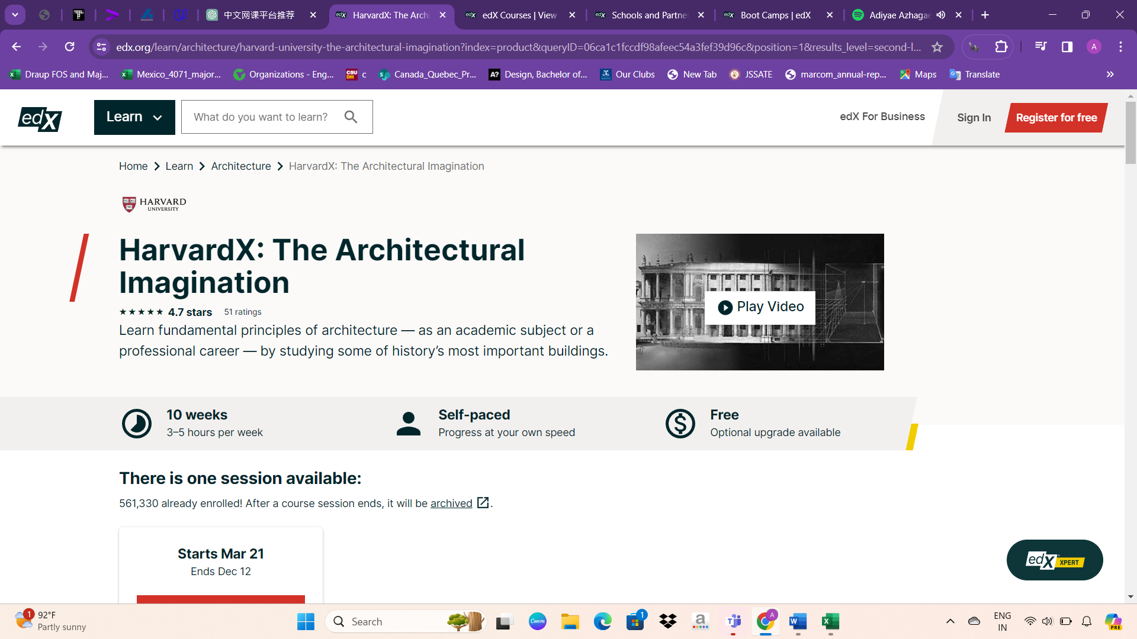

Upon entering a course page on edX, users encounter comprehensive details about the selected course, including its title, institution logo (e.g., Harvard University), course rating (e.g., 4.7 stars), number of ratings, course description, duration (e.g., 10 weeks), estimated weekly time commitment (e.g., 3-5 hours), learning pace (e.g., self-paced), cost (e.g., free with optional upgrade), session availability, enrollment status, and options to enroll or receive email notifications. The page also provides insights into the course content, instructors, FAQs, and ways to enroll, ensuring users have access to all relevant information before committing to the course.

The "Enroll Now" option is prominently displayed in a bright color, drawing the user's attention and encouraging them to take immediate action. This design technique is strategically used to make the enrollment process easily accessible and enticing for users, ultimately increasing the likelihood of course enrollment. By prominently featuring the enrollment button in a vibrant color, the website effectively guides users towards the desired action, enhancing the user experience and encouraging engagement with the course offerings.

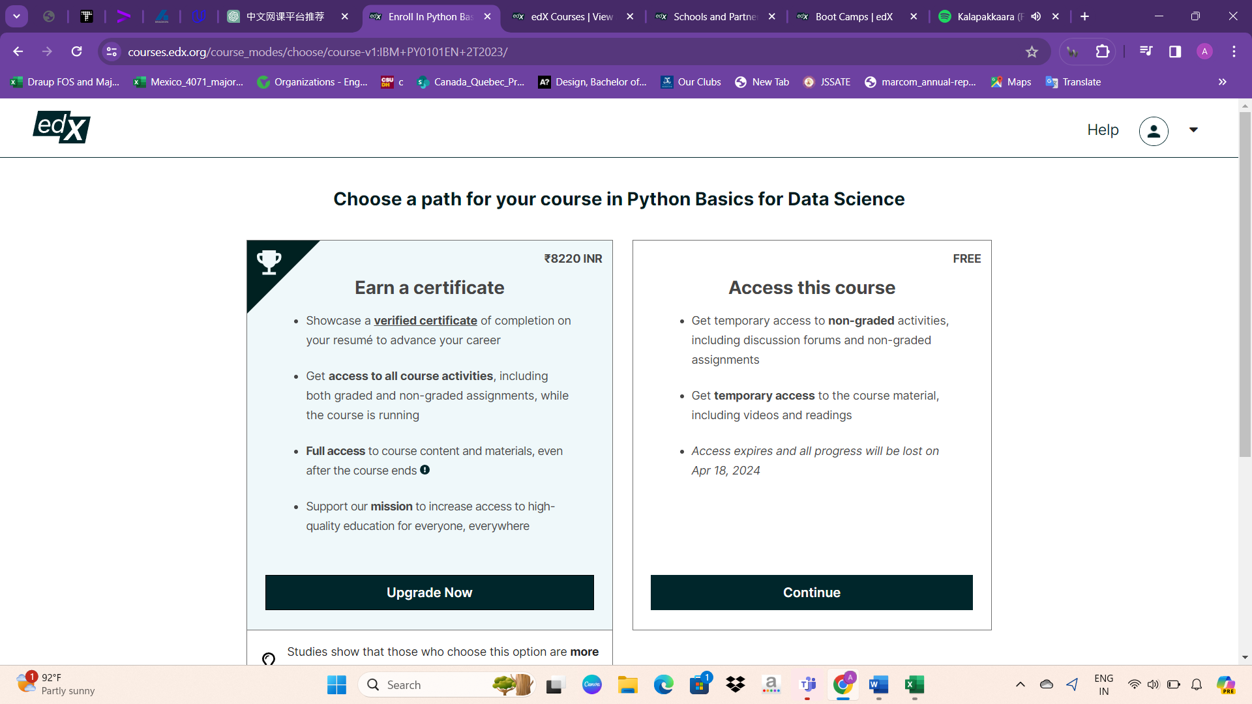

If users wish to receive a certificate upon completing the course, they are prompted to make a payment. However, if they opt not to obtain a certificate, they can still access the course content by simply logging in, albeit without receiving any certification upon completion. This approach provides users with flexibility, allowing them to choose whether they value certification and are willing to pay for it or if they are content with accessing the course material without certification. It caters to different user preferences and needs, enhancing the accessibility and appeal of the platform.

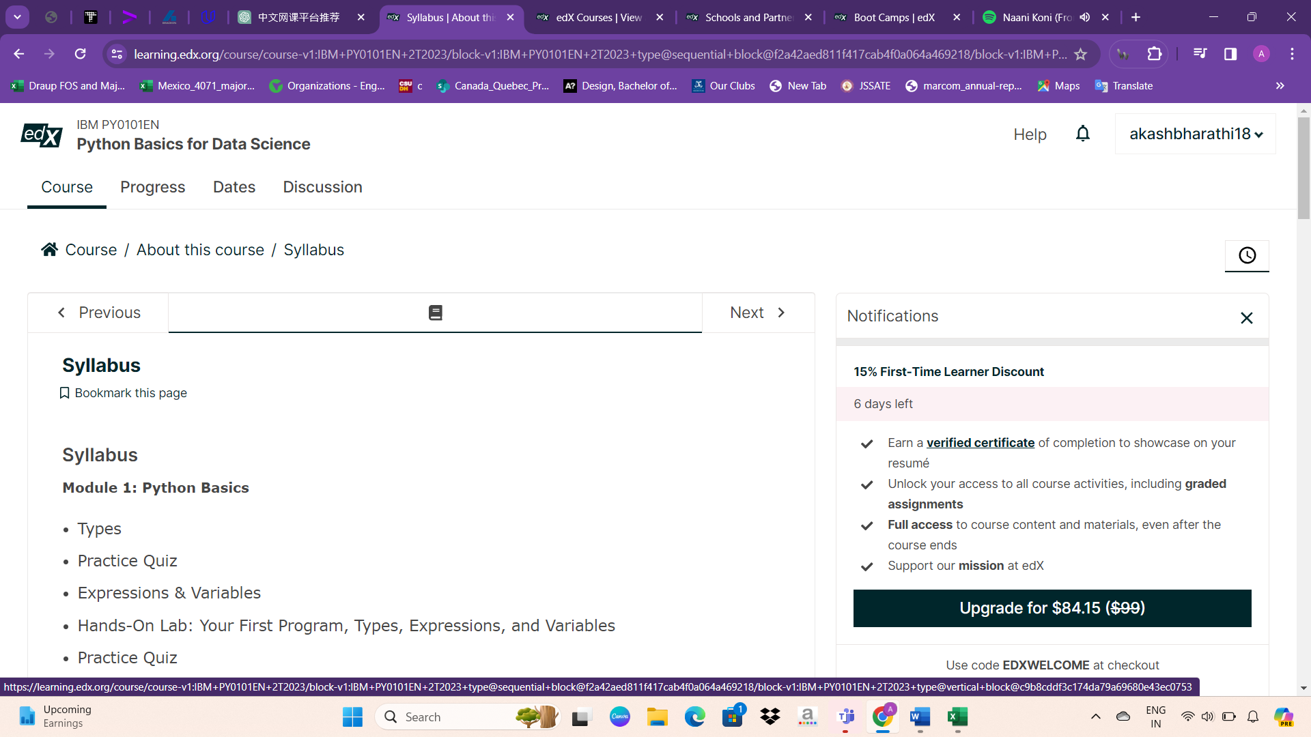

Upon entering a free course, users are provided with several tabs to navigate the course content effectively:

Course: This tab offers an overview of the course, including its title, description, and instructors.

Progress: Here, users can track their progress throughout the course, monitoring completed sections or modules.

Dates: This tab displays important dates related to the course, such as start and end dates, as well as any deadlines for assignments or assessments.

Discussion: Users can engage in discussions with fellow learners and instructors, asking questions, sharing insights, and collaborating on course-related topics.

Syllabus: The syllabus tab outlines the course curriculum, providing detailed information about the topics covered, learning objectives, readings, assignments, and assessments.

These tabs offer a structured approach to accessing and navigating course content, ensuring users can easily find and engage with the material while progressing through the course.

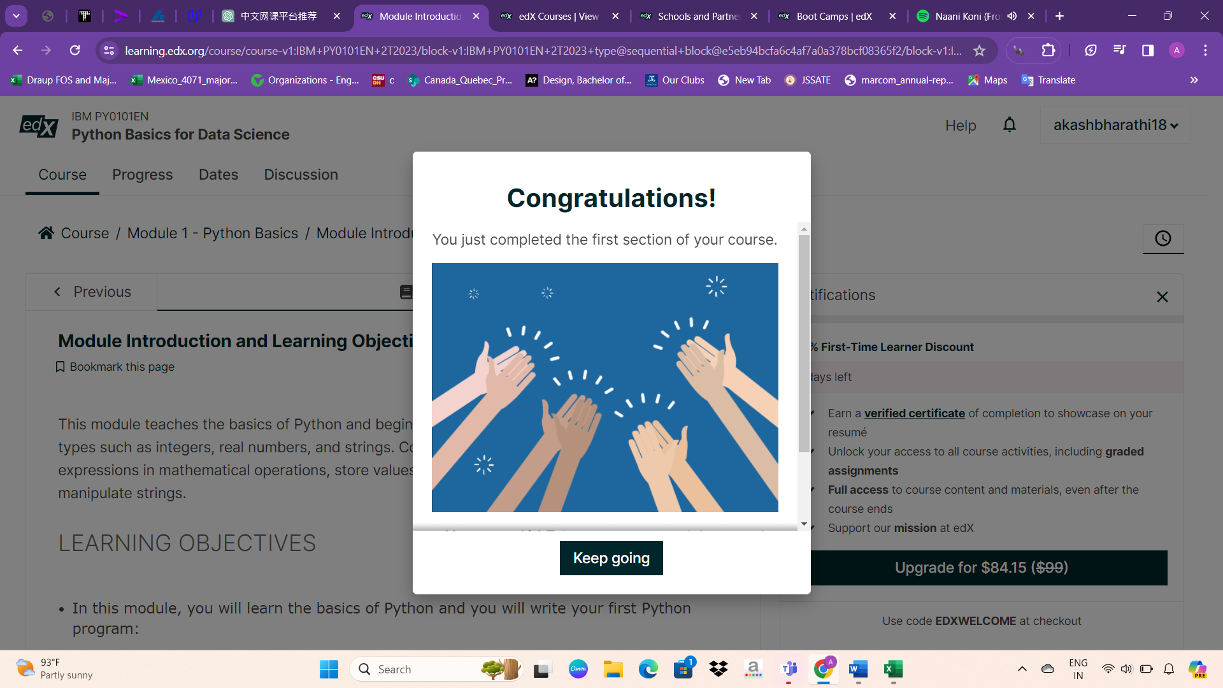

Upon completing the first section of a course, users are greeted with a congratulatory pop-up box, acknowledging their progress and achievement. This pop-up serves as positive reinforcement, motivating users to continue their learning journey. Additionally, it may include encouraging messages such as "Congratulations on completing your first section!" or "Well done on reaching this milestone!" The pop-up box may also provide options for users to share their achievement on social media platforms or to explore additional resources or courses. Overall, this feature enhances user experience by celebrating milestones and fostering a sense of accomplishment.

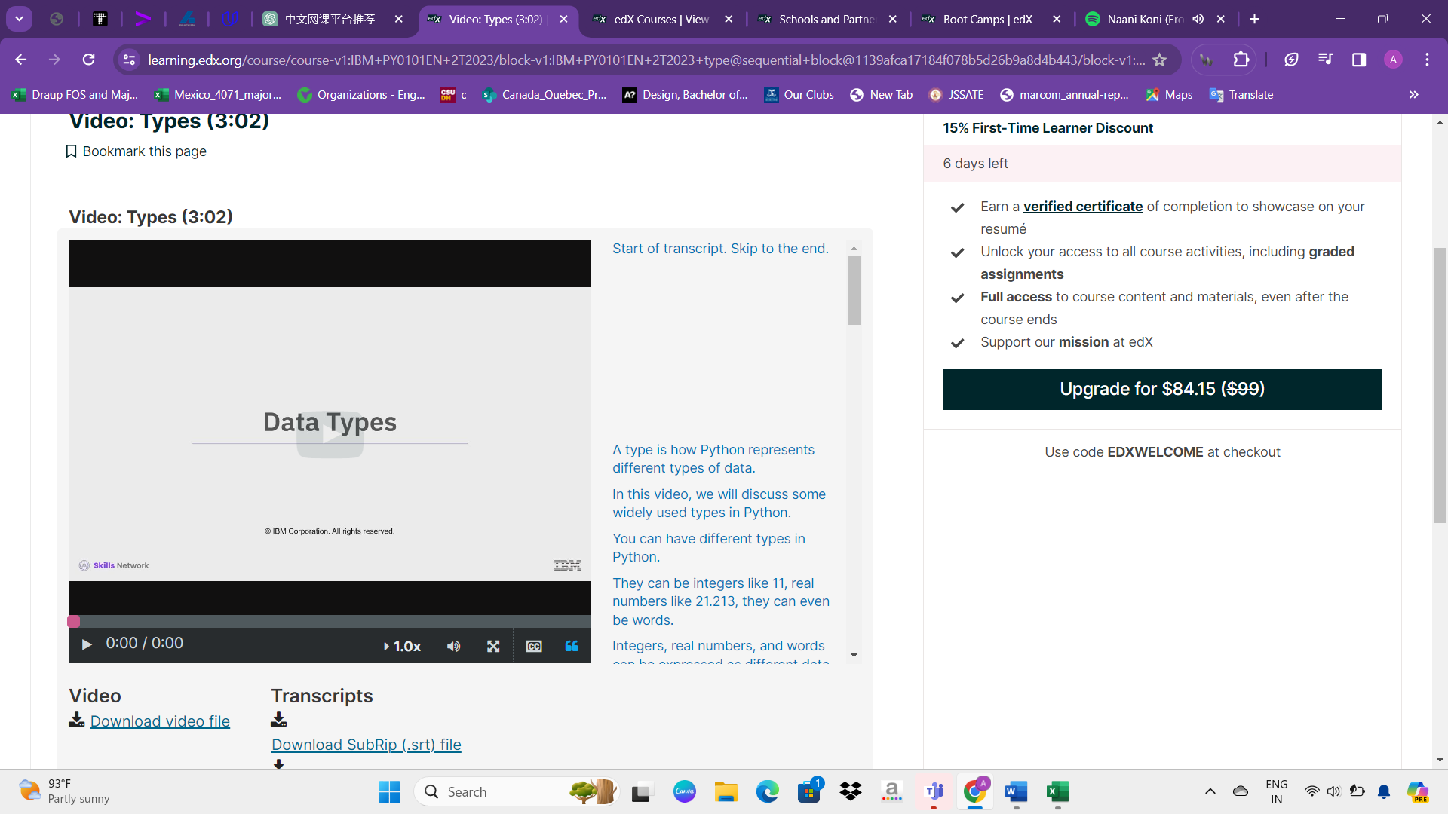

After accessing the course content, users can delve into the course materials, which typically include instructional videos covering various topics. These videos serve as the primary means of teaching and learning within the course, providing users with valuable insights, explanations, and demonstrations related to the subject matter. They may feature expert instructors delivering lectures, demonstrations, or presentations in an engaging and informative manner. Users can watch these videos at their own pace, pausing, rewinding, or rewatching segments as needed to fully grasp the concepts being taught. Overall, these videos play a crucial role in facilitating the learning experience and helping users gain a deeper understanding of the course content.

Users are provided with the option to download course materials for offline viewing, enhancing accessibility and flexibility in their learning experience. This download feature allows users to save course videos, documents, or other resources to their device, enabling them to access the content even without an internet connection. By offering this functionality, the platform empowers learners to study at their convenience, whether they are traveling, in areas with limited internet access, or simply prefer offline learning. Additionally, downloading course materials enables users to revisit the content at any time, making it easier to review key concepts or reference specific information as needed throughout their learning journey.

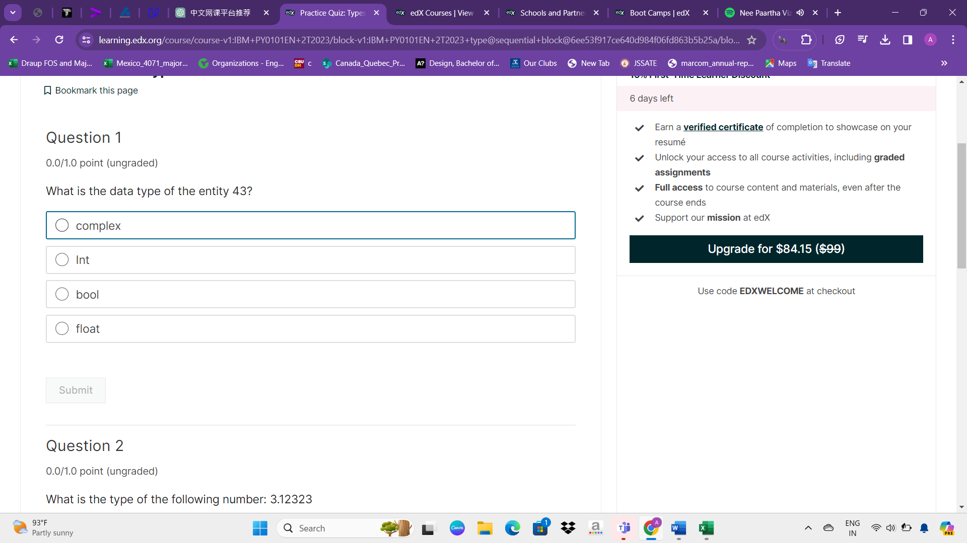

After completing each topic, users are prompted to participate in a quiz that assesses their understanding of the material covered. These quizzes serve as checkpoints to ensure comprehension and retention of the course content. By testing users on the topics they have just learned, the platform reinforces learning objectives and helps users gauge their progress. Additionally, quizzes provide valuable feedback to learners, identifying areas of strength and areas that may require further review. This interactive assessment approach enhances the learning experience by promoting active engagement and facilitating mastery of the course material.

the design and structure described apply to most courses on the platform. Each course typically begins with an overview of the content, followed by segmented modules or lessons covering specific topics. Users engage with the material through videos, readings, and interactive elements. Progress is tracked, and quizzes or assessments are interspersed throughout to reinforce learning. Certificates may be offered upon completion, often requiring payment or verification. The platform aims to provide a comprehensive and engaging learning experience, catering to diverse interests and skill levels across various subject areas.

Overview about Skillcrush

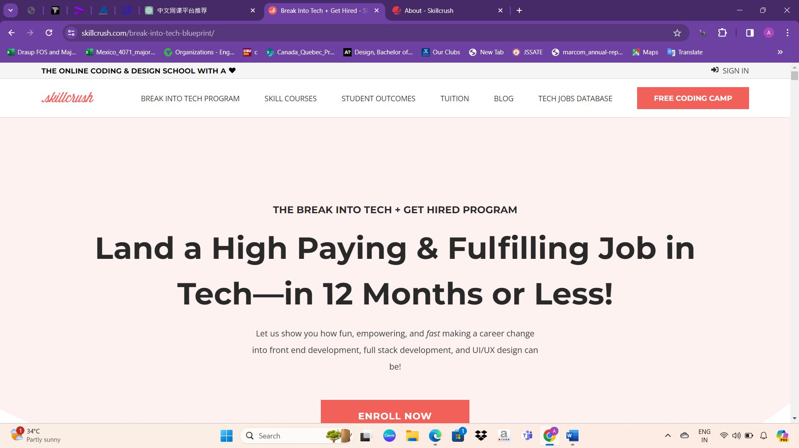

Skillcrush is an online coding school that aims to make technology accessible to everyone, regardless of their background or identity. Here's a breakdown of their mission and target audience:

1. Mission: Skillcrush believes that technology doesn't have to be difficult and that anyone can learn to use it as a tool to improve their lives. Their mission is to empower individuals with digital skills that can lead to high-earning and flexible careers.

2. Inclusive Community: Skillcrush fosters a supportive community of students, alumni, and instructors who are committed to helping each other succeed. They focus on providing resources and guidance to individuals who may not typically see themselves represented in the tech industry.

3. Target Audience: Skillcrush is specifically geared towards:

- Women and non-binary individuals

- BIPOC (Black, Indigenous, and People of Color)

- Late career changers

- LGBTQ+ individuals

- People with disabilities

- People without college degrees

- Parents and caretakers

- Individuals who have taken long breaks from the workforce

4. Inclusivity: Skillcrush welcomes anyone who feels like there's no place for them in the tech industry because they haven't seen someone like themselves represented. They strive to create a welcoming and inclusive environment for all learners.

Overall, Skillcrush aims to break down barriers to entry in the tech industry and provide opportunities for individuals from diverse backgrounds to thrive in technology-related careers.

About websites UI

Here's a breakdown of the items listed in Skillcrush's website navbar:

1. Break Into Tech Program: This likely leads to information about Skillcrush's flagship program designed to help individuals with no prior tech experience break into the tech industry. It may include details about the curriculum, enrollment process, and success stories from past participants.

2. Skill Courses: This section probably contains information about the various courses offered by Skillcrush, covering topics such as web development, digital marketing, design, and more. Each course may have its own description, syllabus, and enrollment options.

3. Student Outcomes: This page likely showcases success stories and testimonials from Skillcrush students who have completed their programs and achieved their career goals. It may provide insights into the impact of Skillcrush courses on students' lives and careers.

4. Tuition: This section probably outlines the tuition fees and payment options for Skillcrush courses. It may also include information about any financial aid or scholarship opportunities available to students.

5. Blog: This leads to Skillcrush's blog, where they may share articles, tutorials, industry insights, and other relevant content related to technology, career development, and the tech industry.

6. Tech Jobs Database: This could be a resource for Skillcrush students and alumni to explore job opportunities in the tech industry. It may include job listings, internships, freelance opportunities, and resources for job seekers.

7. Free Coding Camp: This likely leads to information about Skillcrush's free coding camp or introductory courses designed to give individuals a taste of what it's like to learn to code with Skillcrush. It may include details about course content, duration, and enrollment options.

* The navigation bar on Skillcrush's website, there's a section with motivating quotes promoting their programs.
* This section likely aims to capture the attention of visitors and encourage them to consider enrolling in Skillcrush's programs by highlighting the benefits and opportunities available to them. The "Enroll Now" button provides a clear call-to-action for interested individuals to take the next step and sign up for the program.
* Subsequently, a video presentation outlines the courses available on the website, offering users a comprehensive overview of the platform's offerings. This video serves as a helpful resource for individuals seeking to understand the available courses and make informed decisions about their learning journey.
* Following the video presentation, the website showcases div elements containing quotes that highlight the platform's benefits and program timeline. These quotes provide insights into the website's offerings and help users understand the timeline for completing various programs.
* Following the quotes, the website presents a step-by-step guide. Step 1 focuses on learning the necessary tech skills to secure a job. Enrollees gain access to three career tracks: Front End Developer, Full Stack Developer, and UI/UX Designer. Professional mentors assist in choosing the right path, with the flexibility to switch tracks easily.
* Following the overview, the website details three career tracks: Front End Development, UI/UX Design, and Full Stack Development.
* Front End Development: Learn HTML, CSS, and JavaScript to implement web designs. Skills include Git version control, responsive design, and building web apps with React.
* UI/UX Design: Explore UX theory, user research, wireframing, and prototyping for creating optimal user interfaces.
* Full Stack Development: Master HTML, CSS, JavaScript, and Python for both front end and back end development. Skills cover web hosting, Git, responsive design, and data handling.
* Each track includes 15 tech classes covering essential topics like HTML/CSS, Git, JavaScript, React, Python, web design, and user experience.
* Following the course completion, Skillcrush extends support in securing employment by encouraging students to develop their portfolios. They provide guidance on creating impressive portfolios and showcase examples of portfolios from their successful alumni to inspire and guide aspiring tech professionals.
* Skillcrush provides guidance on portfolio building and offers strategies for securing jobs. Additionally, they showcase student reviews, demonstrating the practical benefits of their courses and enhancing user engagement.
* Top of Form
* Skillcrush offers a 14-Day Money Back Guarantee, recognizing the significance of career transitions. If you determine within this period that Skillcrush or a tech career isn't the right fit, you're eligible for a full refund, ensuring your comfort in investing in both Skillcrush and yourself.
* After proceeding, the following payment options are displayed:

**12 Monthly Payments:**

$259 per month

Payment can be made using a credit card or PayPal.

Enroll Now

Best Deal:

**One-time payment of $2,999**

Payment can be made using a credit card, PayPal, or Affirm.

Enroll Now

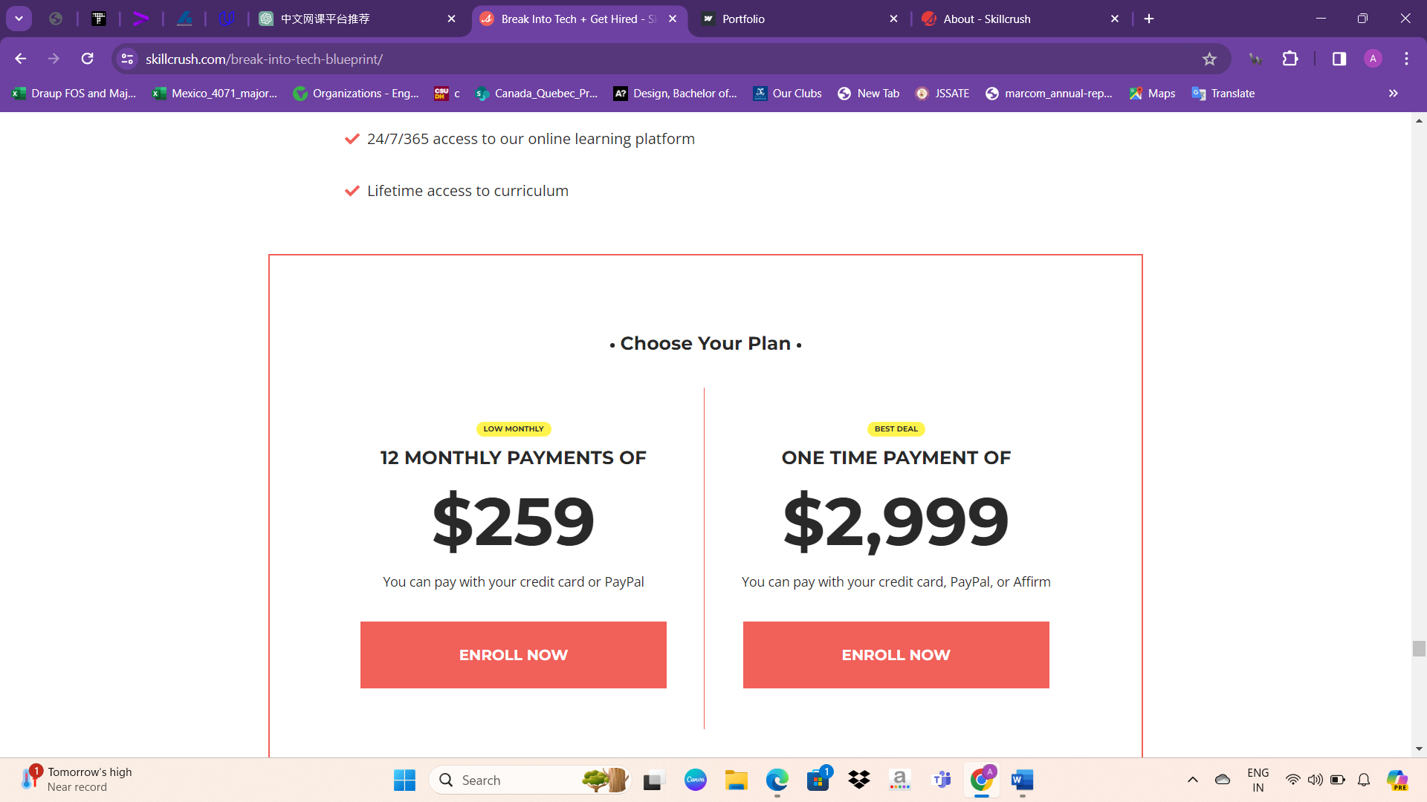

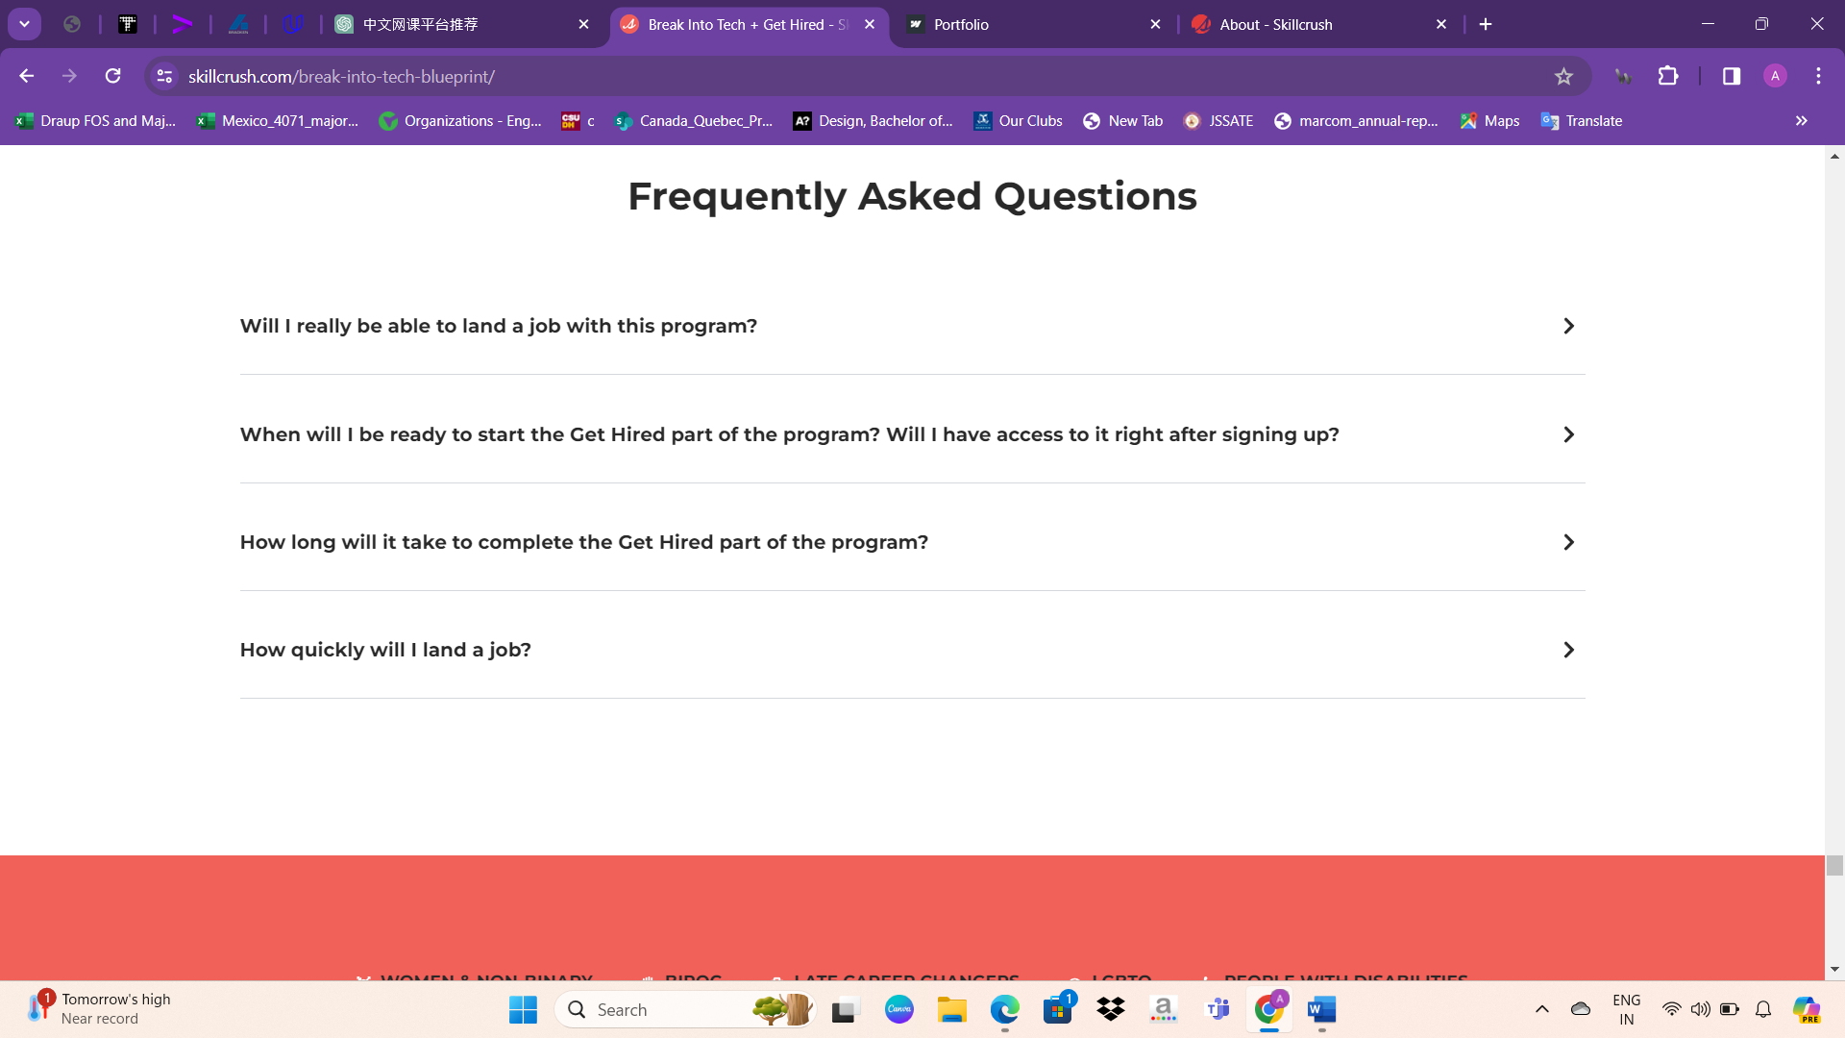

Following the payment options, users encounter frequently asked questions (FAQs) addressing common queries.

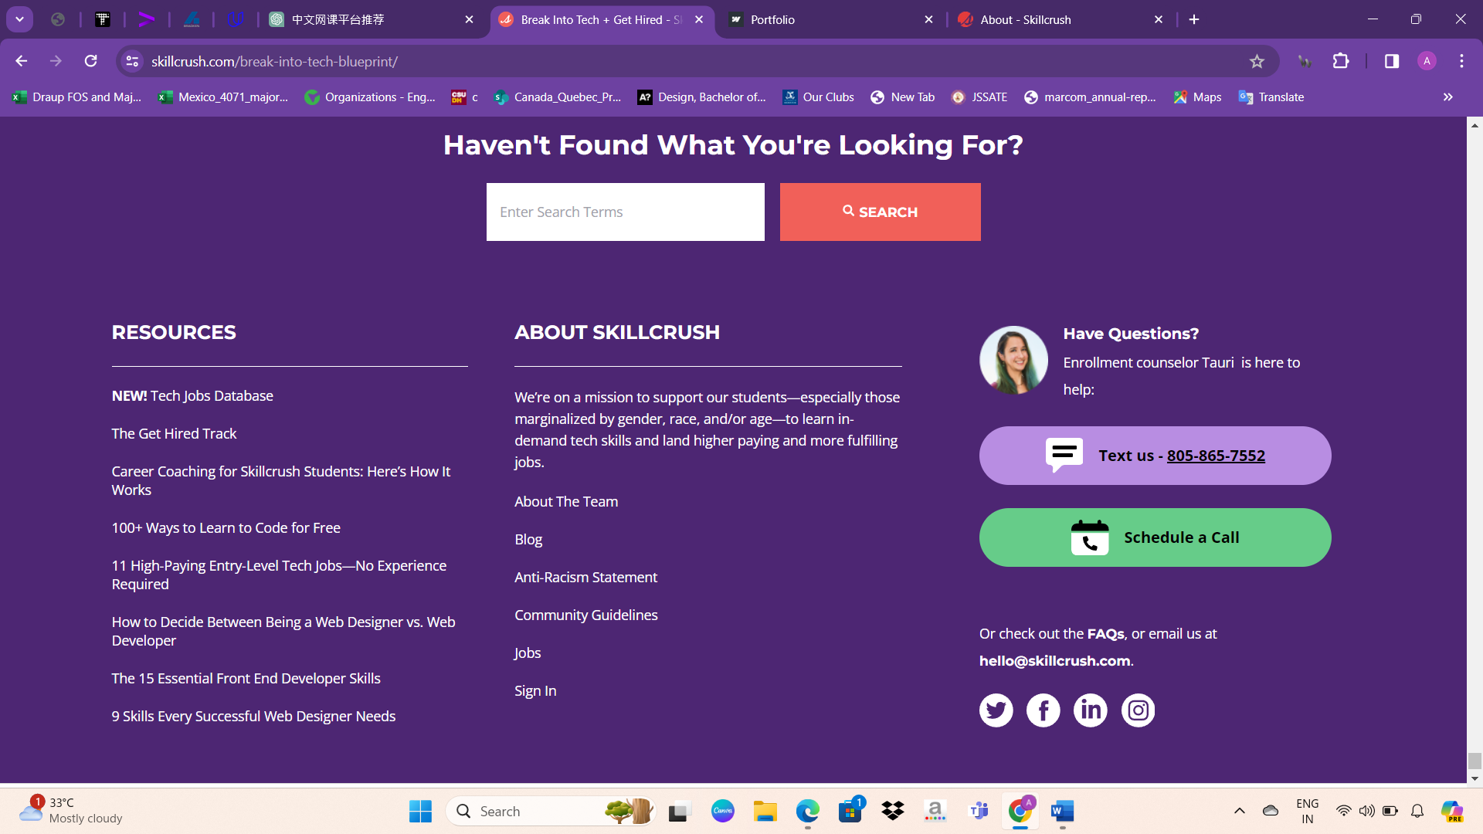

Following the FAQs, the website's footer typically includes links to sections such as "About The Team," "Blog," "Anti-Racism Statement," "Community Guidelines," "Jobs," and "Sign In."

Courses design

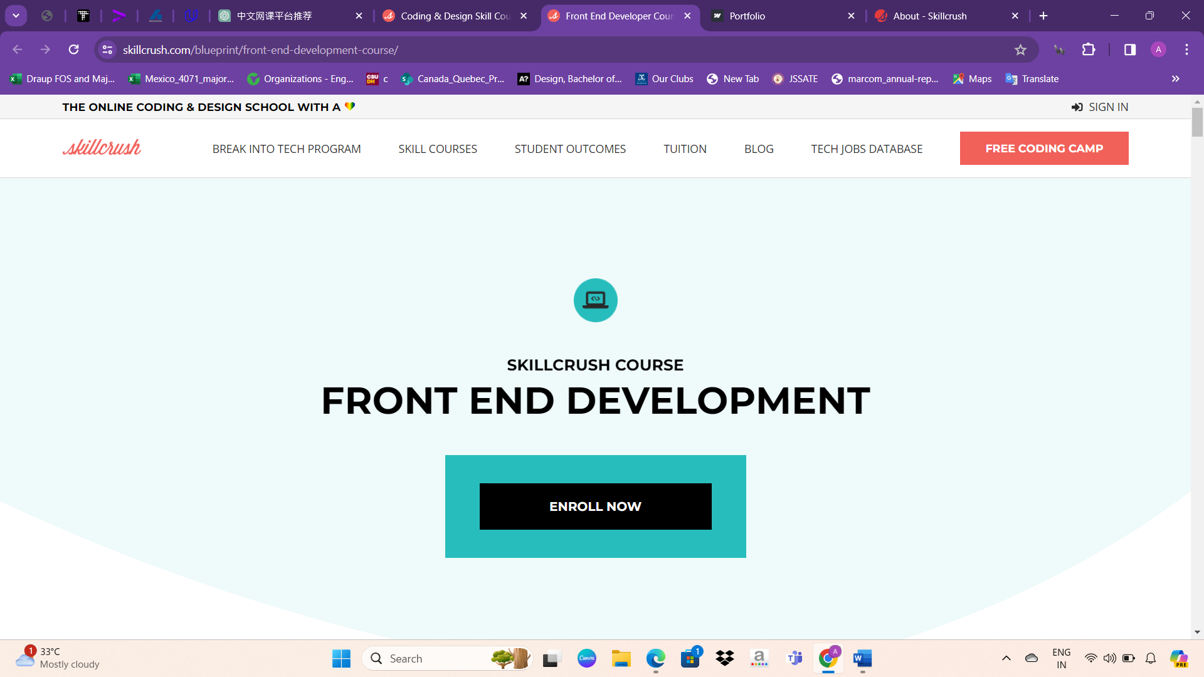

At the outset, the website prompts users to enroll in courses, encouraging immediate engagement with its offerings.

Following the enrollment prompt, the website presents brief course descriptions alongside compelling statistics, such as the average salary of a front-end developer, web development job opportunities in the US, and annual job growth, aiming to motivate users to make prompt payment

The website outlines the course components, including classes, projects, lessons, and videos, providing users with an overview of the comprehensive learning experience offered.

Some disadvantages

* Indeed, offering free access to introductory course content can be beneficial for users to assess the quality and relevance of the material before committing to enrollment. Providing a taste of what the course offers can build trust and confidence in the website's offerings, potentially encouraging users to invest further in their learning journey.
* Making the website simpler by removing less important sections and emphasizing main topics can make it easier for users. By organizing information **clearly** and prominently, users won't have to scroll too much or get lost in unnecessary details. This ensures they find what they're looking for quickly and have a better experience.
* By enhance vibrant colors, subtle animations, and engaging background videos can enhance the visual appeal of the website, making it more attractive and captivating for users. These elements not only make the website look more modern and dynamic but also create a more immersive and enjoyable browsing experience.
* The website offers a limited range of courses primarily focused on technology-related subjects. Expanding the course offerings to include a broader variety of topics beyond just technology could attract a wider audience and cater to different interests and skill levels. This diversification could enhance the appeal and accessibility of the platform.
* The absence of a course filter option makes it challenging for users to navigate and explore the available courses effectively. Implementing a filter feature would enable users to refine their search based on specific criteria such as subject, skill level, or course format. This enhancement would improve the user experience and facilitate easier access to relevant courses.
* The lack of courses related to art or non-tech fields limits the diversity of learning options available on the website. Including courses in these areas would attract a broader audience with varied interests and skill sets. Expanding the course catalog to encompass art and non-tech subjects would cater to a wider range of users and enhance the platform's appeal.

Privacy policy

* + Personal information, such as name, email, and payment details, may be collected to facilitate service provision. This data may be shared with third-party service providers to support operational functions. Contact details are not shared with third-party marketers without explicit consent.
  + Cookies and tracking technologies are employed for website analysis and service enhancement. Browser settings can be adjusted to reject cookies, although this may limit access to certain features.
  + Third-party website links are provided for convenience, but their privacy practices are not under our control. Usage of our services implies consent to the international transfer of data.
  + Unsubscribing from marketing emails or deleting accounts can cease communications from our end. While security measures are in place to safeguard data, absolute security cannot be guaranteed.
  + Our services are not intended for children under 13, and we do not knowingly collect personal information from them. Public forums may display personal information shared voluntarily by users.
  + This Privacy Policy is governed by the laws of the State of New York. Updates to the policy may occur, and continued use of our services constitutes acceptance of any revisions. For comprehensive details, please refer to the complete Privacy Policy on our website.

Technologies used in skillcrush

Content Management Systems:

- WordPress: PHP and MySQL-based CMS.

- Elementor: WordPress-based website builder.

- Help Scout: Hosted knowledge base/help desk software.

- Leadpages: Hosted service for creating landing pages.

Server-side Programming Languages:

- PHP: Scripting language for websites.

- Python: General-purpose scripting language.

Client-side Programming Language:

- JavaScript: Lightweight, object-oriented scripting language.

JavaScript Library:

- jQuery: Simplifies HTML document traversing, event handling, and more.

CSS Framework:

- Tailwind: CSS framework for rapid web interface building.

Web Servers:

- Nginx: Lightweight open-source web server.

- Cloudflare Server: Web server developed by Cloudflare.

Operating System:

- Ubuntu: Linux distribution.

Web Hosting Providers:

- Kinsta: Managed WordPress hosting.

Reverse Proxy Service:

- Cloudflare: Content delivery network provider.

DNS Server Provider:

- Cloudflare: Provides DNS servers and web services.

Email Server Provider:

- Gmail: Email service by Google.

SSL Certificate Authority:

- DigiCert: SSL certificate authority.

JavaScript Content Delivery Networks:

- jsDelivr: Service for hosting JavaScript files.

- jQuery CDN: Hosts copies of the jQuery library.

Traffic Analysis Tools:

- Google Analytics: Detailed visitor statistics service by Google.

- Facebook Pixel: Tracks actions on websites for analytics.

- HubSpot Marketing Analytics: Web analytics tool by HubSpot.

- Cloudflare Web Analytics: Privacy-respecting website traffic analytics service.

- CrazyEgg: Website visitor and click tracking service.

Advertising Network:

- Google Ads: Google's advertising network including AdSense and DoubleClick.

Tag Manager:

- Google Tag Manager: Google service for managing tags on websites.

Site Elements:

- External Cascading Style Sheets: Separate CSS file defining style rules.

- Embedded Cascading Style Sheets: Style rules within a web page's <style> element.

- Inline Cascading Style Sheets: Style rules directly within (X)HTML elements.

- Brotli Compression: Lossless compression algorithm developed by Google.

- IPv6: Larger address space Internet Protocol version.

- HTTP/2: Second major version of the HTTP network protocol.

- HTTP/3: Third major version of the HTTP network protocol, derived from QUIC.

- Default protocol https: Redirects visitors to use SSL encryption.

Structured Data Formats:

- Open Graph: RDFa-based format enabling rich object representation in social graphs.

- Twitter Cards: Enables automatic attachment of media elements to Tweets.

- JSON-LD: Method of encoding Linked Data using JSON.

- Generic RDFa: RDFa without further specialization.

Markup Language:

- HTML5: Fifth revision of the HTML standard.

Character Encoding:

- UTF-8: Variable-length character encoding for Unicode.

Image File Formats:

- PNG: Lossless compression image format.

- JPEG: Lossy compression method for photographic images.

- SVG: XML-based vector image format.

- GIF: Lossless compression image format suitable for graphics and animations.

- WebP: Image format providing lossless and lossy compression, developed by Google.

Overview about TED Ed

TED Conferences, LLC is an American-Canadian non-profit media organization founded in February 1984 by Richard Saul Wurman and Harry Marks. Initially focused on technology and design, TED later expanded to cover scientific, cultural, political, humanitarian, and academic topics. Since July 2019, it has been curated by Chris Anderson through the non-profit TED Foundation.

The main TED conference is held annually in Vancouver, British Columbia, Canada, although it was previously held in Monterey, California, and Long Beach, California. TED events are also held globally, offering live streaming of talks. TED Talks, which have been freely available online since June 2006, cover a wide range of topics and have been watched over one billion times worldwide. While the talks are free to watch online, commercial use requires a license.

TED Conferences, LLC, operating as a limited liability company (LLC), hosts conferences and provides online content through its website, ted.com. It offers talks on various topics, available primarily in English with multilingual subtitles and transcripts. Founded on February 23, 1984, by Richard Saul Wurman and Harry Marks, it was initially owned by the Sapling Foundation before transitioning to the TED Foundation in 2019. TED generates revenue, with a reported increase of $66.2 million in 2015. The organization is headquartered in New York, New York, and Vancouver, British Columbia, serving primarily Canada and the United States. Registration on the website is optional, and TED.com was launched on February 23, 1984, with the first annual event held on February 22, 1990. As of now, TED remains an active platform.

TED, short for Technology, Entertainment, and Design, is a global platform devoted to spreading ideas through short, powerful talks. It believes that ideas can transform attitudes, lives, and the world. TED encompasses various initiatives, including TED Conferences, TEDx events, TED Books, the TED Fellows Program, and the TED Open Translation Project.

TED-Ed is TED's youth and education initiative, launched in 2012, with the mission to spark and celebrate the ideas of teachers and students worldwide. It supports learning by offering original animated videos, providing a platform for teachers to create interactive lessons, helping students develop presentation literacy skills, and recognizing innovative leadership within its network of over 650,000 teachers.

TED-Ed Animations are short, award-winning animated videos that aim to ignite curiosity among learners globally. These animations are created through collaborations between experts such as TED Speakers, TED Fellows, educators, designers, animators, screenwriters, directors, science writers, historians, journalists, and editors. Each TED-Ed Animation is accompanied by questions and resources, collectively forming what is known as TED-Ed Lessons.

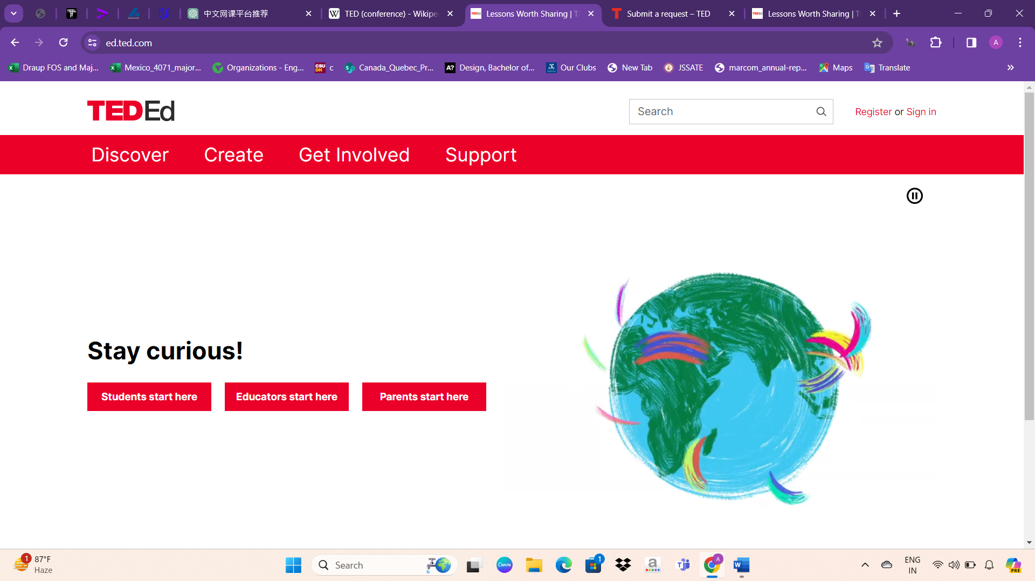

About UI design

The UI design of the website is minimalist, featuring only a navbar and a single div containing quotes and an animated image. This simplicity may contribute to a clean and focused user experience.

The navbar of the website includes the following options:

* Search
* Register or Sign in
* Discover
* Create
* Get Involved
* Support

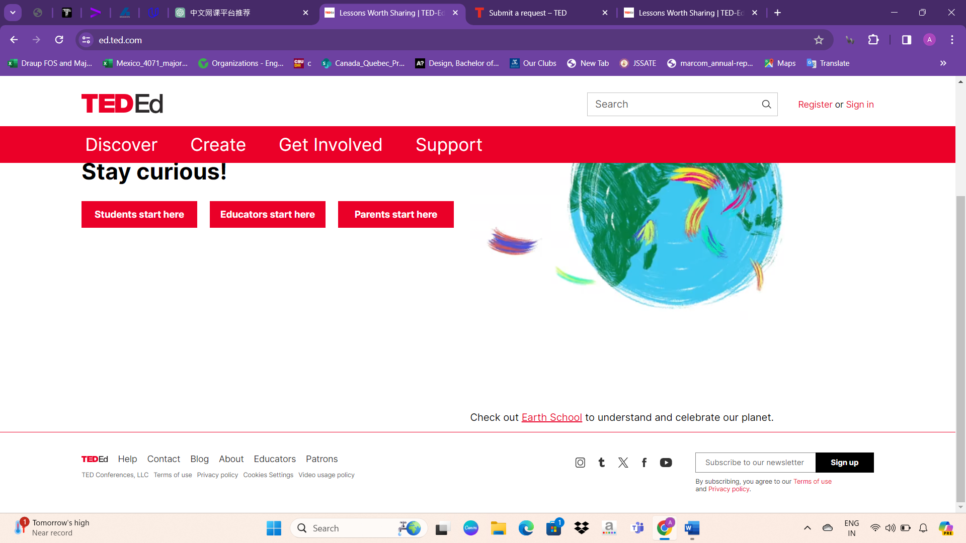

At the bottom of the website, you'll find a variety of navigation and informational options, including Help, Contact, Blog, About, Educators, Patrons, TED Conferences, LLC, Terms of use, Privacy policy, Cookies Settings, Video usage policy, and Subscribe to our newsletter. These links provide access to a range of resources and information, such as support, contact details, blog posts, TED-related information, resources for educators and patrons, legal documents like terms of use and privacy policy, cookie settings, video usage policy, and the option to subscribe to the newsletter.

Courses design

The "Discover" option on the website provides access to two main sections: "Lessons" and "Collections." In the "Lessons" section, users can watch video-based lessons categorized by subject and age, offering a diverse range of educational content tailored to different learning needs and age groups. Additionally, the "Collections" section offers curated compilations of video-based lessons grouped by thematic topics, allowing users to explore content that aligns with specific interests or areas of study. This user-friendly interface enables seamless navigation and discovery of educational resources, enriching the learning experience for users of all backgrounds and interests.

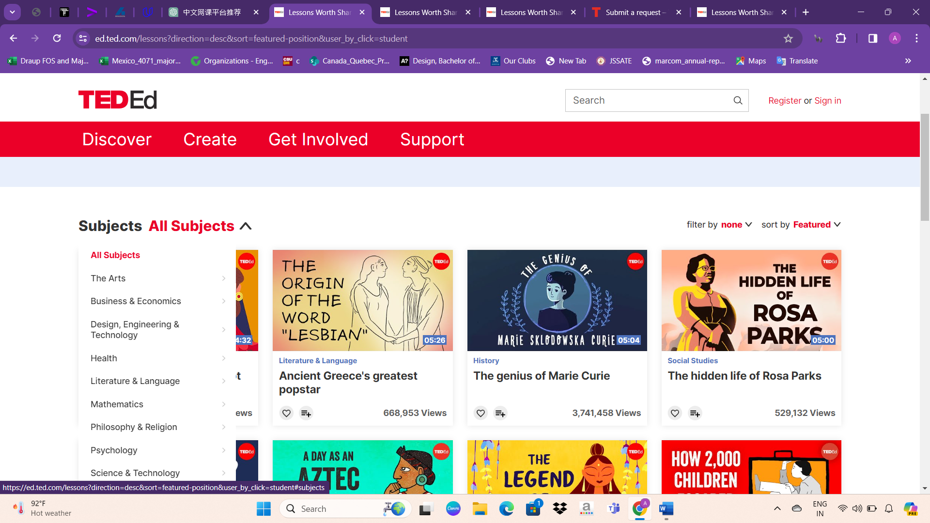

After entering the "Lessons" section, users are presented with a variety of subjects to choose from according to their specific educational needs. This feature allows users to select subjects that align with their interests or learning objectives, facilitating a personalized learning experience. By offering a diverse array of subjects, the platform caters to a wide range of interests and academic pursuits, ensuring that users can access relevant and engaging educational content tailored to their preferences.

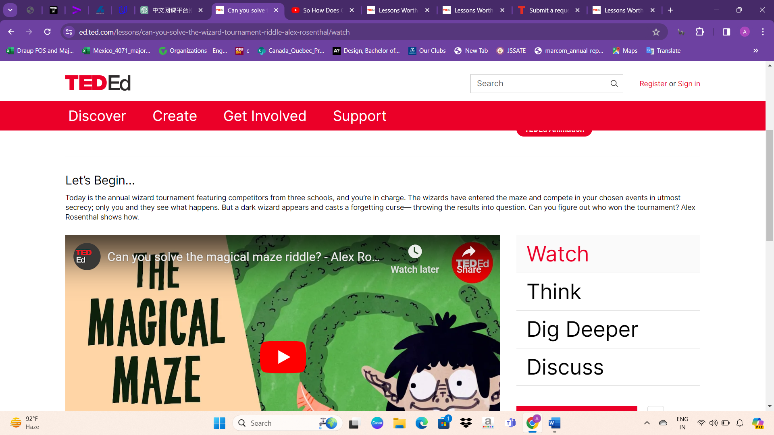

Upon entering a specific field, users can view the number of views for each course, along with the number of questions answered. Each course is accompanied by a short description providing an overview of the video content. Users can access the video course directly from the platform, enabling them to engage with the educational material seamlessly. This feature enhances user experience by offering comprehensive information about each course and facilitating easy access to the video content, ensuring a smooth and intuitive learning journey for users. 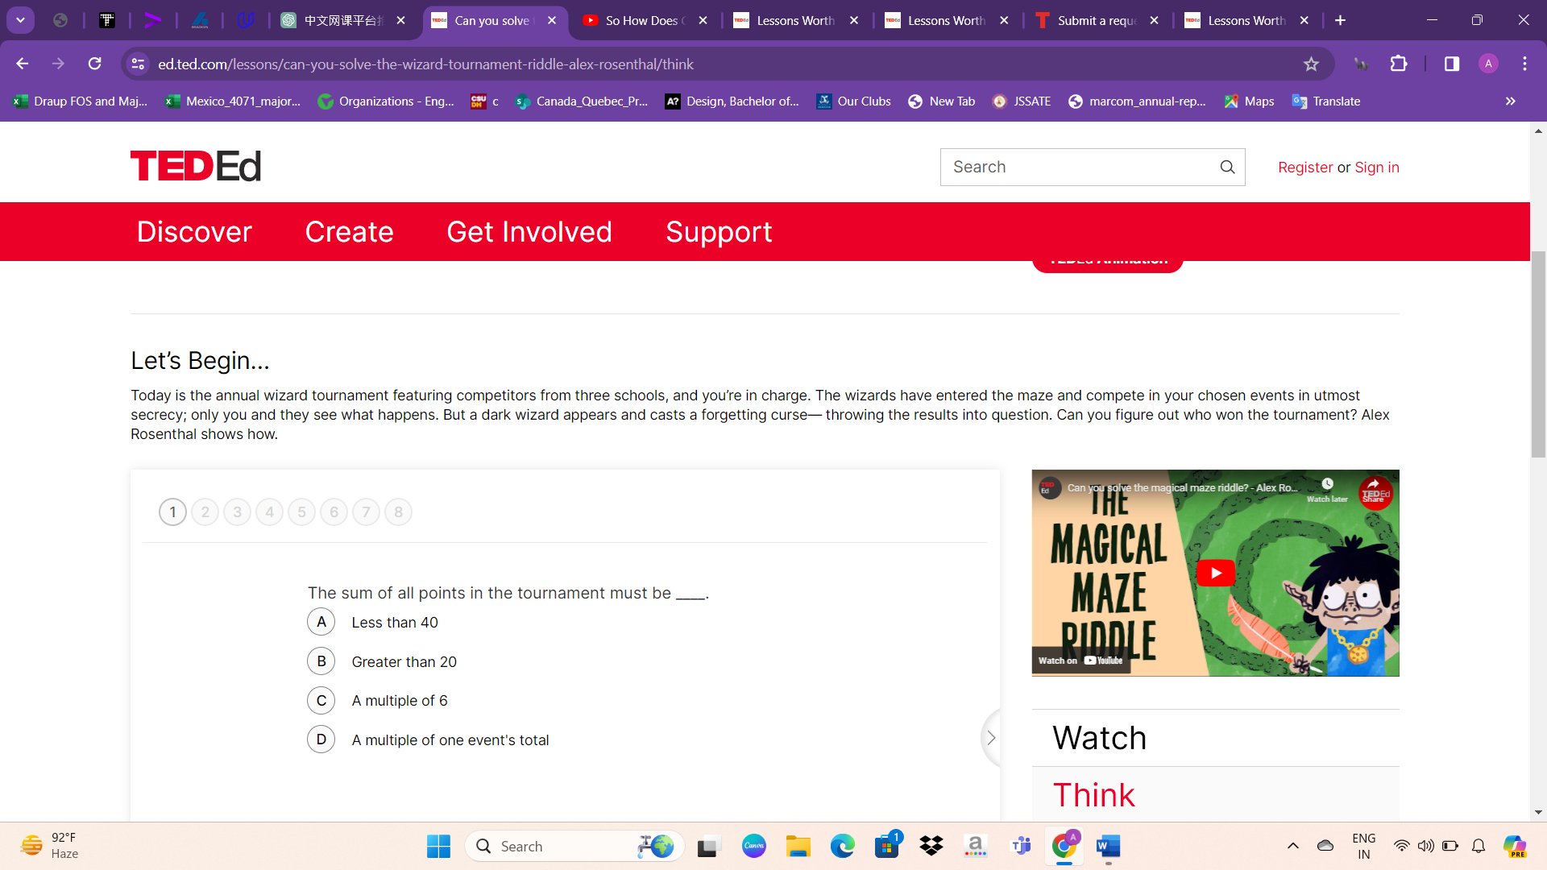

Near each video, users encounter options such as "Watch," "Think," "Dig Deeper," and "Discuss." Clicking on "Think" prompts users to engage with a question related to the content they've viewed, fostering critical thinking and reflection. These questions are tailored to the specific video content, encouraging users to deepen their understanding and apply concepts learned. By providing interactive elements, the platform encourages active participation and enhances the learning experience, promoting deeper engagement with the material presented in the videos.

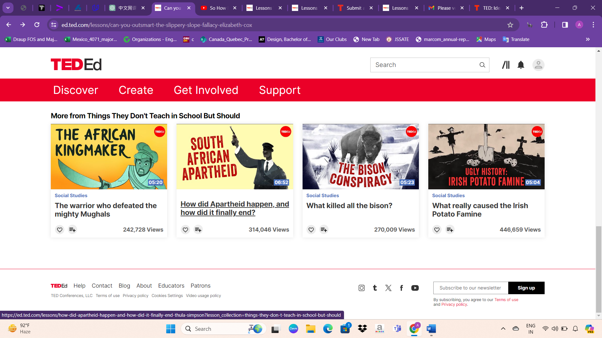

After engaging with the questions, users are presented with a selection of related videos below, allowing them to explore further content aligned with their interests or learning objectives. Each video is accompanied by its duration, view count, and other relevant details. Users have the option to add these videos to their liked videos list, facilitating easy access to content of interest for future reference or continued learning. This feature enhances user experience by providing curated recommendations and promoting continuous discovery and exploration of relevant educational material.

Privacy policy

TED prioritizes the privacy of its global community members across all its platforms, including TED.com, mobile apps, and related sites. This privacy policy outlines the information collected, its usage, and the protective measures implemented to safeguard personal data. By utilizing TED Sites, users consent to this policy. The information collected falls into three categories: personal information provided directly by users, data collected automatically (e.g., tracking information, IP addresses), and cookies to enhance user experience. Personal information encompasses account details, conference and event registrations, masterclass participation, subscriptions, donations, and research data provided voluntarily. TED ensures secure handling of payment information, maintaining only the last four digits of credit card numbers. Additionally, TED may conduct social science research, using data solely for research purposes and sharing it with trusted third parties for collaborative projects. Public activities on TED.com, including comments and recommendations, are visible to other users, while Mighty Networks community sites operate under their privacy policies. Non-personal data, such as viewing and participation patterns, and device information, are also collected to inform product development and audience demographics. This comprehensive approach to privacy underscores TED's commitment to safeguarding user data while fostering an inclusive and enriching online community.

TED is committed to protecting the privacy of children under the age of 13 by refraining from knowingly collecting their personal information without verifiable parental consent. In compliance with this commitment, any such information collected will be promptly deleted from our database upon discovery. Users who believe that we may have inadvertently collected information from a child under the age of 13 are encouraged to contact us at privacy@ted.com for resolution. Additionally, our privacy policy may be subject to periodic updates to reflect changes in our practices and to address new requirements or developments. These updates will be clearly communicated to users, and any material changes will be highlighted for a period of 30 to 60 days following the update. The most recent update to our privacy policy occurred on March 1, 2024, incorporating new details about TED's communication practices and subscriber newsletters.

TED Talks are meant to be shared and enjoyed by individuals for personal, non-commercial use, under the terms of the Creative Commons license CC BY-NC-ND 4.0 International. This means that you can share TED Talks on your blog or website, provided that you include proper attribution to TED as the owner of the talk and use the TED embeddable player. However, you cannot use TED Talks in any commercial context or modify them in any way. For commercial or corporate use, including employee learning, events, training materials, or media projects, a license is required through programs like TED@Work. Additionally, projecting TED Talks to groups, such as in classrooms or at conferences, may require a license depending on the context. If you're interested in using TED Talks for screening to groups or in media projects like documentaries or television, you can submit a media licensing request. TED also provides opportunities for translating talks through the official TED Translator community. For specific inquiries or unique requests regarding media usage, you can submit a licensing request through the TED Talks media licensing request form.

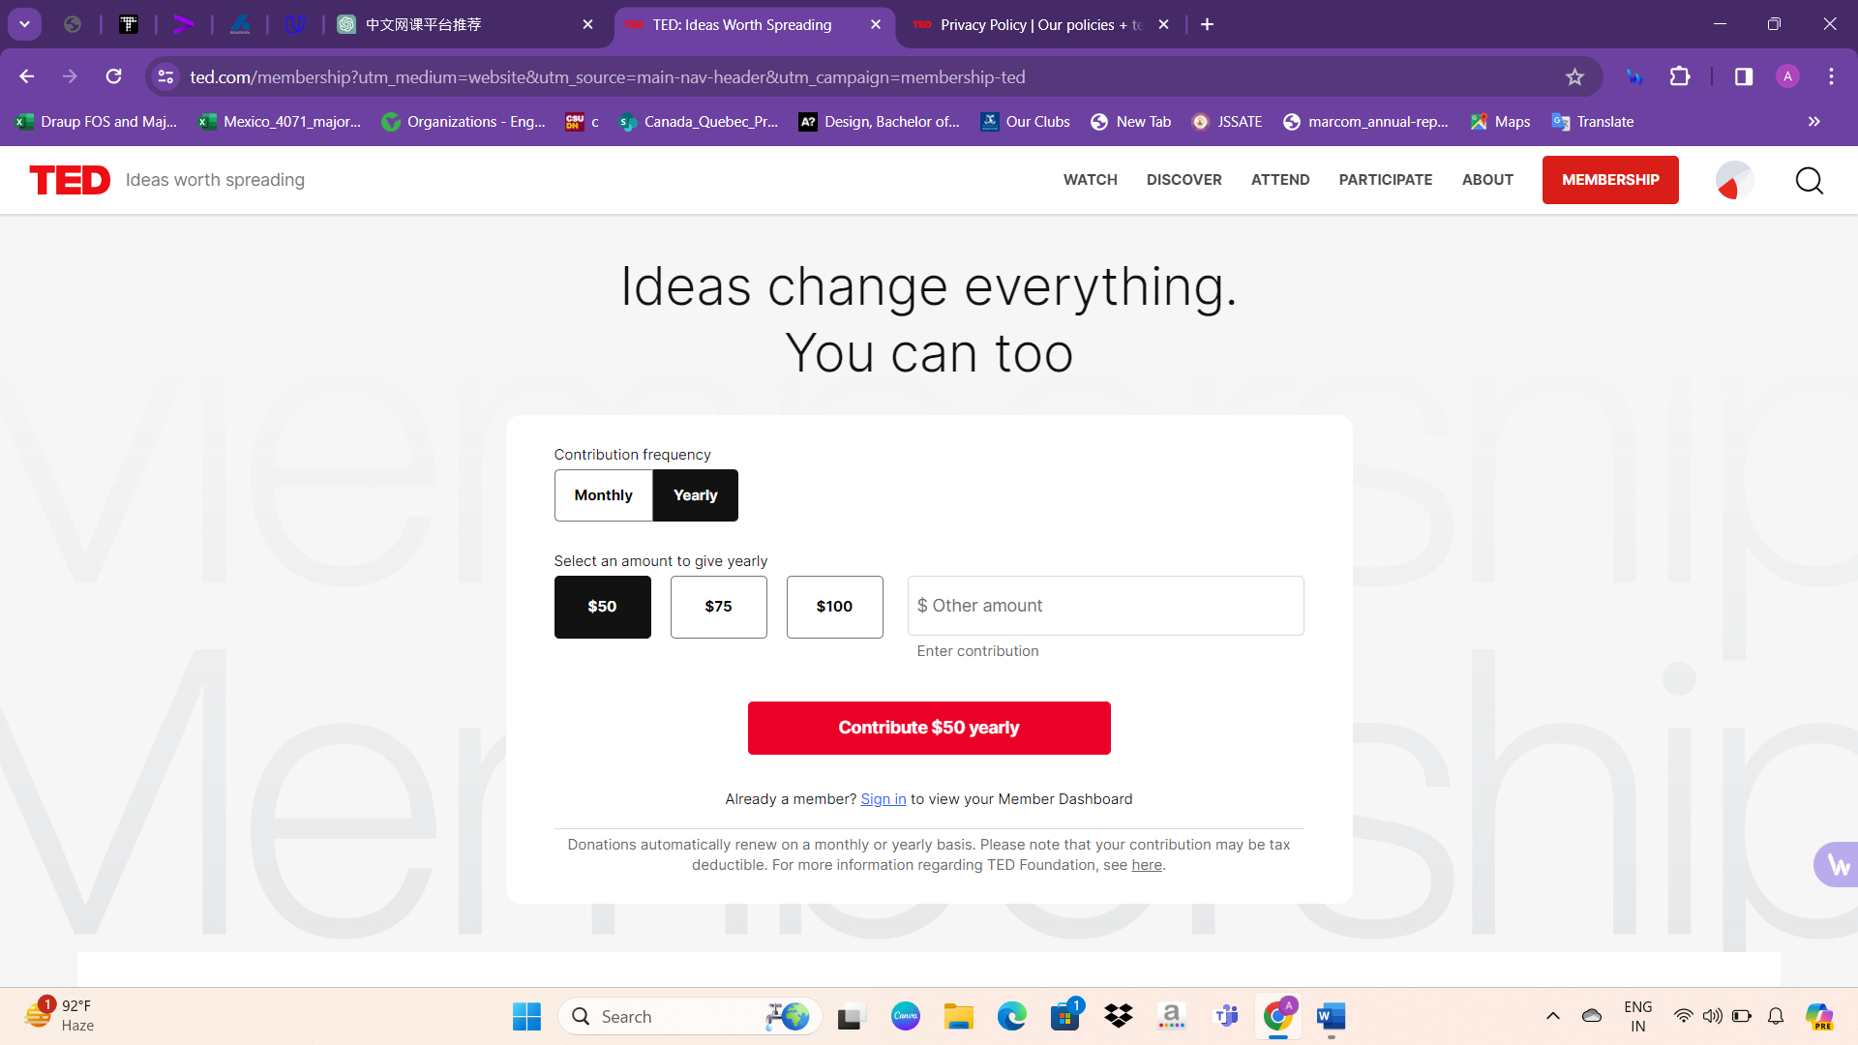

TED Membership offers a range of exclusive benefits designed to keep you engaged with groundbreaking ideas and discussions year-round. Gain access to virtual events featuring live Q&A sessions with renowned speakers, including past guests like Dr. Anthony Fauci, Susan Cain, Yuval Noah Harrari, and Daniel Pink. Stay informed with the TED Monthly Newsletter, providing in-depth insights into the work supported by TED Members. Enjoy ad-free thought-provoking content through the TED Talks Daily Podcast, hosted by journalist Elise Hu. With TED Membership, you'll have the opportunity to explore and engage with the most important conversations shaping our world today.

By proceeding with this transaction, agreed to donate the specified amount, which can be renewed monthly or yearly. Renewals can be canceled at any time through the settings tab of the member dashboard. Please note that donations are non-refundable, but if made in error or unauthorized, you can contact Customer Support for assistance. TED Foundation Inc. is a Section 501(c)(3) charitable organization, and all donations are considered tax-deductible on US income, subject to any limitations on deductibility. Membership benefits include access to programming and unique content, with no goods provided in exchange. This may involve access to a digital network powered by Mighty Networks, subject to their privacy policy. For more information on how your personal information is managed and communicated with you, please review TED’s Privacy Policy and Terms of Use. Additional state-required disclosures may apply.

Technologies used

TED's website utilizes a combination of technologies and services to deliver its content and functionality:

Content Management Systems:

- WordPress: Used for blog publishing and content management.

- Webflow: A hosted website building service.

- Gatsby: An open-source static website generator.

- Zendesk: Provides hosted customer service software.

Server-side Programming Languages:

- JavaScript

- PHP

- Ruby

- Static files for static websites

Client-side Programming Language:

- JavaScript

JavaScript Libraries:

- jQuery

- Modernizr

Web Servers:

- Node.js

- Nginx

- Cloudflare Server

Web Hosting Providers:

- Amazon

- Automattic (WordPress)

- Webflow

- Netlify

- Zendesk

Data Center Providers:

- Amazon

- Automattic

- Google

Reverse Proxy Services:

- Fastly

- Cloudflare

DNS Server Provider:

- Amazon

Email Server Providers:

- Gmail

- Zendesk

SSL Certificate Authorities:

- Sectigo (formerly Comodo CA)

- IdenTrust

- Let’s Encrypt

JavaScript Content Delivery Networks:

- CDNJS

- Google Hosted Libraries

- jsDelivr

Traffic Analysis Tools:

- New Relic

- Google Analytics

- Full Circle Studies

- Mixpanel

- Facebook Pixel

- WordPress Jetpack Stats

- Hotjar

- LinkedIn Insight Tag

- Parse.ly

Advertising Network:

- Google Ads

Tag Manager:

- Google Tag Manager

Social Widget:

- AddThis

Site Elements:

- External, Embedded, and Inline Cascading Style Sheets (CSS)

- Persistent cookies

- Gzip and Brotli compression

- Strong and weak ETags

- Support for IPv6

- HTTP/2

- HTTP Strict Transport Security (HSTS)

- Redirection to www subdomain

- SSL encryption

- Structured Data Formats: Open Graph, Twitter Cards, Generic RDFa

- Markup Language: HTML5

- Character Encoding: UTF-8

- Image File Formats: SVG, PNG, JPEG, WebP

Top Level Domain: .com

Server Locations: United States, Germany, Ireland

Content Language: English

Overview about CreativeLive

At CreativeLive, a profound belief resides in the innate creativity harbored within every individual. Throughout history, humanity has harnessed creativity to surmount challenges, actualize aspirations, and convey our unique identities. Creativity serves as more than just a skill—it's a unifying force that imbues hope, fosters innovation, and shapes our world.

The mission at CreativeLive centers on ensuring equal access to quality education for all. There exists a firm conviction that education serves as the cornerstone for breaking down barriers, facilitating growth, and fostering collaboration. Regardless of background or circumstance, the aim is to empower individuals to pursue their creative passions and effect positive change.

As a collective of innovators, doers, and hustlers, the significance of community and support throughout the creative journey is recognized. Whether in moments of triumph or adversity, the community stands in solidarity, championing each other's voices and uplifting one another's spirits.

The steadfast belief is that success is attainable for all, contingent upon dedication, resilience, and a willingness to step beyond comfort zones. Through customized content and independent exploration, students are encouraged to embrace their unique paths and strive for excellence in their creative pursuits.

The story originates in 2009 when Chase Jarvis and Craig Swanson embarked on a mission to revolutionize education by granting access to visionary leaders and professionals. Since then, CreativeLive has blossomed into a platform boasting over 1500 carefully curated classes taught by 650+ esteemed instructors, with a community comprising over 10 million students worldwide.

About websites UI design

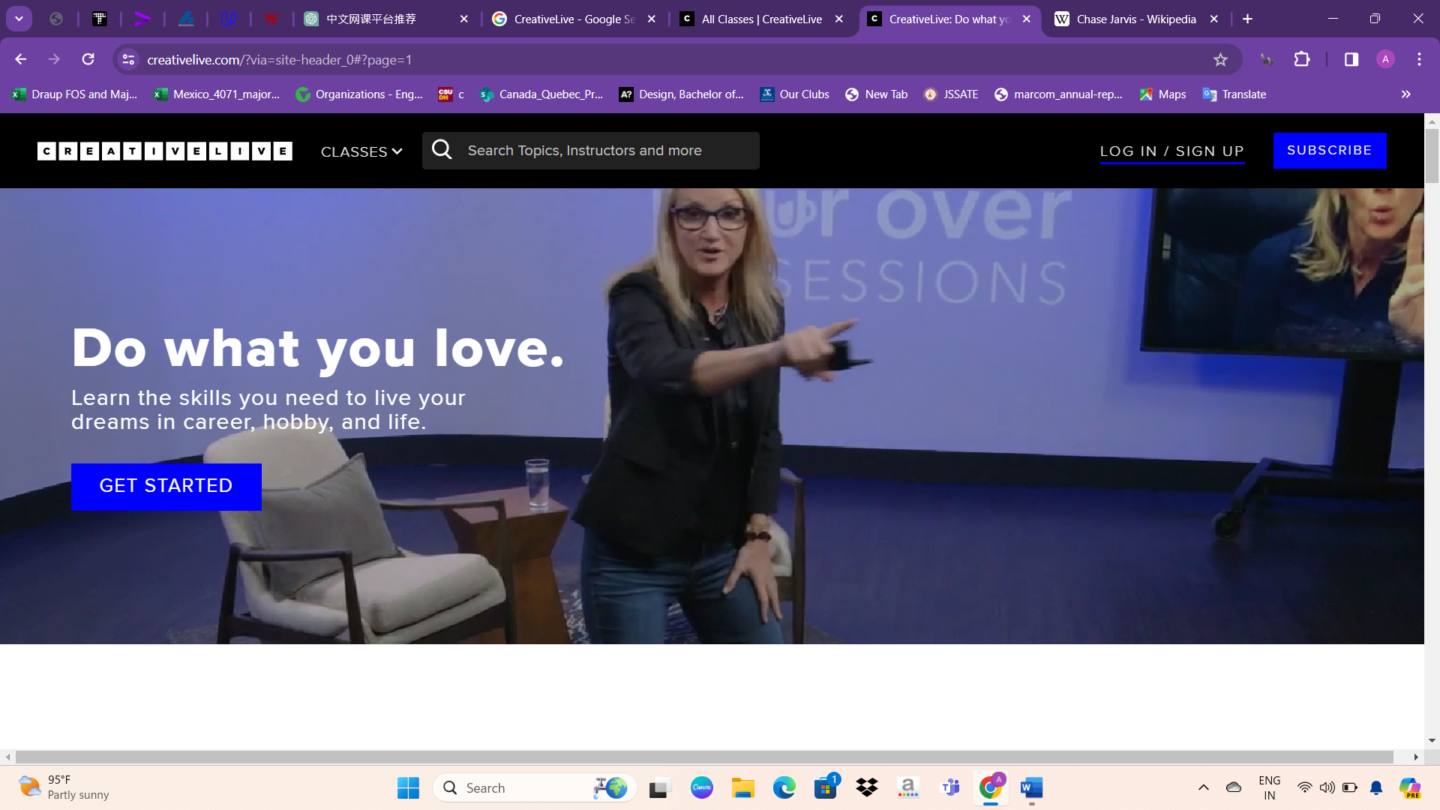

* The website features a well-designed navigation bar with intuitive options for users to explore. These options include:
* CLASSES: This tab directs users to a comprehensive list of available classes, covering a diverse range of topics and disciplines.
* Search Topic: Users can easily search for specific topics of interest, allowing for efficient navigation and discovery of relevant content.
* Log In: This option enables registered users to access their accounts by logging in with their credentials.
* Sign Up: New users can register for an account by signing up, gaining access to the website's full range of features and resources.
* Subscribe Option: Users have the opportunity to subscribe to the website, potentially receiving updates, newsletters, or other exclusive content.
* Overall, the streamlined design and functionality of the navbar enhance the user experience, facilitating seamless navigation and engagement with the website's offerings.

Following the navigation bar, the website features a visually captivating background video within the next section. This dynamic element adds depth and engagement to the site, setting the tone for an immersive user experience. Complementing the video are compelling quotes strategically placed throughout the page. These quotes serve to inspire and motivate visitors, creating a sense of intrigue and curiosity while enriching the overall aesthetic appeal of the website. Together, the combination of the background video and impactful quotes enhances the website's visual appeal, leaving a lasting impression on users.

In the next section of the website, alongside the background video, there are impactful quotes that encourage visitors to subscribe. These quotes are strategically placed to capture the attention of users and convey the value of subscribing to the website's content. Additionally, there is an accompanying image on the side, which complements the quotes and adds visual interest to the section. The image may feature relevant visuals that resonate with the website's theme or content, further enhancing the overall appeal and effectiveness of the subscription call-to-action.

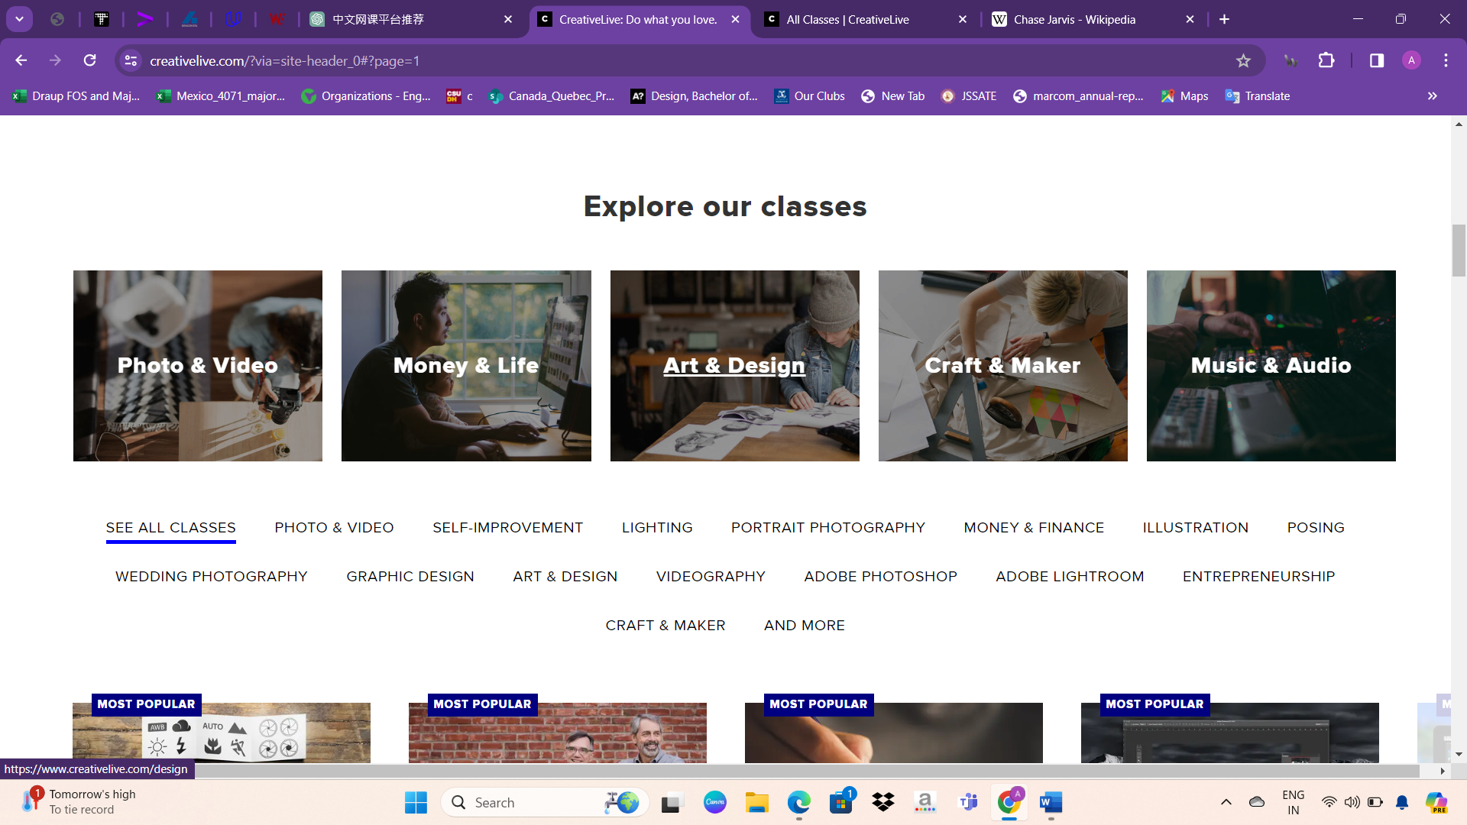

In the subsequent section, titled "Explore Our Classes," various types of classes are showcased along with corresponding images. When a user clicks on one of these classes, it expands to a larger size, creating an engaging animation-like effect. This interactive feature allows visitors to preview the content of each class more closely and encourages them to explore further. By incorporating dynamic elements like this, the website provides a visually appealing and interactive experience for users, enhancing engagement and usability.

Upon selecting a class, the website displays course videos related to that specific lesson. This feature enables users to access the video content directly within the context of the class they're interested in. By organizing course videos in this manner, the website facilitates seamless navigation and ensures that users can easily find and consume the content they're looking for. This approach enhances the user experience by providing relevant video content within the appropriate course context, making it convenient for learners to engage with the material.

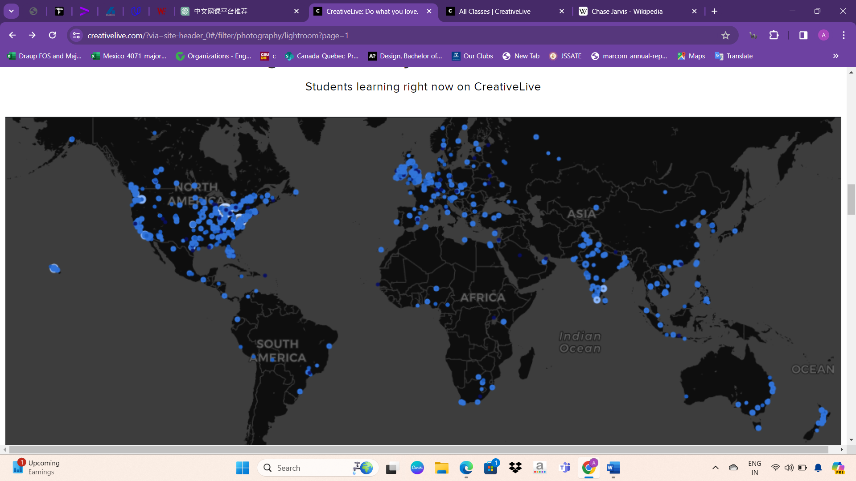

Following the course videos section, there is another search bar option accompanied by an image that highlights the community aspect of the platform. The image showcases the diverse community of over 10 million creators engaged in learning on CreativeLive. Below the image, there are quotes from industry icons emphasizing the platform's significance in the creative industry. Additionally, recent student stories and blog articles are featured to provide users with insights, inspiration, and valuable resources related to their creative journey. These elements contribute to fostering a sense of belonging, inspiration, and continuous learning within the CreativeLive community.

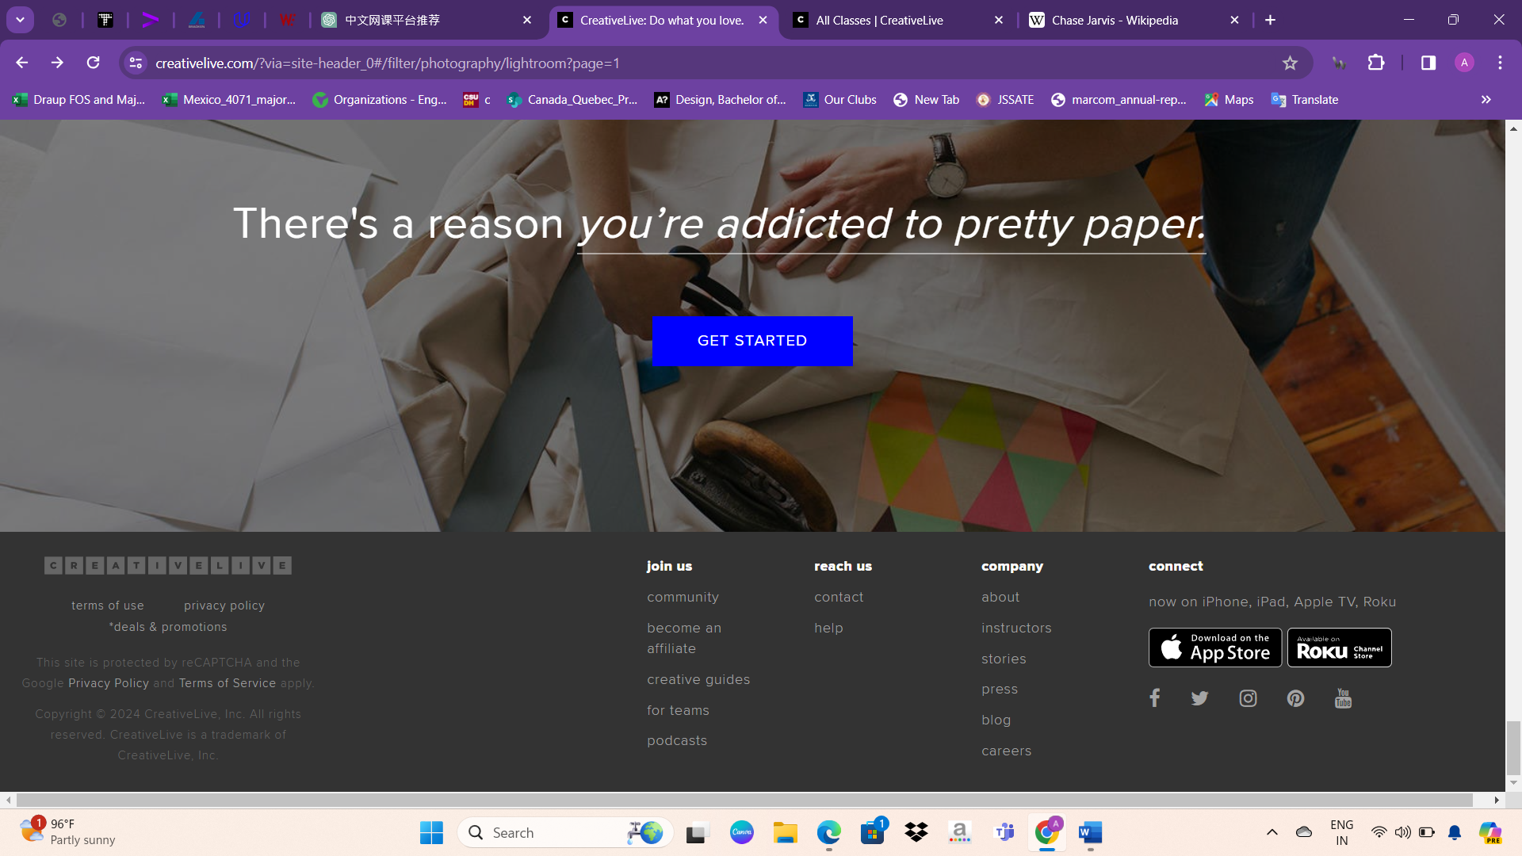

At the bottom of the website, there are various options and links provided:

- Join Us

- Community

- Become an Affiliate

- Creative Guides

- For Teams

- Podcasts

- Reach Us

- Contact

- Help

- Company

- About

- Instructors

- Stories

- Press

- Blog

- Careers

These links offer users access to different sections of the website, including information about the company, its instructors, stories, press releases, blog posts, and career opportunities. Additionally, users can reach out for assistance, join the community, explore podcasts, or become affiliates. These options aim to provide users with comprehensive access to resources and support related to their creative endeavors.

Course Available

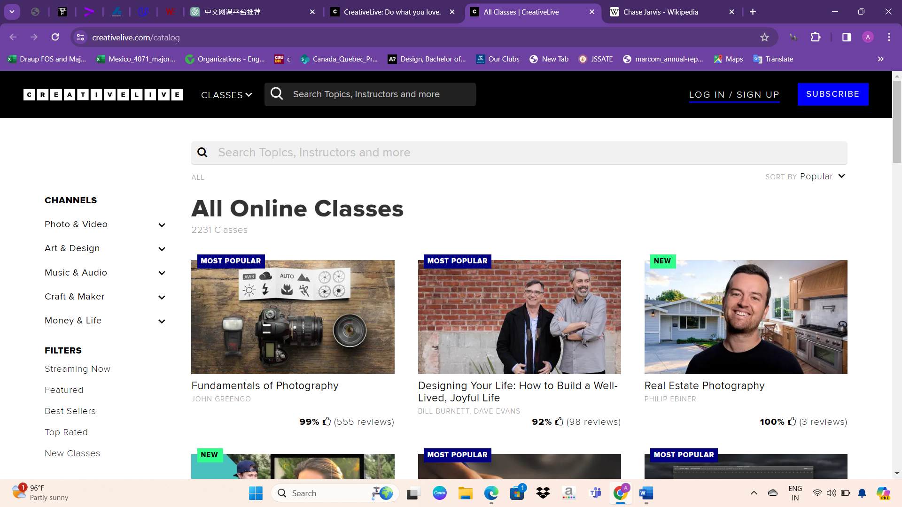

Under the "Channels" section, users can explore various categories of content, including:

- Photo & Video

- Art & Design

- Music & Audio

- Craft & Maker

- Money & Life

In the "Filters" section, users can refine their search based on different criteria:

- Streaming Now

- Featured

- Best Sellers

- Top Rated

- New Classes

Lastly, users can access different collections of content, such as:

- Bundle & Save

- Conferences

- Interviews

- Learning Paths

These filters and collections provide users with options to navigate through the available content more efficiently and find classes or resources that suit their interests and needs.

Users have the option to select filters based on their preferences, such as streaming status, popularity, or content type. They can also choose a specific channel, like Photo & Video or Art & Design, to browse through a variety of courses within that category. Once they've selected their filters and channel, the website displays a range of courses that match their criteria, allowing users to choose the one that best fits their interests or learning goals.

User selects a course, they are directed to the course page where they can find detailed information about the selected course.

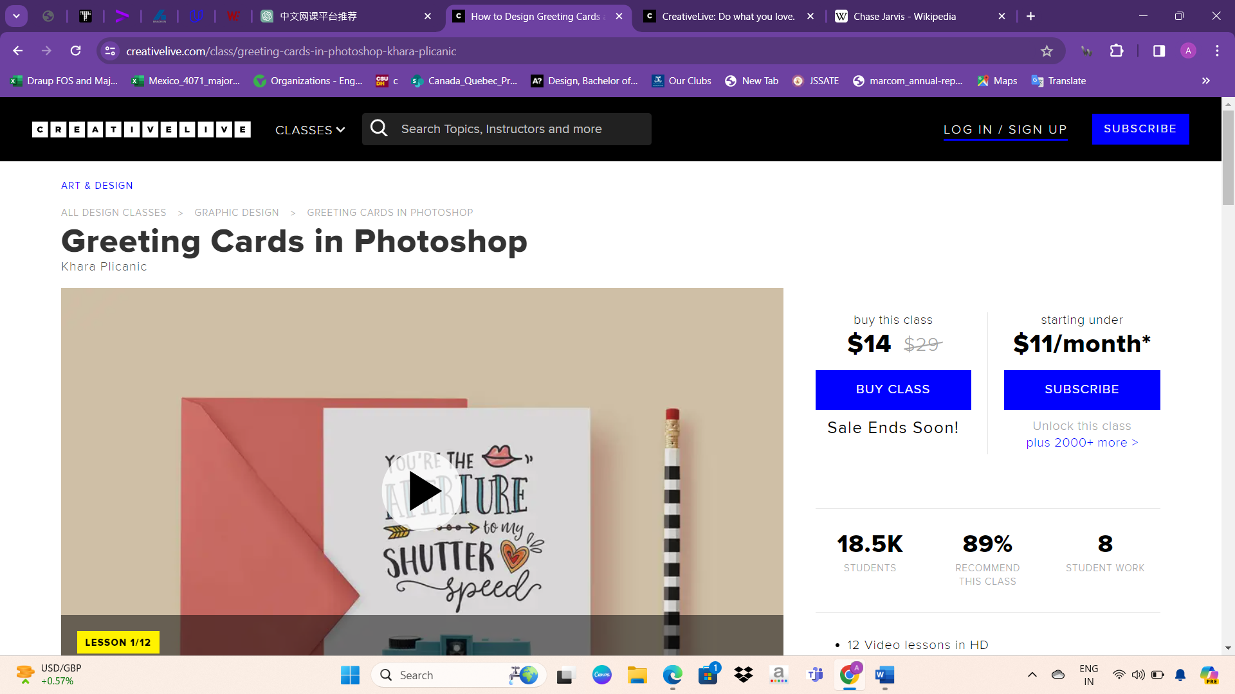

After selecting a course, users are presented with details such as:

1. Course Name: The title of the selected course.

2. Course Cost: The price of enrolling in the course.

3. Enrollment Options: Buttons or links for purchasing the course or subscribing to a membership that includes access to multiple courses.

4. Number of Students: The total number of students who have enrolled in the course.

5. Course Duration: The estimated duration of the course.

6. Course Format: Information about whether the course is self-paced or scheduled.

7. Course Description: A more detailed overview of the course content and objectives.

8. Instructor Information: Details about the instructor(s) who teach the course, including their credentials and expertise.

9. Course Curriculum: A breakdown of the topics covered in the course, often organized into lessons or modules.

10. Reviews and Ratings: Feedback from other students who have taken the course, along with ratings based on their experiences.

11. Prerequisites: Any requirements or recommended skills needed before enrolling in the course.

Users can review this information to make an informed decision about enrolling in the course or exploring other options.

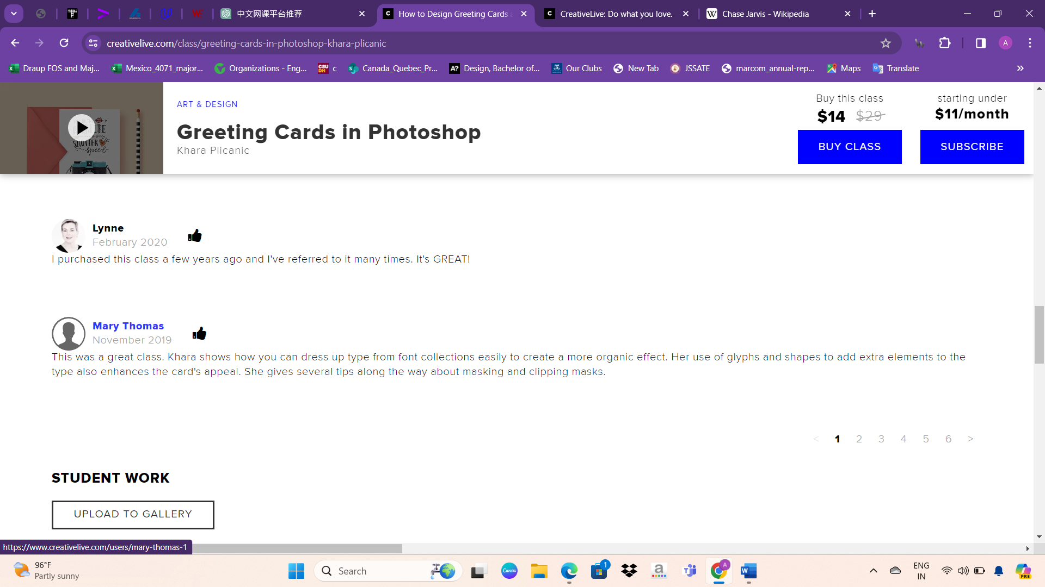

* Below the course details, there is a chat section where students can discuss various aspects of the course and related classes. In this chat section:
* Students can ask questions: Users can post questions about the course content, assignments, or any other related topics.
* Instructors and peers can provide answers: Both instructors and fellow students can respond to questions posted in the chat, offering explanations, advice, and support.
* Discussion on course material: Students can engage in discussions about specific topics covered in the course, sharing their insights, experiences, and tips with others.
* Exchange of ideas and feedback: The chat facilitates the exchange of ideas and feedback among students, allowing them to learn from each other and enhance their understanding of the course material.
* Networking opportunities: The chat provides a platform for students to connect with each other, build relationships, and potentially collaborate on projects or future learning endeavors.
* Overall, the chat section fosters a sense of community among students enrolled in the course, creating an interactive and collaborative learning environment.

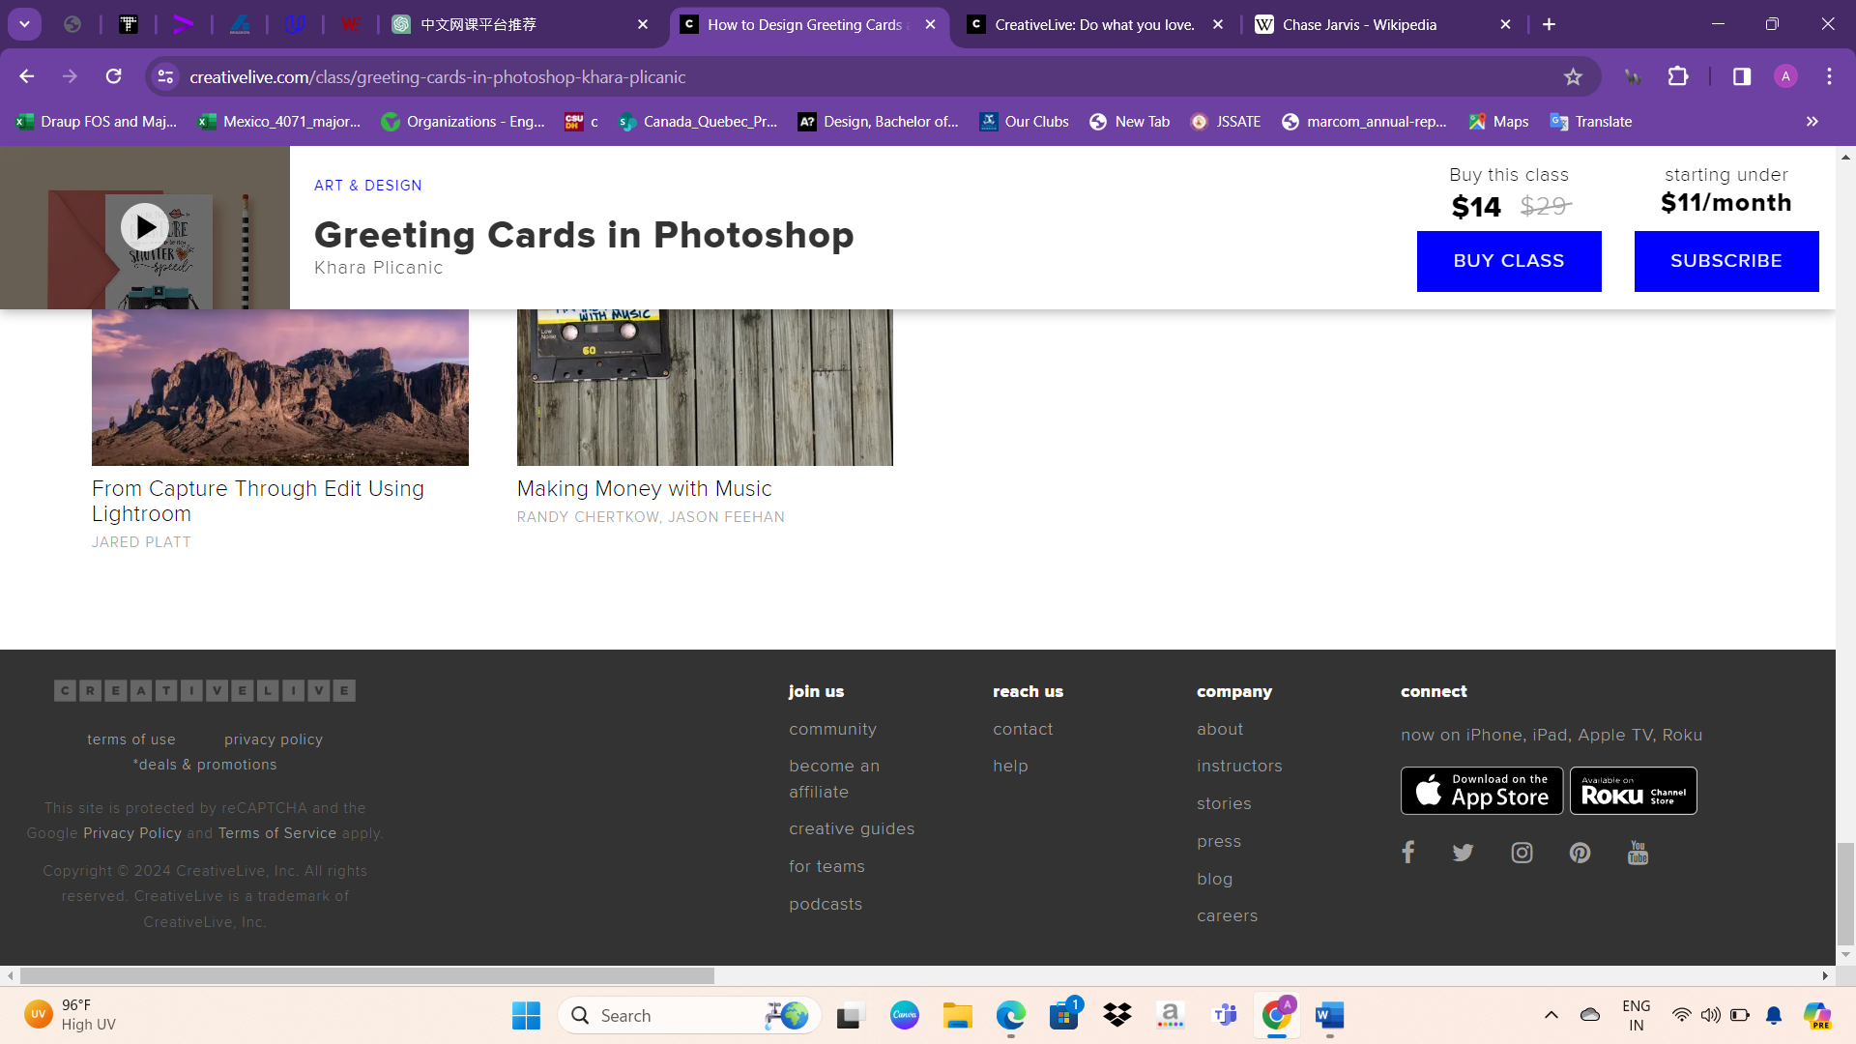

The "Buy Class" and "Subscribe" options in the navigation bar have a fixed style, ensuring they remain visible to users as they navigate through the website. This design choice serves to remind users of the available purchase options and encourages them to consider enrolling in courses or subscribing to the platform's services. By maintaining a prominent position in the navigation bar, these options are easily accessible, allowing users to make purchasing decisions conveniently as they explore the site's content.

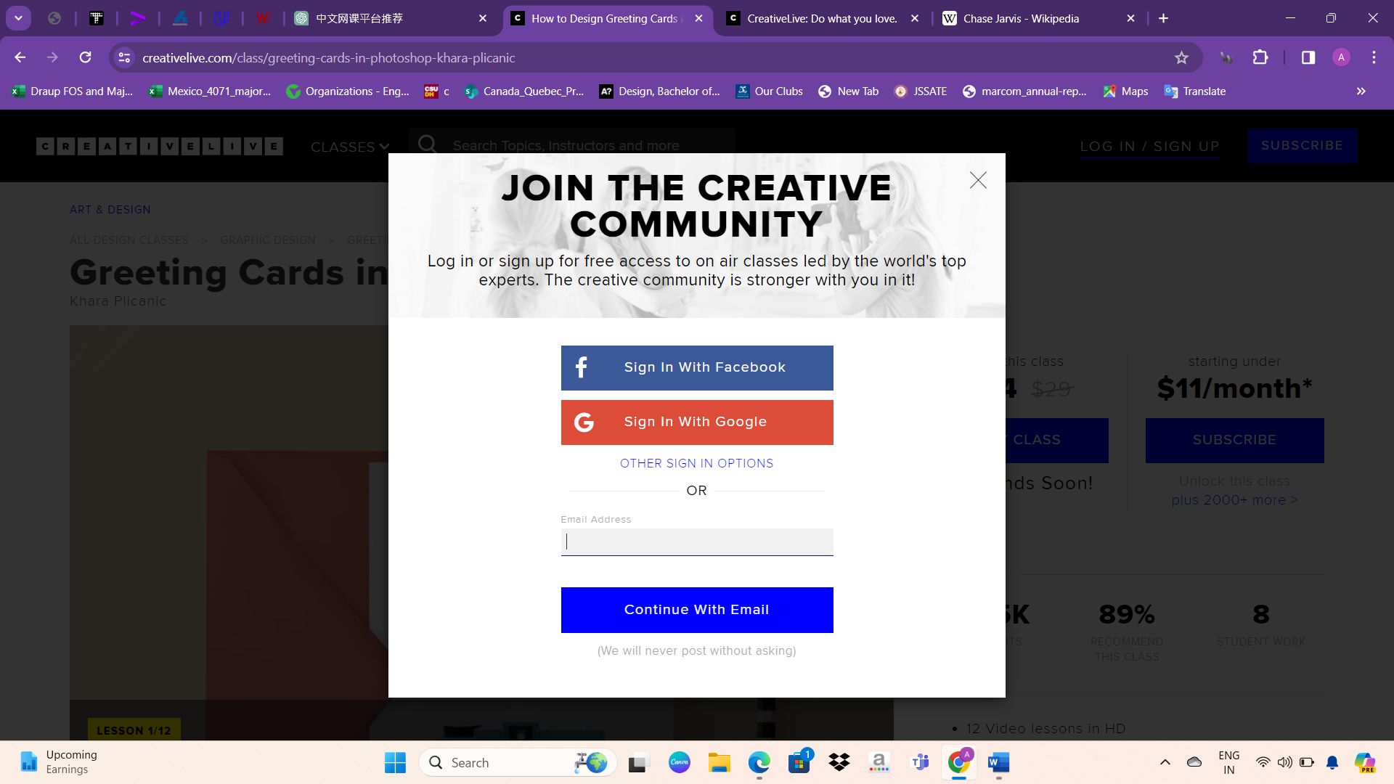

While browsing the website, a pop-up box suddenly appears, prompting users to sign in. This encourages users to create an account or sign in to their existing account on the website. This approach aims to enhance user engagement and personalization by allowing users to access exclusive features, save their progress, and receive personalized recommendations tailored to their interests. Additionally, signing in enables the website to provide a seamless and customized user experience across different devices and sessions.

Overall, the website is highly interactive and user-friendly, offering a visually appealing experience with the use of animations, background videos, and vibrant colors. The website strikes a balance in terms of size, neither being too overwhelming nor too minimalistic. Incorporating more animation effects and background videos enhances the visual appeal and engagement for users. The rich colors add depth and vibrancy to the design, making it visually stimulating. Overall, the website effectively combines aesthetics with functionality to create an engaging user experience.

Some potential disadvantages of the website include limited coverage of topics beyond arts-related subjects, such as science or technology. Additionally, requiring users to log in before accessing course content may deter some potential learners who prefer to browse freely before committing. Furthermore, the absence of course previews may make it challenging for users to assess whether a course aligns with their interests and learning objectives before making a purchase or subscription. Offering previews or free trials could potentially improve user engagement and encourage more sign-ups.

Privacy Policy

This Privacy Policy outlines how CreativeLive, Inc. collects, uses, stores, discloses, and processes Personal Information through its services, including online educational programs, websites, and related applications. References to "we," "us," and "our" refer to CreativeLive, Inc.

* Exclusions: This Privacy Policy does not apply to Personal Information collected by third parties through the service, such as third-party websites linked within the service.
* Children: Users must be 18 years or older to use the service, and CreativeLive does not knowingly collect Personal Information from individuals under 18 years of age.
* Personal Information Collected: CreativeLive collects various types of Personal Information, including identifiers, commercial information, internet or network activity, protected classification characteristics, geolocation data, sensory data, and other categories of personal information as described in California or federal law.
* Sources of Personal Information: Personal Information may be collected directly from users, automatically through the service, or from third parties such as social media platforms.
* Cookies and Similar Technologies: CreativeLive uses cookies and similar technologies for essential functions, analytics, and marketing purposes. Users can manage cookie preferences through their browser settings.
* 6. Purposes of Collection: We collect Personal Information to provide, improve, administer, and market the Service, as well as to further legal, health, and safety objectives. Additionally, Personal Information may be used in connection with the sale or transfer of our business, and for purposes disclosed at the time of collection.
* 7. Disclosure of Personal Information: We may disclose Personal Information to third-party service providers for business purposes and to others in certain circumstances, such as to affiliates, legal entities, or in response to legal requests.
* 8. Protective Measures: We retain Personal Information for specific purposes, implement security measures, and encourage users to protect their own information. Users have rights regarding access, correction, deletion, and restriction of their Personal Information.
* 9. Your Preferences and Options: Users can modify their account information, opt-out of marketing communications, request deletion of their Personal Information, and withdraw consent. Additional options are available for EU and California residents.
* 10. Additional Notice for EU Residents: This section provides information specific to users in the European Union regarding the processing, transfer, and lawful basis of Personal Information, as well as rights related to access, correction, deletion, and withdrawal of consent.
* 11. Additional Notice for California Residents: California residents have rights regarding the disclosure, deletion, and non-discrimination of their Personal Information under the California Consumer Privacy Act (CCPA). Procedures for exercising these rights are outlined.
* 12. Changes: The Privacy Policy may be amended, and any changes will be posted on the Service. Users are encouraged to review the Privacy Policy periodically.
* 13. Contact: Users can contact CreativeLive with questions or comments about the Privacy Policy via email or mail.

Technologies used

Based on the provided information, here's an overview of the website's background, technology stack, and various components:

Website Background:

- CreativeLive: An online platform offering classes in photography, art, design, marketing, business, and entrepreneurship.

- Popularity Rank: Top 100k among all websites.

Website Quality Alerts:

- No title defined for the web page on the support page.

- Webmasters can register as users to receive quality alerts via email.

Technology Stack:

- Content Management System: WordPress (version 6.4.3)

- Server-side Programming Languages: PHP (used on inner pages), Java (used on a subdomain)

- Client-side Programming Language: JavaScript

- JavaScript Libraries: jQuery 3.6.0 (used on inner pages), React (used on a subdomain)

- Web Server: Apache (used on inner pages)

Hosting and Data Centers:

- Web Hosting Providers: Amazon and Zoho (used on a subdomain)

- Data Center Providers: Amazon and Zoho (used on a subdomain)

Security Measures:

- SSL Certificate Authorities: Let’s Encrypt, IdenTrust (used until recently)

- Cookies: Session cookies, HttpOnly cookies (used on a subdomain), Non-HttpOnly cookies, Secure cookies (all used on inner pages)

- Security Protocols: Gzip Compression, Strong ETag (used on inner pages), HTTP Strict Transport Security (HSTS)

Analytics and Tracking:

- Traffic Analysis Tools: Google Analytics, New Relic, Facebook Pixel (used until recently), Microsoft UET (used until recently)

- Advertising Networks: Amazon Associates, Google Ads (used until recently)

- Tag Manager: Google Tag Manager

Social Integration:

- Social Widgets: Facebook, Twitter, Pinterest

Structured Data Formats:

- Open Graph Protocol, Twitter Cards, Generic RDFa, JSON-LD (used on inner pages)

Markup and Encoding:

- Markup Language: HTML5

- Character Encoding: UTF-8

mage Formats:

- PNG, SVG, JPEG (used on inner pages)

Domain and Server Location:

- Top Level Domain: .com (Commercial entities)

- Server Location: United States

This overview provides insights into the website's technology stack, security measures, analytics integration, and more.

Overview about Sitepoint

SitePoint, headquartered in Melbourne, Australia, is a prominent player in the publishing industry, founded by Matt Mickiewicz and Mark Harbottle. Serving a global audience, SitePoint offers a comprehensive range of products including books, courses, and websites, catering to the needs of web professionals. With subsidiaries like Flippa, a platform for trading websites and online businesses, and Learnable, providing online courses in web development and design, SitePoint continues to be a valuable resource for developers, designers, and entrepreneurs worldwide.

Founded in 1999 by Matt Mickiewicz and Mark Harbottle, SitePoint originated from Mickiewicz's internet forum, Webmaster-Resources.com, initially serving as a resource hub for novice web developers. After the Dot-com bubble burst in 2000, the company shifted its focus to publishing, releasing its first book, "Build Your Own Database Driven Website Using PHP and MySQL," in November of the same year, which quickly gained popularity. By 2004, SitePoint had published six books and expanded its distribution through O'Reilly. The launch of SitePoint Marketplace in 2005 provided a platform for web designers and developers to outsource projects, eventually leading to the spinoff of 99designs in 2007. In 2009, Flippa was introduced as a dedicated marketplace for buying and selling websites and domain names. In 2010, Learnable was launched as an online learning platform for web developers, which later evolved into SitePoint Premium, offering access to a comprehensive library of resources. Despite changes in its offerings and structure, SitePoint remains a prominent figure in the web development and publishing industry.

Websites UI design

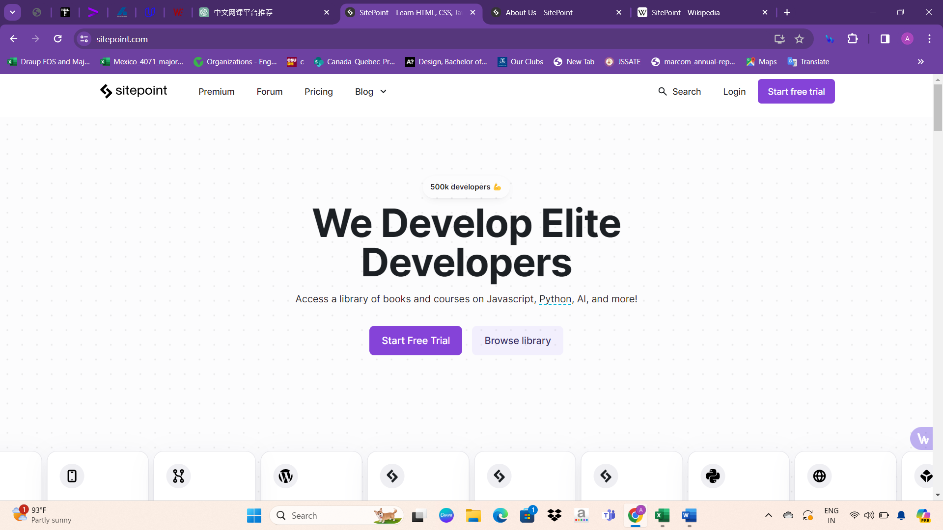

At the navbar, SitePoint offers a range of options including Premium, Forum, Pricing, and Blog, catering to diverse user needs and interests. Additionally, users can utilize the search function to find specific content or topics of interest. For those looking to access additional features or resources, options to login or start a free trial are readily available, providing easy navigation and accessibility to SitePoint's offerings.

Following the navigation options, a prominent div showcases inspiring quotes about web development, capturing the essence of SitePoint's mission. Positioned at the center of this div is a compelling call-to-action button encouraging users to "Start Free Trial," enticing them to explore SitePoint's offerings with no initial commitment. This strategic placement aims to prompt user engagement and potentially lead to conversion, while also offering a seamless transition for those ready to subscribe and access premium content or services.

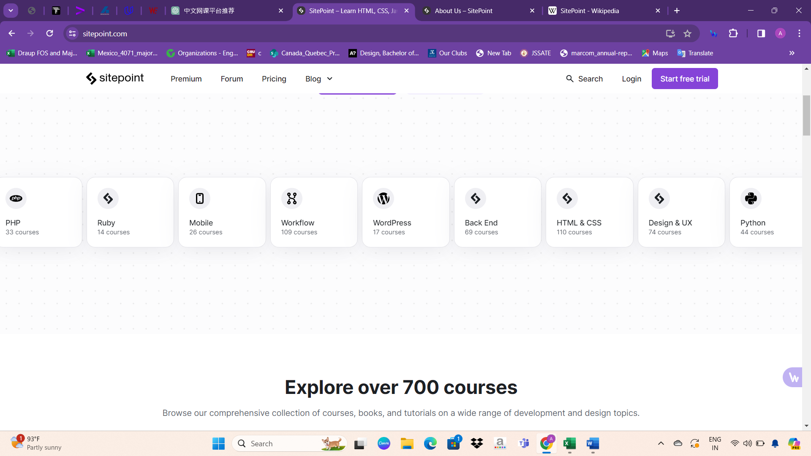

The dynamic box positioned prominently on the page scrolls through a captivating array of course topics meticulously curated by SitePoint, showcasing the platform's rich educational offerings. Each topic is accompanied by a visual representation and the count of available courses, dynamically updating to reflect the breadth and depth of content available. This dynamic presentation not only captures the user's attention but also provides a compelling glimpse into the platform's extensive resources in areas such as JavaScript, PHP, Ruby, Mobile development, Workflow optimization, WordPress, Back End technologies, HTML & CSS, Design & UX, Python, Web development, Blockchain, Cloud & DevOps, and beyond. By offering such a comprehensive overview, SitePoint effectively caters to diverse user interests and professional requirements, empowering users to navigate through the vast array of courses with ease and confidence. This engaging feature not only enhances user experience but also encourages exploration and discovery, fostering a dynamic and interactive learning environment tailored to each user's needs and aspirations.

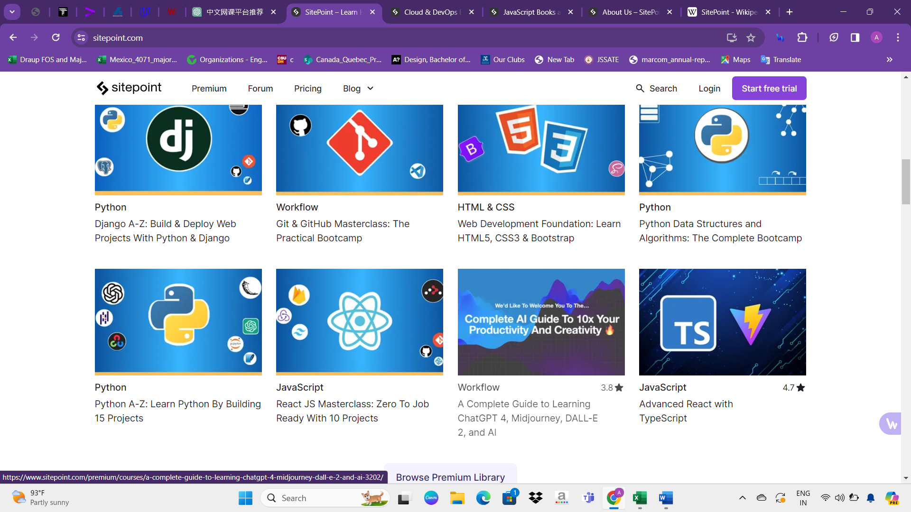

After the dynamic box displaying course topics, another section highlights the breadth of SitePoint's offerings, showcasing over 700 courses available on the platform. Users are encouraged to explore this comprehensive collection, which includes courses, books, and tutorials covering a wide array of development and design topics. This presentation aims to entice users with the wealth of educational resources available, catering to individuals seeking to enhance their skills or knowledge in various aspects of web development and design.x

In this section, users are presented with a list of topics covering a broad spectrum of web development and design. The topics include JavaScript, PHP, Ruby, Mobile, Workflow, WordPress, Back End, HTML & CSS, Design & UX, Python, Web, Blockchain, and Cloud & DevOps. Each topic serves as a gateway to explore relevant courses and resources tailored to the specific area of interest, enabling users to delve deeper into their preferred subjects and acquire relevant skills and knowledge.

Continuing from the dynamic box highlighting various course topics, the SitePoint website presents an extensive array of courses available in diverse formats to cater to varying learning preferences and skill levels. Whether users prefer self-paced tutorials, interactive video lessons, or comprehensive written guides, SitePoint offers a versatile selection of courses designed to accommodate different learning styles. From beginner-friendly introductions to advanced masterclasses, the platform covers a wide spectrum of topics ranging from programming languages like JavaScript, Python, and Ruby to design principles, UX/UI concepts, and emerging technologies like Blockchain and Cloud computing. Each course is meticulously crafted by industry experts and instructors, ensuring high-quality content and practical insights that empower learners to enhance their skills and achieve their learning goals effectively. With flexible learning options and a wealth of educational resources, SitePoint remains a trusted destination for individuals and professionals seeking to stay ahead in the rapidly evolving fields of web development, design, and technology.

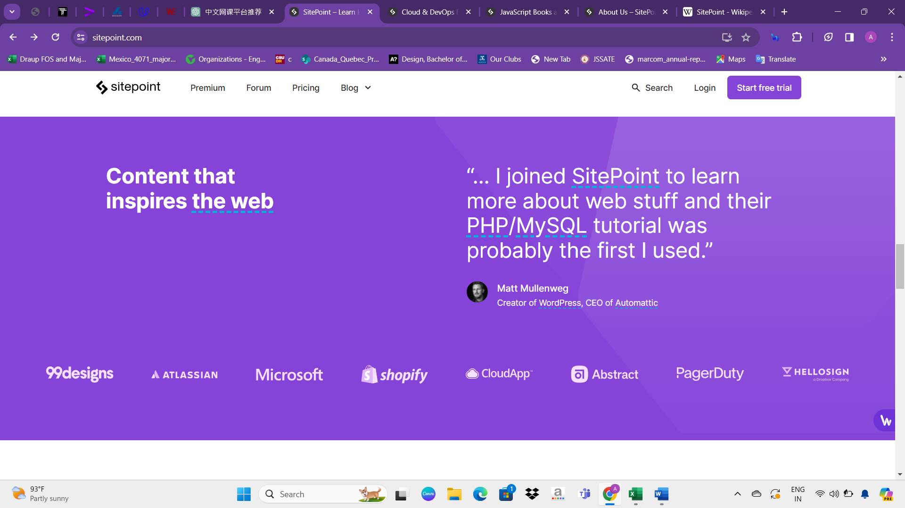

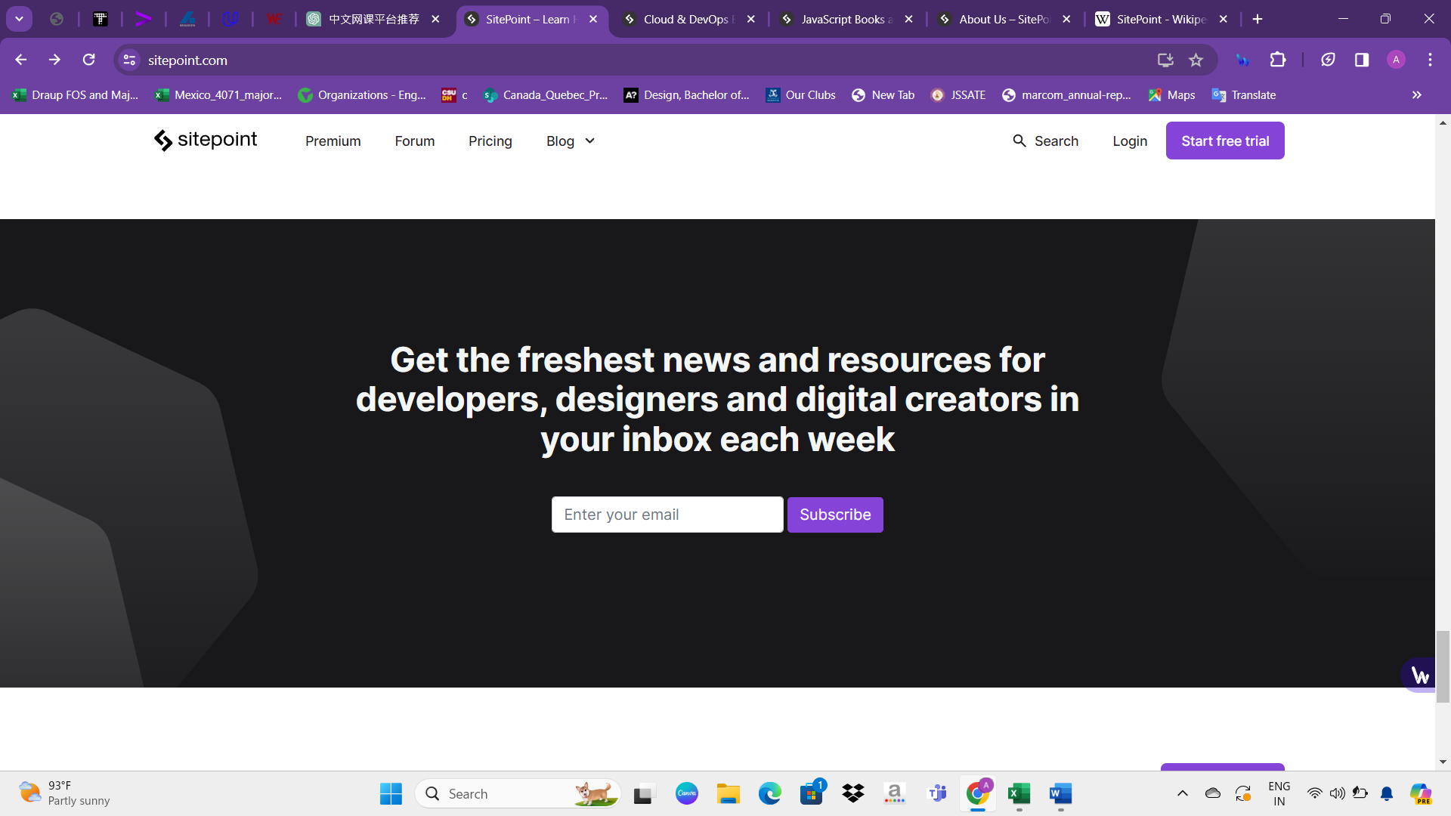

Concluding the browsing experience, SitePoint prompts users to subscribe to their newsletter via email, serving as a gentle reminder to stay updated on the latest courses, tutorials, and industry insights. This subscription option not only keeps users informed about new offerings but also subtly encourages them to consider paid subscription plans or premium content, reinforcing the platform's value proposition and enticing users to explore further. By strategically placing the email subscription option at the end of the browsing journey, SitePoint aims to maintain user engagement and foster a sense of community while also nudging potential subscribers towards paid offerings. This holistic approach to user interaction ensures that SitePoint effectively balances providing valuable free resources with promoting premium services, ultimately driving conversions and sustaining user loyalty.

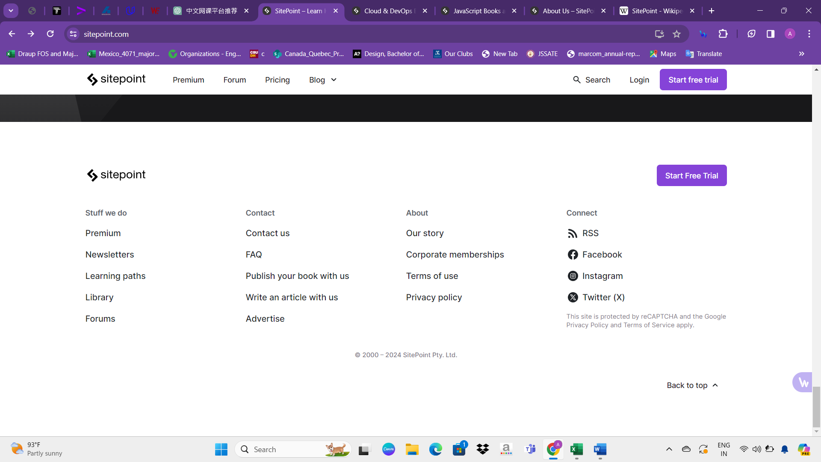

Courses Design

At any point during their browsing session on the SitePoint website, users have the freedom to select a topic that aligns with their learning goals and interests. With a wide variety of courses available across different topics, users can navigate through the entire website and explore courses seamlessly. Whether they are browsing through the homepage, exploring specific topic pages, or even reading blog posts or forum discussions, users can easily identify and select courses that cater to their needs. This intuitive navigation system ensures that users have access to SitePoint's comprehensive collection of educational content from anywhere on the website, empowering them to personalize their learning experience and make informed choices about their course selections.

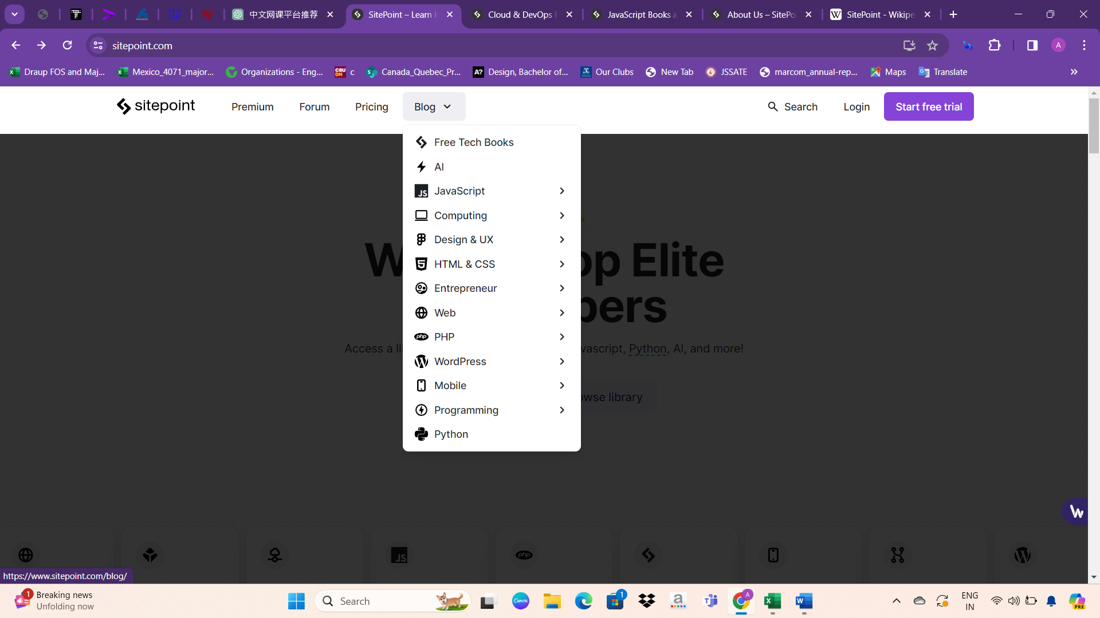

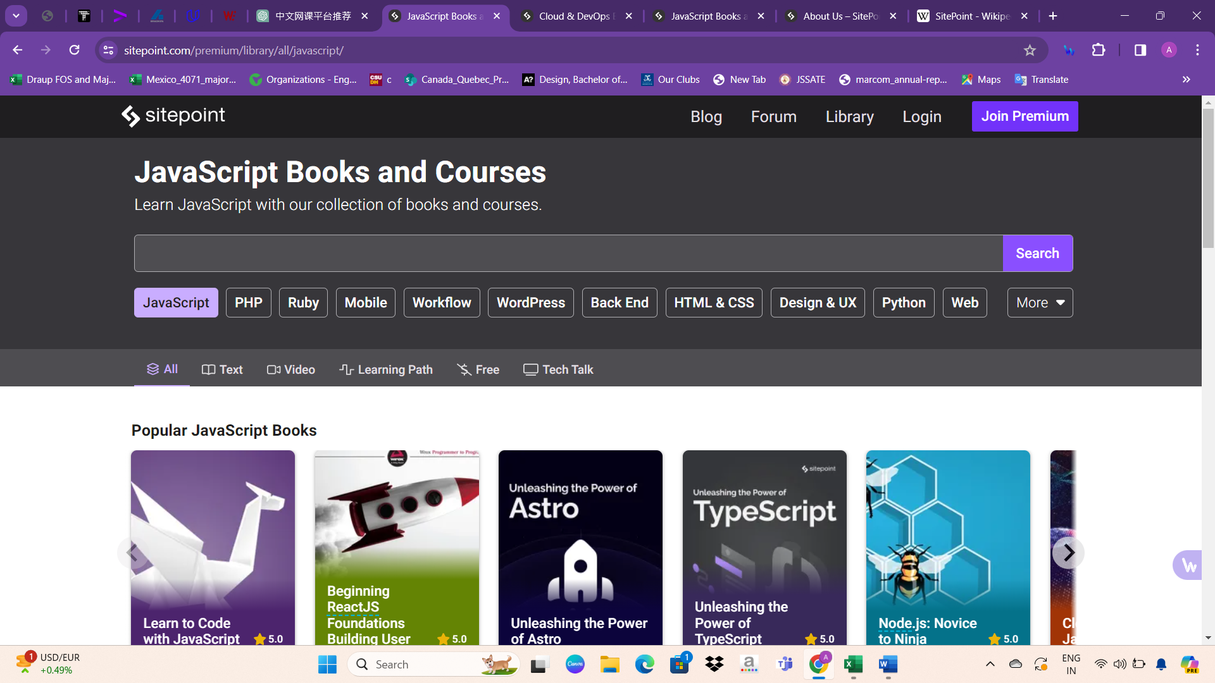

Once a user selects a topic of interest on the SitePoint website, they are presented with a curated list of courses within that specific topic. From this list, users can browse through the available courses and select the one that best suits their learning objectives and preferences. Each course is accompanied by a detailed description, outlining its content, objectives, duration, and any prerequisites. Users can explore these details to make informed decisions about which course to enroll in based on their skill level, learning pace, and specific areas of interest within the chosen topic. Additionally, users may have access to reviews or ratings from other learners, providing valuable insights into the course quality and effectiveness. By offering a user-friendly interface and comprehensive course information, SitePoint empowers users to confidently select the courses that meet their individual learning needs.

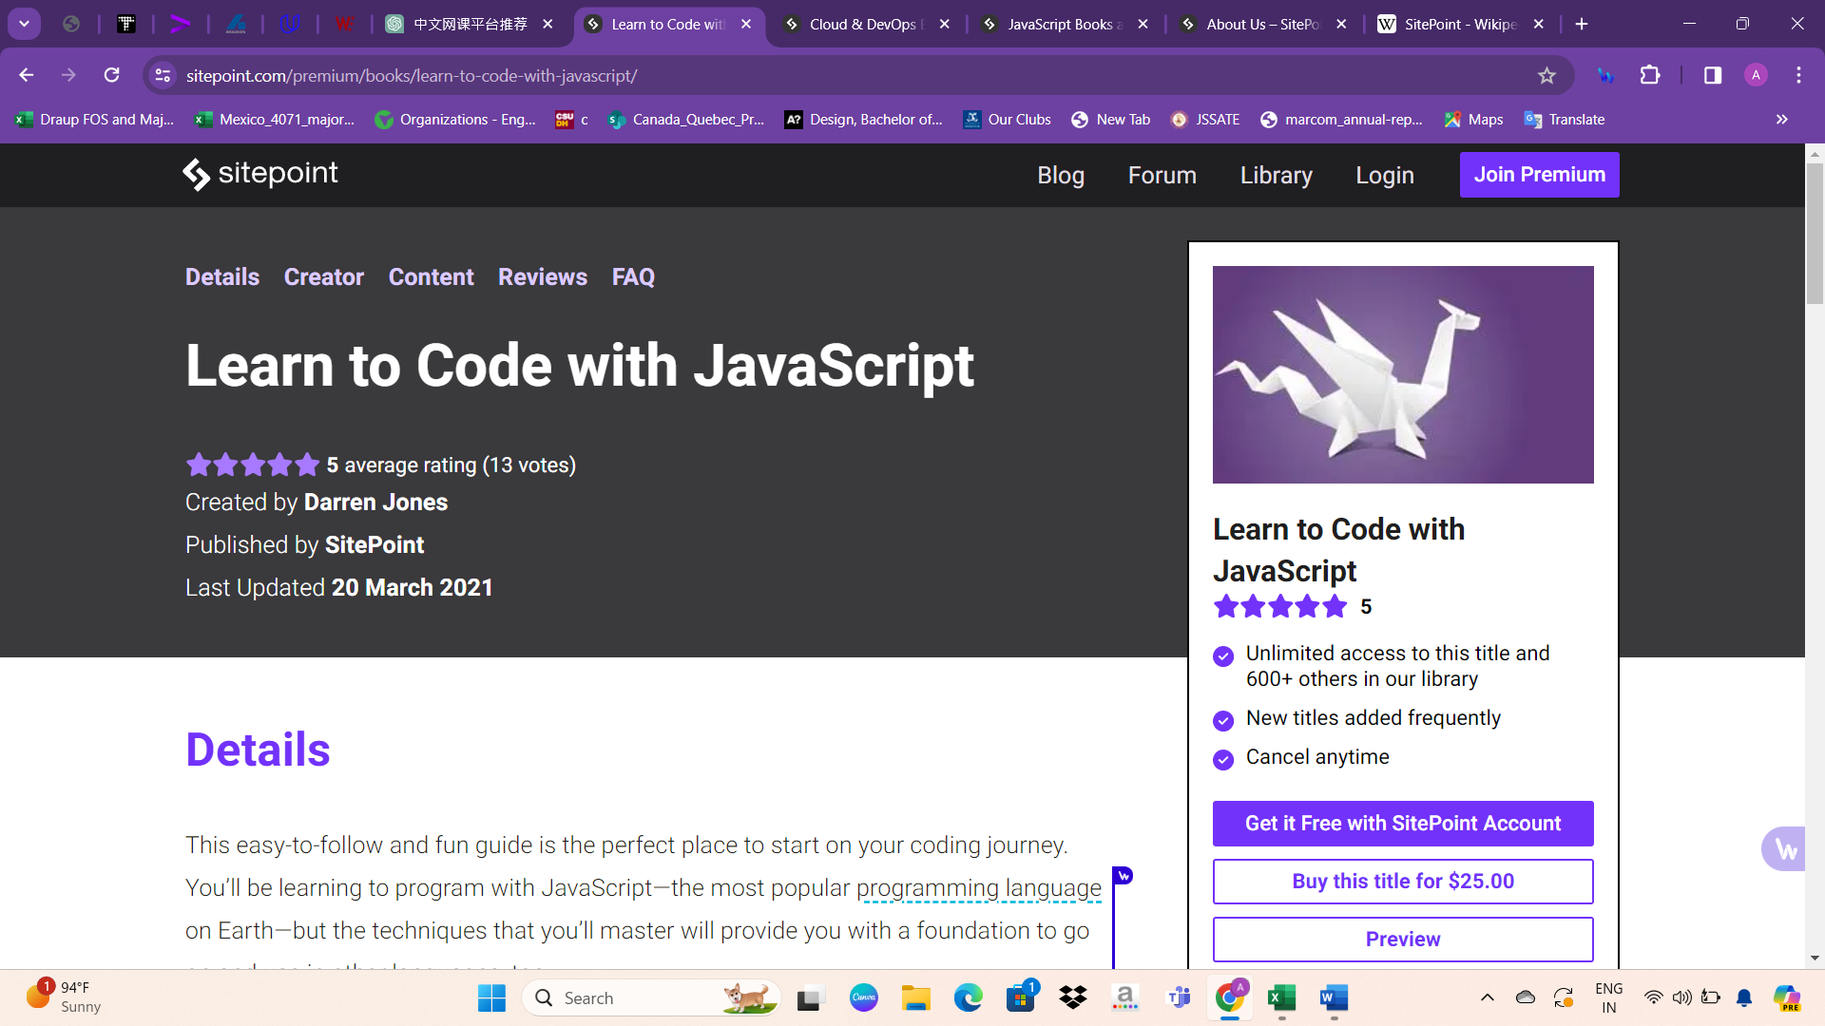

Upon entering a course, users encounter comprehensive sections including Details, Creator, Content, Reviews, and FAQ. These segments furnish essential information such as course creator, publisher, brief description, and user reviews. Additionally, a FAQ section addresses common queries, ensuring a thorough understanding before enrollment.

On the right side of the course page, the premium option "Learn to Code with JavaScript" is highlighted, showcasing its benefits:

Unlimited access to this title and 600+ others in our library

New titles added frequently

Cancel anytime

Users are given the option to access it for free with a SitePoint account or purchase the title for $25.00. Additionally, a preview is available for users to explore before making a decision.

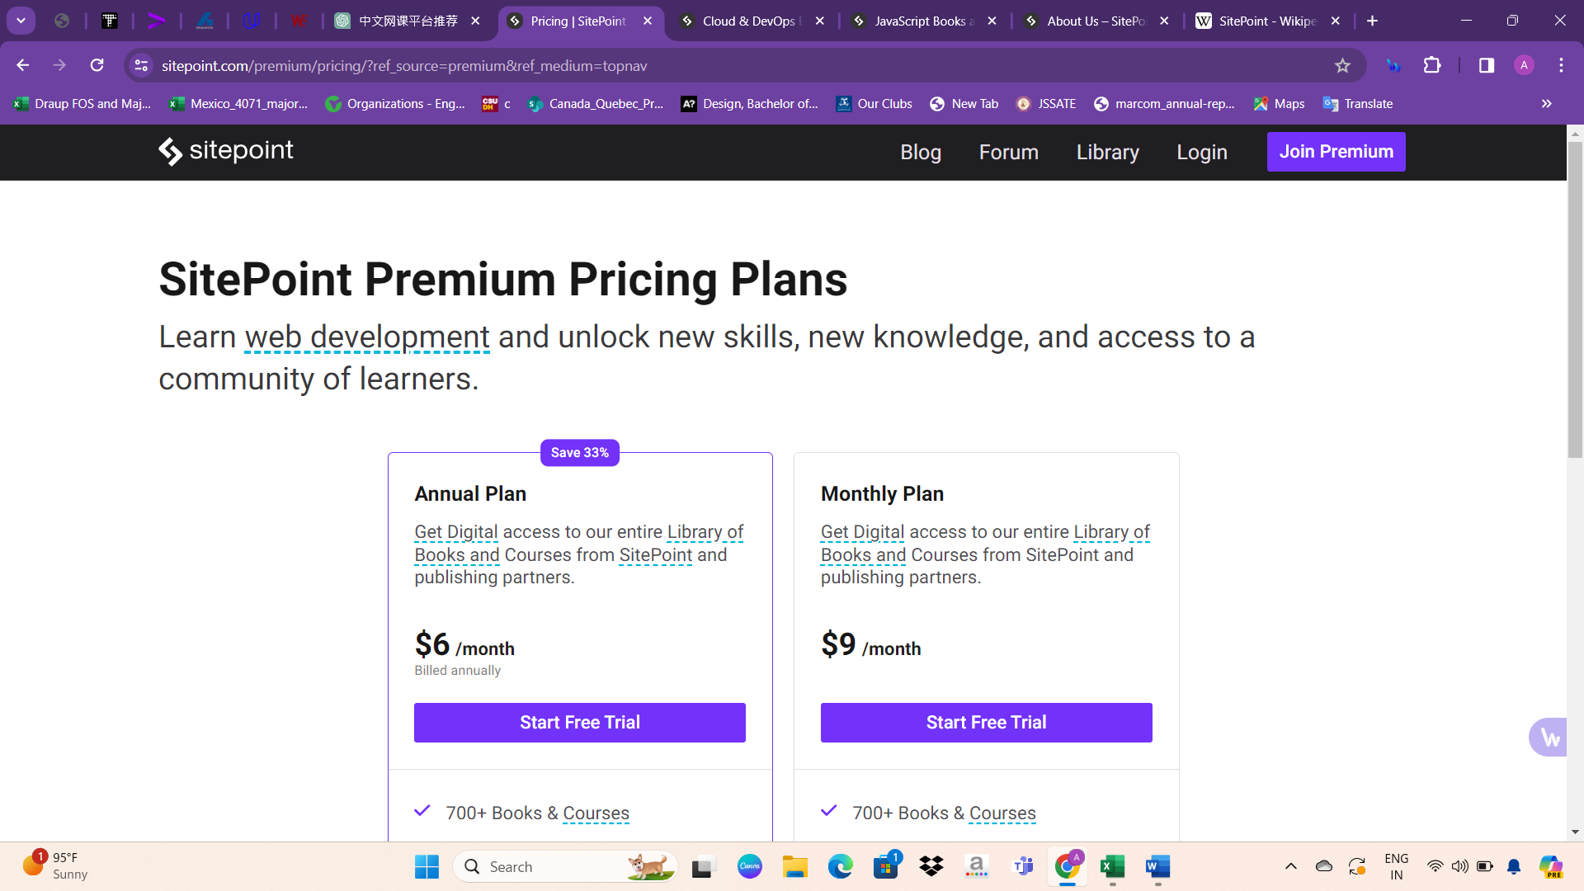

Upon clicking the premium option, users are presented with two subscription plans: the Annual Plan, priced at $6 per month billed annually, and the Monthly Plan, priced at $9 per month. Both plans provide digital access to SitePoint's entire library of books and courses, comprising over 700 titles and 35+ premium coding assessments. Additionally, they offer a 7-day free trial period and the flexibility to cancel at any time. This provides users with options to choose a plan that best suits their needs and budget, ensuring convenient access to a wealth of educational resources.

Users are offered a 7-day free trial upon subscribing to either the Annual Plan or the Monthly Plan for premium access. Following the trial period, a subscription fee of $6 per month (billed annually) or $9 per month applies, depending on the chosen plan. This trial period allows users to explore the platform's extensive library of books and courses before committing to a paid subscription.

Privacy policy

Privacy Policy:

Effective May 18, 2018, SitePoint Pty Ltd (ACN 089 647 638), operating the https://www.sitepoint.com website and SitePoint Mobile app, outlines its policies regarding the collection, use, and disclosure of personal data. By using the Service, users agree to the data collection and usage terms. The Privacy Policy defines terms like Personal Data, Usage Data, Cookies, Data Controller, Data Processors, and Data Subject. Information collected includes Personal Data such as email addresses, names, phone numbers, and addresses, as well as Usage Data and Cookies. This data is used to provide and improve the Service, notify users about changes, facilitate interactive features, provide customer support, analyze usage, and offer news and promotions. Legal basis for processing Personal Data under GDPR is outlined, including the need for performance of contracts, user consent, legitimate interests, compliance with law, and payment processing. Retention of data aligns with legal obligations and internal analysis purposes. Data may be transferred internationally, with appropriate security measures. Disclosure of data may occur in business transactions or to comply with legal requirements. While security measures are in place, absolute security cannot be guaranteed. Users have rights under GDPR, including access, correction, deletion, objection, restriction, data portability, and withdrawal of consent. Complaints can be directed to relevant data protection authorities. Third-party Service Providers, including analytics and advertising partners, may be engaged. Opt-out options for interest-based advertising are provided. Payments within the Service are handled by third-party payment processors, with adherence to PCI-DSS standards. Links to external sites are not governed by this Privacy Policy. The Service does not address anyone under 18 years old, and parental consent is required if a minor provides Personal Data. Changes to the Privacy Policy will be communicated via email or a notice on the Service. Users are encouraged to review the Privacy Policy periodically for updates.

Technologies used

Here are the highlighted topics from the website background:

1. Content Management Systems

- Gatsby

- Discourse

- Zendesk

2. Programming Languages

- Ruby

- JavaScript

3. Client-side Programming Language

- JavaScript

4. JavaScript Libraries

- Bootstrap

- Vue.js

- jQuery

- React

5. Web Servers

- Nginx

- Node.js

- Cloudflare Server

6. Web Hosting Providers and Data Center

- Amazon

7. Reverse Proxy Services and DNS Server Provider

- Amazon CloudFront

- Cloudflare

8. Email Server Providers

- Gmail

- Zendesk

9. SSL Certificate Authorities

- Starfield Technologies

- IdenTrust

10. JavaScript Content Delivery Network

- jsDelivr

11. Traffic Analysis Tools

- Google Analytics

- Facebook Pixel

- Hotjar

12. Advertising Networks

- Google Ads

- BuySellAds

13. Tag Manager

- Google Tag Manager

14. Site Elements

- CSS (External, Embedded, Inline)

- Compression (Brotli, Gzip)

- ETag Headers

- IPv6, HTTP/2

- HTTP Strict Transport Security (HSTS)

- Subdomain Redirection

- SSL Encryption

15. Structured Data Formats

- Open Graph protocol

- Twitter Cards

- JSON-LD

- Generic RDFa

- Microdata

16. Markup Language and Character Encoding

- HTML5

- UTF-8

17. Image File Formats

- PNG

- JPEG

- SVG

- GIF

- WebP

18. Top Level Domain

- Commercial entities.

Overview about The Odin Project

The Odin Project is an invaluable resource for individuals navigating the journey of learning to code independently. Here's an overview of what you can expect from The Odin Project:

1. Comprehensive Curriculum: The Odin Project offers a full roadmap to becoming a developer, catering to individuals at all experience levels. Their curriculum is free and covers everything you need to know to become a full stack developer.

2. Hands-on Learning: Learning by doing is emphasized throughout the curriculum. By working on projects strategically integrated into the learning path, students gain practical experience and build a strong portfolio to showcase their skills.

3. Community Support: The Odin Project maintains a Discord community where students can seek assistance from maintainers, volunteers, and fellow learners. This supportive environment fosters collaboration and encourages growth.

4. Open Source Philosophy: Both the website hosting the curriculum and the curriculum itself are open source. This means that anyone can contribute to improving the curriculum or the platform, ensuring that content remains up-to-date and relevant.

5. Origin and Success Stories: Founded in 2013 by Erik Trautman, The Odin Project has helped numerous students secure developer positions and embark on personal coding projects. Its success stems from its hands-on approach and meticulously curated curriculum.

6. Opportunities to Contribute: The Odin Project welcomes contributions from individuals worldwide. Whether it's enhancing existing lessons, adding new resources, or fixing bugs on the website, there are various ways to get involved and make a difference.

7. Community Engagement: To connect with The Odin Project community, individuals can join their Discord channel for networking and support. Additionally, there are opportunities to contribute financially or through open source projects.

In summary, The Odin Project is more than just a coding curriculum—it's a supportive community-driven platform that empowers individuals to pursue their coding aspirations and contribute to the world of software development.

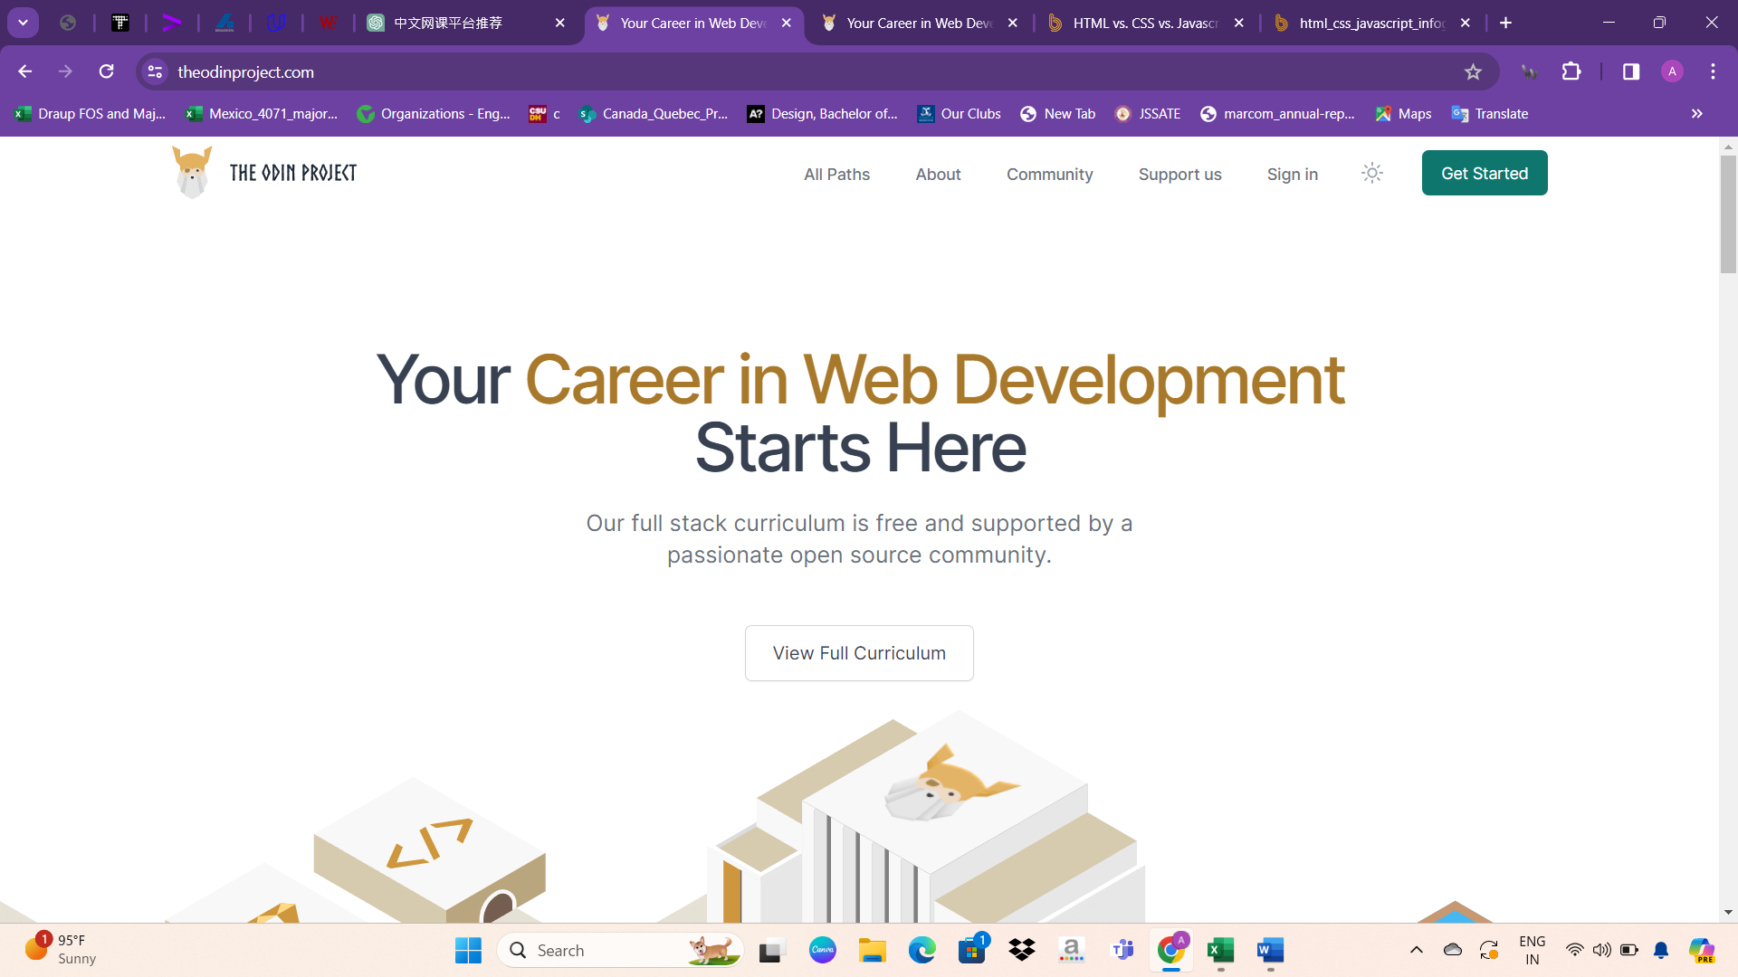

Websites UI design

It seems like you're describing the navigation bar or menu items commonly found on The Odin Project website. Here's a breakdown of what each item might represent:

1. All Paths: This likely refers to a section or page on the website where users can explore different learning paths or tracks offered by The Odin Project. These paths could cater to different programming languages, frameworks, or specialties.

2. About: This is likely a link to a page providing information about The Odin Project, its mission, history, team, and any other relevant details.

3. Community: This could lead to a section of the website dedicated to community engagement, where users can connect with fellow learners, mentors, and contributors. It might include forums, chat rooms, or social media links.

4. Support Us: This link may direct users to a page where they can find information on how to support The Odin Project financially, through donations, sponsorships, or other means. It might also provide options for contributing time or resources to the project.

5. Sign In: This would likely lead to a login page where registered users can sign in to access their accounts, track their progress, or participate in interactive features of the website.

6. Get Started: This could be a call-to-action button or link encouraging new visitors to begin their learning journey with The Odin Project. It might lead to a page with information on how to get started, including registration instructions, an overview of available resources, and suggested first steps.

These menu items together provide a comprehensive navigation experience for users, allowing them to explore the platform, engage with the community, and access resources to support their learning journey.

The Odin Project website that includes a div containing quotes, possibly testimonials or inspirational messages from learners or contributors. Additionally, there is likely a "View Curriculum" option associated with this section.

The "View Curriculum" option could serve as a call-to-action button or link that directs users to explore the curriculum offered by The Odin Project. Clicking on this button would likely take users to a page where they can browse through the available courses, paths, or learning resources provided by the platform.

Overall, this section with quotes and the "View Curriculum" option aims to inspire and encourage users to engage with the educational content offered by The Odin Project, highlighting the value of the curriculum and inviting users to begin their learning journey.

After the section containing the "View Curriculum" option, the next div likely features motivational quotes about the courses offered by The Odin Project. These quotes may emphasize key principles such as "Learn," "Build," and "Connect," reflecting the core values and approach of the educational platform.

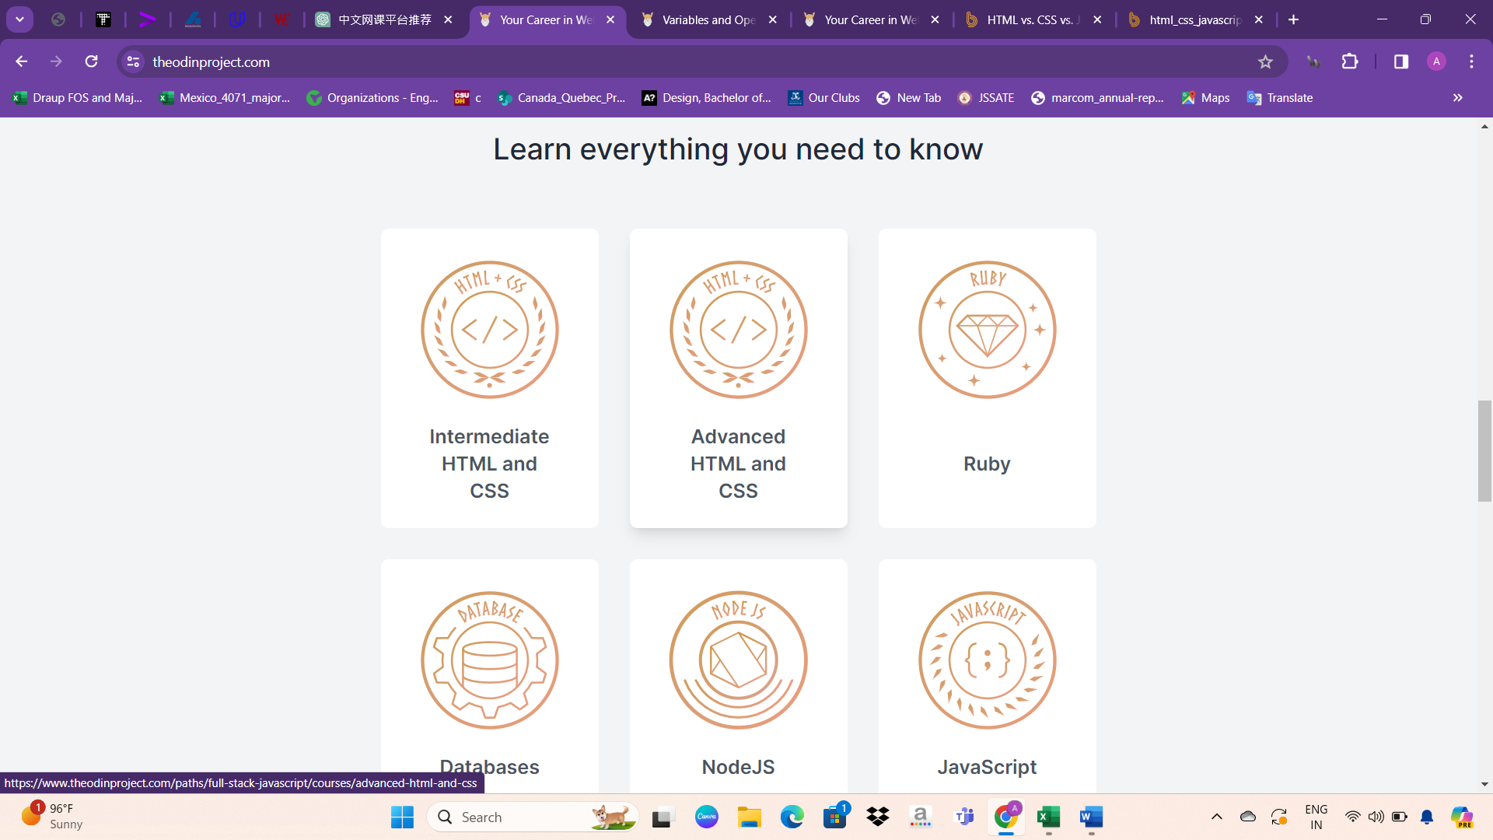

Following the motivational quotes about learning, building, and connecting, the website likely utilizes a grid system to present information about its courses. This grid layout organizes course titles and brief descriptions, providing users with an overview of the available educational opportunities. Each course may be accompanied by key details to help users understand its content and relevance. Additionally, the grid layout ensures that the presentation of course information is visually appealing and easy to navigate. At the bottom of this section, users may find a prominent button or link inviting them to explore the complete curriculum. This design approach optimizes user experience by offering clear pathways to access detailed information about the courses offered by the platform.

The website likely showcases success stories from users who have benefited from the platform. These success stories serve as testimonials, highlighting real-life examples of individuals who have achieved their goals or made significant progress in their careers through the courses offered. Alongside these success stories, user reviews may be featured, providing further validation of the platform's effectiveness and quality. By showcasing success stories and user reviews, the website aims to inspire visitors and build trust in its educational offerings. These personal accounts demonstrate the tangible impact of the courses and serve as social proof, encouraging prospective users to enroll and embark on their own learning journey.

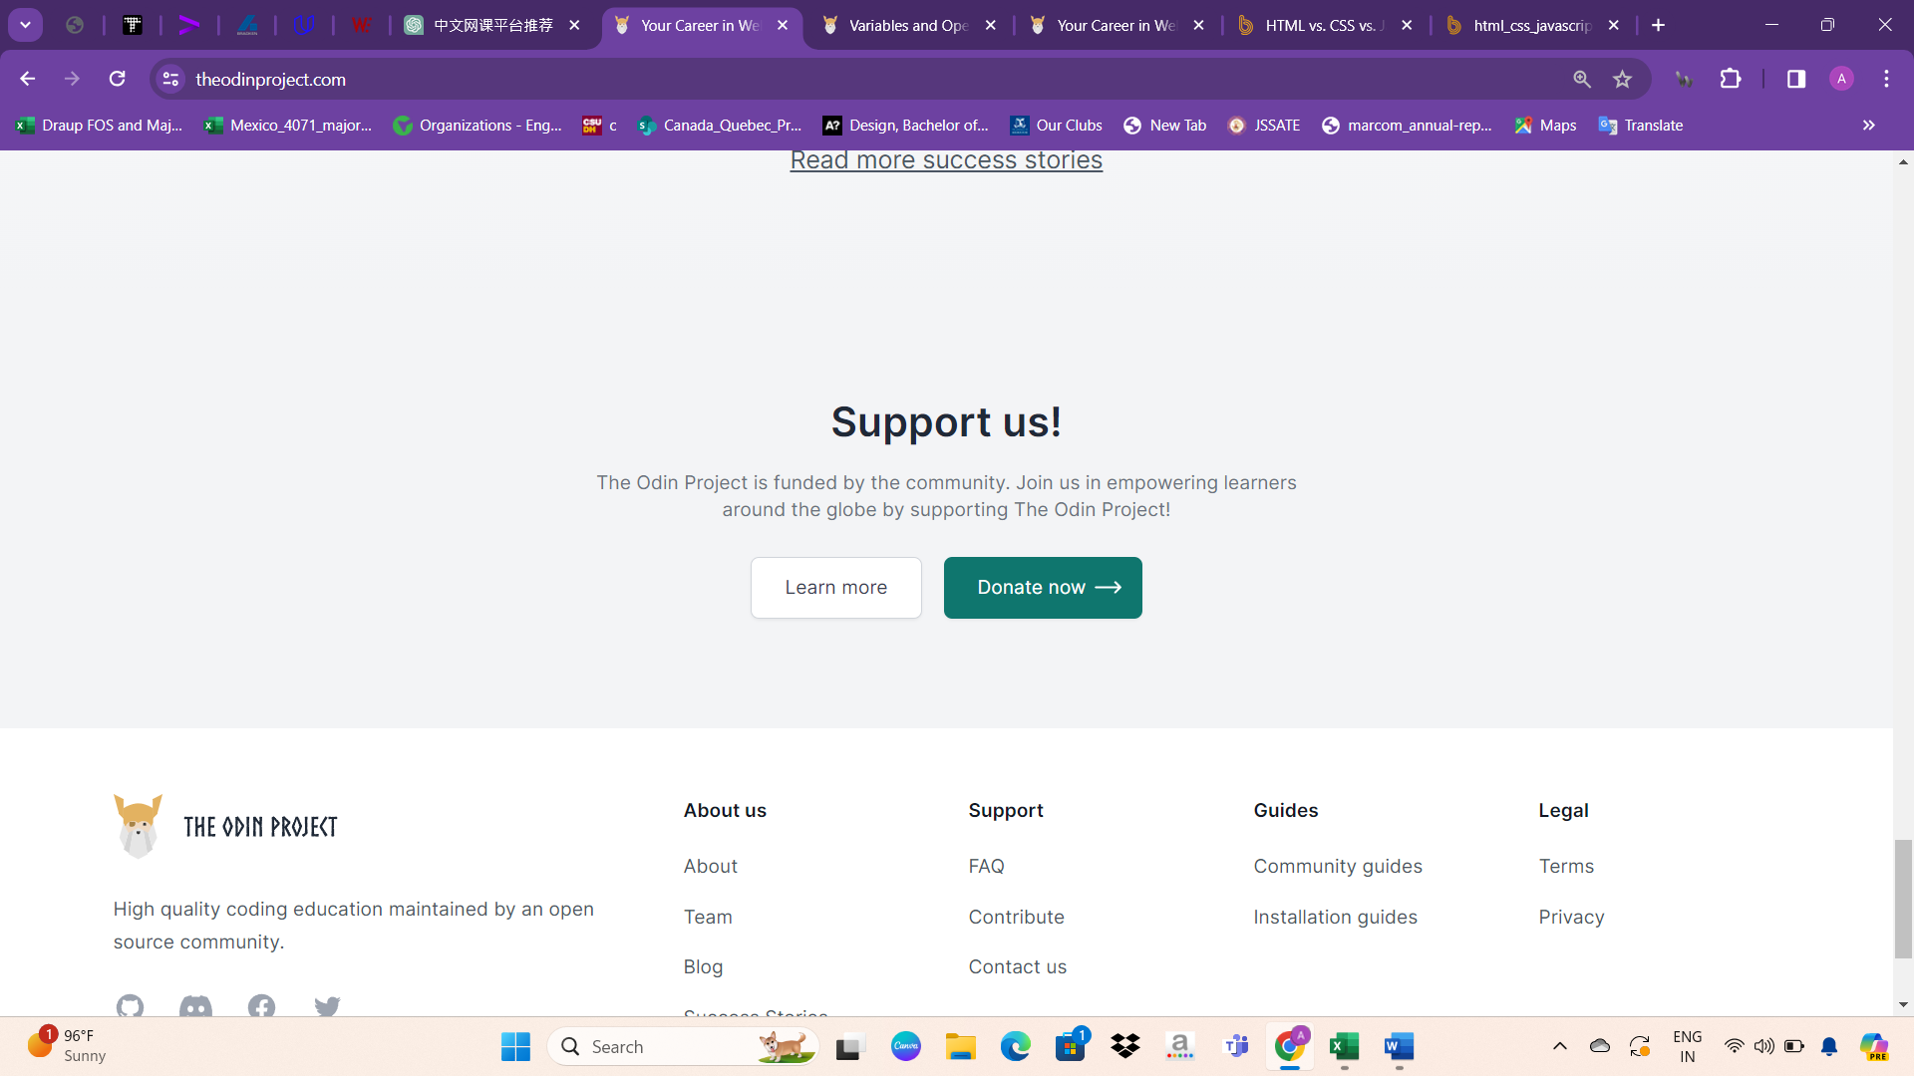

At the bottom of the page, there is a section titled "Support us!" which emphasizes the community-driven nature of The Odin Project. It invites visitors to join in funding the platform and empowering learners worldwide. By supporting The Odin Project, individuals contribute to the ongoing development and accessibility of the educational resources provided. The section encourages users to learn more about how they can contribute or make a donation to sustain and enhance the platform's offerings. This call to action reinforces the collaborative spirit of the community and encourages individuals to play a part in supporting the learning journey of others.

As usual, the page concludes with standard sections such as "About," "Privacy Policy," and similar informational links. These sections provide essential information about The Odin Project, including its mission, goals, and policies regarding user data and privacy. Visitors can learn more about the platform's background, its founding principles, and how it operates. Additionally, the Privacy Policy outlines the guidelines and procedures regarding the collection, use, and protection of user data, ensuring transparency and accountability. These standard sections serve to inform users about the platform's objectives, practices, and commitments, fostering trust and credibility.

Privacy policy

The Odin Project prioritizes the privacy of its visitors and is committed to transparently outlining its practices in this Privacy Policy. As a Data Controller, The Odin Project collects and uses personal information based on legitimate interests, user consent, contractual obligations, or legal compliance. Personal data is retained only for necessary purposes, and individuals in the European Economic Area (EEA) have specific data protection rights, including access, rectification, objection, and portability. Log files are utilized for standard analytics, while cookies enhance user experience by customizing content. Third-party advertisers may employ cookies or similar technologies for advertising campaigns, and users are encouraged to review their privacy policies. The Odin Project does not target or knowingly collect information from children under 13. This policy applies solely to online activities on The Odin Project's website, with users consenting to its terms by utilizing the platform.

Technologies used

Sure, here are the highlighted topics from the website background presented in a structured format:

1. Content Management Systems

- Gatsby

- Discourse

- Zendesk

2. Programming Languages

- Ruby

- JavaScript

3. Client-side Programming Language

- JavaScript

4. JavaScript Libraries

- Bootstrap

- Vue.js

- jQuery

- React

5. Web Servers

- Nginx

- Node.js

- Cloudflare Server

6. Web Hosting Providers and Data Center

- Amazon

7. Reverse Proxy Services and DNS Server Provider

- Amazon CloudFront

- Cloudflare

8. Email Server Providers

- Gmail

- Zendesk

9. SSL Certificate Authorities

- Starfield Technologies

- IdenTrust

10. JavaScript Content Delivery Network

- jsDelivr

11. Traffic Analysis Tools

- Google Analytics

- Facebook Pixel

- Hotjar

12. Advertising Networks

- Google Ads

- BuySellAds

13. Tag Manager

- Google Tag Manager

14. Site Elements

- CSS (External, Embedded, Inline)

- Compression (Brotli, Gzip)

- ETag Headers

- IPv6, HTTP/2

- HTTP Strict Transport Security (HSTS)

- Subdomain Redirection

- SSL Encryption

15. Structured Data Formats

- Open Graph protocol

- Twitter Cards

- JSON-LD

- Generic RDFa

- Microdata

16. Markup Language and Character Encoding

- HTML5

- UTF-8

These topics provide an overview of the various technologies and services used by the website.